`

AMERICAN NATIONAL STANDARD

ANSI/ISA-95.00.04-ed2 CVD04

Enterprise-Control System Integration

− Part 4: Objects and Attributes for

Manufacturing Operations Management Integration

ANSI/ ISA-95.00.04-ed2 CVD04 (ISA 95.00.04 ed2Mod)

Enterprise-Control System Integration − Part 4: Objects and Attributes for Manufacturing

Operations Management Integration

Copyright © 2018 by the International Society of Automation (ISA). All rights reserved. Not for resale. Printed in the United States of America. No part of this publication may be reproduced, stored in a retrieval system, or transmitted in any form or by any means (electronic mechanical, photocopying, recording, or otherwise), without the prior written permission of the Publisher.

ISA  
67 Alexander Drive  
P.O. Box 12277  
Research Triangle Park, North Carolina 27709

CONTENTS

CONTENTS 3

Figures 6

Tables 7

FOREWARD 11

INTRODUCTION 13

1 Scope 14

2 Normative references 14

3 Terms, definitions, abbreviations and conventions 14

3.1 Terms and definitions 14

3.2 Abbreviations 16

3.3 Conventions 16

3.3.1 General 16

3.3.2 UML notation in information object models 17

3.3.3 Object color convention for object relationship between UML models 17

3.3.4 Relationship types 17

3.3.5 Relationship table 17

3.3.6 Relationship role table 17

3.3.7 Object attribute tables 17

3.3.8 Relationships between information models and resource models 17

4 Information exchange between manufacturing operations activities 17

4.1 Manufacturing operations management information models 17

4.1.1 General 17

4.1.2 Information models 17

4.1.3 Relationship of exchange information models to operations management activity categories 17

4.1.4 Cross model relationships for MOM activity context in exchanges 17

4.1.5 Abstract UML model information 18

4.1.6 Attributes of an object in an information model 18

4.2 Information exchange network between MOM activities 18

4.2.1 Process segment, operations segment, and work master information models 19

4.2.2 Common resource definitions 19

4.2.3 Work information models 20

5 Resource relationship network information 20

5.1 Resource relationship network model 20

5.2 Resource relationship network 22

5.3 Resource relationship network property 23

5.4 Resource network connection 24

5.5 Resource network connection property 25

5.6 From resource reference 25

5.7 From resource reference property 26

5.8 To resource reference 27

5.9 To resource reference property 28

5.10 Resource network connection type 29

5.11 Resource network connection type property 30

6 Work definition information 30

6.1 Work definition model 30

6.2 Work master 33

6.3 Work directive 34

6.4 Work definition 35

6.5 Work master relationship roles and attributes 37

6.6 Work directive relationship roles and attributes 38

6.7 Parameter specification 38

6.8 Personnel specification 38

6.9 Personnel specification property 38

6.10 Equipment specification 38

6.11 Equipment specification property 39

6.12 Physical asset specification 39

6.13 Physical asset specification property 39

6.14 Material specification 39

6.15 Material specification property 39

6.16 Workflow specification information 39

6.16.1 Workflow specification model 39

6.16.2 Workflow specification 43

6.16.3 Workflow specification property 44

6.16.4 Workflow specification node 45

6.16.5 Workflow specification node property 46

6.16.6 Workflow specification connection 46

6.16.7 Workflow specification connection property 47

6.16.8 Workflow specification node type 48

6.16.9 Workflow specification node type property 49

6.16.10 Workflow specification connection type 49

6.16.11 Workflow specification connection type property 50

7 Work schedule information 51

7.1 Work schedule model 51

7.2 Work schedule 56

7.3 Work request 58

7.4 Job list definition 60

7.5 Job list 60

7.6 Job order 61

7.7 Job order parameter 63

7.8 Personnel requirement 64

7.9 Personnel requirement property 64

7.10 Equipment requirement 64

7.11 Equipment requirement property 64

7.12 Physical asset requirement 64

7.13 Physical asset requirement property 64

7.14 Material requirement 64

7.15 Material requirement property 64

7.16 Job order to work master relationship 64

8 Work performance information 65

8.1 Work performance model 65

8.2 Work performance 68

8.3 Work response 69

8.4 Job response list 71

8.5 Job response 72

8.6 Job response data 73

8.7 Personnel actual 74

8.8 Personnel actual property 74

8.9 Equipment actual 74

8.10 Equipment actual property 74

8.11 Physical asset actual 74

8.12 Physical asset actual property 74

8.13 Material actual 74

8.14 Material actual property 74

8.15 Test result 74

9 Work capability information 74

9.1 Work capability model 74

9.2 Work capability 76

9.3 Personnel capability 78

9.4 Personnel capability property 78

9.5 Equipment capability 78

9.6 Equipment capability property 78

9.7 Physical asset capability 78

9.8 Physical asset capability property 78

9.9 Material capability 78

9.10 Material capability property 78

10 Work master capability information 79

10.1 Work master capability model 79

10.2 Work master capability 81

10.3 Personnel capability 84

10.4 Personnel capability property 84

10.5 Equipment capability 84

10.6 Equipment capability property 84

10.7 Physical asset capability 84

10.8 Physical asset capability property 84

10.9 Material capability 84

10.10 Material capability property 84

11 Work KPI information 84

12 Work alert information 84

12.1 Work alert model 84

12.2 Work alert definition 85

12.3 Work alert definition property 86

12.4 Work alert 87

12.5 Work alert property 88

13 Work calendar information 88

13.1 Work calendar model 88

13.2 Work calendar definition 90

13.3 Work calendar definition property 90

13.4 Work calendar definition entry 91

13.5 Work calendar definition entry property 92

13.6 Work calendar 93

13.7 Work calendar property 93

13.8 Work calendar entry 94

13.9 Work calendar entry property 94

14 Documents for the scheduling, execution and reporting of work 95

15 Work record information 95

15.1 Operations record model (abstract) 95

15.2 Work record information, an operations record specialization 96

15.3 Work record specification 97

15.4 Work record model 99

15.5 Work record 100

15.6 Work record entry 101

16 Inter-relationships between object models 103

17 Compliance 106

Annex A (informative) Questions and answers about object use 107

A.1 How are dependencies in the *work schedule* and *work response* handled? 107

A.2 Use of hierarchy scope in workflow specification model 107

A.3 What are examples of resource relationships? 107

Annex B (informative) Related standards 110

Annex C (informative) Representing a workflow specification in BPMN 112

Annex D (informative) Representing a workflow specification in flowchart notation 116

Annex E (informative) Example of work calendars 118

E.1 Four-day 24-hour shift pattern 118

E.2 Example of ISO 8601 format strings 119

E.3 Bank holiday work calendar 120

Annex F (informative) Examples of work record implementation 121

F.1 Representation of ISA-88 production record 121

F.2 Extension of ISA-88 production record to included ISA-95 objects 122

F.3 Work record model as presented in IEC WG5 122

F.3.1 Work record definition 122

F.3.2 Work record 123

F.3.3 Work record extensions 123

F.3.4 Work record model example 126

F.3.5 Work record entry 127

F.3.6 Work record container objects 128

F.3.7 Event types and subtypes 129

Bibliography 131

Figures

Figure 1 – Information exchange between manufacturing operations management activities 19

Figure 2 – Resource relationship network model 21

Figure 3 – Work definition model 31

Figure 4 – Relationship of work master to work directive 35

Figure 5 – Workflow specification model 40

Figure 6 – Example, a workflow specification in BPMN format 42

Figure 7 – Example, workflow specification in flowchart format 43

Figure 8 – Work schedule model 52

Figure 9 – Example, operations schedule for a site 54

Figure 10 – Example, work schedule for an area 55

Figure 11 – Example, work request, job order, and job list 55

Figure 12 – Example, Work request for continuous processing 56

Figure 13 – Example, job orders and work master relationships 65

Figure 14 – Work performance model 66

Figure 15 – Work capability model 75

Figure 16 – Work master capability model 80

Figure 17 – Work alert model 85

Figure 18 – Work calendar model 89

Figure 19 – Operations record model (abstract) 96

Figure 20 – Work record activities 97

Figure 21 – Work record model 99

Figure 22 – Relationship between models 104

Figure A.1 – Equipment resources 108

Figure A.2 – Routing relationship network 108

Figure A.3 – Gas main relationship network 109

Figure A.4 – “Usable in” relationship network 109

Figure B.1 – Relationship between Part 2, Part 4, and ANSI/ISA-88 (IEC 61512) standards 111

Figure C.1 – Example, workflow specification in BPMN notation 114

Figure C.2 – Example workflow process in the workflow specification model 115

Figure D.1 – Example, workflow specification in flowchart notation 116

Figure D.2 – Example workflow process in the workflow specification model 117

Figure F.1 – Work record activities 123

Figure F.2 – Example, Work record container 125

Figure F.3 – Example, work record element reference 126

Figure F.4 – Example, work record model 127

Tables

Table 1 – Resource relationship network model relationships 21

Table 2 – Resource relationship network relationships roles 22

Table 3 – Resource relationship network attributes 23

Table 4 – Resource relationship network property relationship roles 23

Table 5 – Resource relationship network property attributes 24

Table 6 – Resource network connection relationship roles 24

Table 7 – Resource network connection attributes 25

Table 8 – Resource network connection property relationship roles 25

Table 9 – Resource network connection property attributes 25

Table 10 – From resource reference relationship roles 26

Table 11 – From resource reference attributes 26

Table 12 – From resource reference property relationships roles 27

Table 13 – From resource reference property attributes 27

Table 14 – To resource reference relationships roles 27

Table 15 – To resource reference attributes 28

Table 16 – To resource reference property relationships roles 28

Table 17 – To resource reference property attributes 29

Table 18 – Resource network connection type relationship roles 29

Table 19 – Resource network connection type attributes 29

Table 20 – Resource network connection type property relationship roles 30

Table 21 – Resource network connection type property attributes 30

Table 22 – Work definition model relationships 32

Table 23 – Additional material specification attributes 35

Table 24 – Work definition relationship roles 35

Table 25 – Work definition attributes (common in work master and work directive) 36

Table 26 – Work master relationship roles 37

Table 27 – Work master attributes 38

Table 28 – Work directive relationship roles 38

Table 29 – Workflow specification model relationships 40

Table 30 – Workflow specification relationship roles 43

Table 31 – Workflow specification attributes 44

Table 32 – Workflow specification property relationship roles 44

Table 33 – Workflow specification property attributes 44

Table 34 – Workflow specification node relationship roles 45

Table 35 – Workflow specification node attributes 46

Table 36 – Workflow specification node property relationship roles 46

Table 37 – Workflow specification node property attributes 46

Table 38 – Workflow specification connection relationship roles 47

Table 39 – Workflow specification connection attributes 47

Table 40 – Workflow specification connection property relationship roles 48

Table 41 – Workflow specification connection property attributes 48

Table 42 – Workflow specification node type relationship roles 48

Table 43 – Workflow specification node type attributes 49

Table 44 – Workflow specification node type property relationship roles 49

Table 45 – Workflow specification node type property attributes 49

Table 46 – Workflow specification connection type relationship roles 50

Table 47 – Workflow specification connection type attributes 50

Table 48 – Workflow specification connection type property relationship roles 50

Table 49 – Workflow specification connection type property attributes 51

Table 50 – Work schedule model relationships 52

Table 51 – Work schedule relationship roles 56

Table 52 – Work schedule attributes 56

Table 53 – Work request relationship roles 58

Table 54 – Work request attributes 59

Table 55 – Job list relationship roles 60

Table 56 – Job list attributes 60

Table 57 – Job order relationship roles 61

Table 58 – Job order attributes 61

Table 59 – Job order parameter relationship roles 64

Table 60 – Work performance model relationships 66

Table 61 – Work performance relationship roles 68

Table 62 – Work performance attributes 68

Table 63 – Work response relationship roles 70

Table 64 – Work response attributes 70

Table 65 – Job response list relationship roles 71

Table 66 – Job response list attributes 71

Table 67 – Job response relationship roles 72

Table 68 – Job response attributes 73

Table 69 – Job response data relationship roles 74

Table 70 – Work capability model relationships 75

Table 71 – Work capability relationship roles 76

Table 72 – Work capability attributes 77

Table 73 – Work master capability model relationships 80

Table 74 – Work master capability relationship roles 81

Table 75 – Work master capability attributes 82

Table 76 – Work alert model relationships 85

Table 77 – Work alert definition relationship roles 85

Table 78 – Work alert definition attributes 86

Table 79 – Work alert definition property relationship roles 86

Table 80 – Work alert definition property attributes 86

Table 81 – Examples of work alert properties 87

Table 82 – Work alert relationship roles 87

Table 83 – Work alert attributes 87

Table 84 – Work alert property relationship roles 88

Table 85 – Work alert property attributes 88

Table 86 – Work calendar model relationships 89

Table 87 – Work calendar definition relationship roles 90

Table 88 – Work calendar definition attributes 90

Table 89 – Work calendar definition property relationship roles 91

Table 90 – Work calendar definition property attributes 91

Table 91 – Work calendar definition entry relationship roles 91

Table 92 – Work calendar definition entry attributes 91

Table 93 – Work calendar definition entry property relationship roles 92

Table 94 – Work calendar definition entry property attributes 92

Table 95 – Work calendar relationship roles 93

Table 96 – Work calendar attributes 93

Table 97 – Work calendar property relationship roles 93

Table 98 – Work calendar property attributes 93

Table 99 – Work calendar entry relationship roles 94

Table 100 – Work calendar entry attributes 94

Table 101 – Work calendar entry property relationship roles 94

Table 102 – Work calendar entry property attributes 94

Table 103 – Operations record model relationships 96

Table 104 – Work record specification relationship roles 98

Table 105 – Work record specification attributes 98

Table 106 – Work record model relationships 99

Table 107 – Work record relationship roles 100

Table 108 – Work record attributes 100

Table 109 – Work record entry relationships 102

Table 110 – Work record entry attributes 102

Table 111 – Objects and models 105

Table E.1 – Four-day 24-hour shift pattern example 118

Table E.2 – Work calendar definition for 4-day 24–hour shift entry examples 118

Table E.3 – Work calendar definition entry for 4-day 24–hour shift example 118

Table E.4 – Work calendar entries for 2014 shift calendar 119

Table E.5 – Work calendar definition for 2014 England bank holidays 120

Table E.6 – Work calendar definition entries for 2014 England bank holidays 120

Table F.1 – ISA-88 objects as presented in the work record specification 121

Table F.2 – ISA-88 model representation of the allowed content of the *work record* 122

Table F.3 – Work record entry relationship 128

Table F.4 – Work record entry attributes 128

Table F.5 – Additional event types and subtypes 129

FOREWARD

This is Part 4 of a series of standards that defines the interfaces between Level 3 manufacturing operations management activities.

The scope of this Part 4 standard is limited to defining the details of the interface content within manufacturing operations management. The scope of this Part 4 standard is limited to the definition of object models and attributes for the information defined in Part 3 of this standard. The goal is to reduce the effort, cost, and errors associated with implementing these interfaces.

The standard may be used to reduce the effort associated with implementing new product offerings. The goal is to have enterprise systems and control systems that interoperate and easily integrate.

This publication has been drafted in accordance with the ISO/IEC Directives, Part 2. Therefore, the first three clauses present the scope of the standard, normative references, and definitions, in that order.

Clause 4 is informative. It describes the general information about the object information models for manufacturing operations management. It defines the general information model characteristics.

Clause 5 is normative. It defines the object information model, relationships, and attributes for resource relationship network model.

Clause 6 is normative. It defines the object information model, relationships, and attributes for work definition information and workflow specification information.

Clause 7 is normative. It defines the object information model, relationships, and attributes for work schedule information.

Clause 8 is normative. It defines the object information model, relationships, and attributes for work performance information.

Clause 9 is normative. It defines the object information model, relationships, and attributes for work capability information.

Clause 10 is normative. It defines the object information model, relationships, and attributes for work master capability information.

Clause 11 is normative. It defines the references for Work KPI information.

Clause 12 is normative. It defines the object information model, relationships, and attributes for work alert information.

Clause 13 is normative. It defines the object information model, relationships, and attributes for work calendar information.

Clause 14 is informative. It defines the how to exchange documents for the scheduling, execution and reporting of work.

Clause 15 is normative. It defines the object information model, relationships, and attributes for work record information.

Clause 16 is informative. It defines the inter-relationships between the object models and lists the objects defined in the standard as an aid to documenting conformance and compliance.

Clause 17 is normative. It defines completeness, conformance and compliance criteria associated with the objects and attributes.

Annex A is informative. It contains questions and answers on the use and reason for elements in the standard.

Annex B is informative. It provides details on related standards.

Annex C is informative. It illustrates how to represent a workflow specification in BPMN.

Annex D is informative. It illustrates how to represent a workflow specification in flowchart notation.

Annex E is informative. It illustrates examples of work calendars.

Annex F is informative. It illustrates an example of a work record implementation.

INTRODUCTION

This part of the standard further defines the object models and attributes involved in data exchange between activities of manufacturing operations management defined in Part 3 of this standard. The models and terminology defined in Part 3 and this part of the standard.

* emphasize good manufacturing operations management integration practices during the entire life cycle of the systems;
* can be used to improve existing integration capability of manufacturing operations management systems; and
* can be applied regardless of the degree of automation.

Specifically, Part 3 and this part of the standard provide a standard terminology and a consistent set of concepts and models for integrating manufacturing operations management systems that will improve communications between all parties involved. Benefits produced will reduce the user’s time to reach full production levels for new products

* enable vendors to supply appropriate tools for implementing integration of manufacturing operations management systems;
* enable users to better identify their needs;
* reduce the cost of automating manufacturing processes;
* optimize supply chains; and
* reduce life-cycle engineering efforts.

Part 3 and this part of the standard may be used to reduce the effort associated with implementing new product offerings. The goal is to have manufacturing operations management systems that interoperate and easily integrate.

It is not the intent of the standards to

* suggest that there is only one way of implementing integration of manufacturing operations management systems;
* force users to abandon their current way of handling integration; or
* restrict development in the area of integration of manufacturing operations management systems.

ENTERPRISE-CONTROL SYSTEM INTEGRATION –

Part 4: Objects and attributes for manufacturing   
operations management integration

# Scope

This part defines object models and attributes exchanged between Level 3 manufacturing operations management activities defined in Part 3 of this standard.

# Normative references

The following documents, in whole or in part, are normatively referenced in this document and are indispensable for its application. For dated references, only the edition cited applies. For undated references, the latest edition of the referenced document (including any amendments) applies.

ANSI/ISA 95.00.01-2010, Enterprise-control system integration – Part 1: Models and terminology

ANSI/ISA 95.00.02-2010, Enterprise-control system integration – Part 2: Objects and attributes for enterprise-control system integration

ANSI/ISA 95.00.03, Enterprise-control system integration – Part 3: Activity models of manufacturing operations management

IEC 61512-1, Batch control – Part 1: Models and terminology

IEC 61512-4:2009, Batch control – Part 4: Batch production records

ISO/IEC 19501, Information technology – Open Distributed Processing – Unified Modeling Language (UML) Version 1.4.2

ISO/IEC 19505-1, Information technology – Object Management Group Unified Modeling Language (OMG UML) – Part 1: Infrastructure

ISO/IEC 19505-2, Information technology – Object Management Group Unified Modeling Language (OMG UML) – Part 2: Superstructure

ISO 8601, Data elements and interchange formats – Information interchange – Representation of dates and times

ISO 22400-1, Automation systems and integration – Key performance indicators (KPIs) for manufacturing operations management – Part 1: Overview, concepts and terminology

ISO 22400-2, Automation systems and integration – Key performance indicators (KPIs) for manufacturing operations management – Part 2: Definitions and descriptions

IEC 62682, Management of Alarm Systems for the Process Industries

# Terms, definitions, abbreviations and conventions

## Terms and definitions

For the purposes of this document, the terms and definitions given in Part 1 of this standard as well as the following apply.

batch production record

BPR

subset of the execution and business information that is retained based upon business requirements identified by the batch production record specification

NOTE1 This note applies to the French language only.

[SOURCE: IEC 61512-4:2009, 3.2]

job list

collection of *job orders* for one or more work centers and/or resources for a specific time frame

job order

unit of scheduled work that is dispatched for execution [SOURCE: Part 3 of this standard]

job response

information on the result of execution of a *job order*

job response list

collection of *job responses* for one or more work centers and/or resources for a specific time frame

resource relationship network

one or more expressions of a relationship between two or more resources

work alert

notification of a Level 3 event that does not require acknowledgement

work calendar

collection of *work calendar* entries

work calendar entry

information about a specific time period

work capability

collection of information about the resources for work for selected future and past times

work definition

collection of information about resources and workflow specification associated with *job orders*

work directive

type of *work definition* derived from a *work master* and used to perform a specific *job order*

work KPI

key performance indicator related to Level 3 activities

work master

type of *work definition* that is a template for work to be performed for a *job order*

work master capability

collection of information about the resources for selected future and past times for a specific *work master*

work performance

collection of *work responses*

work record

subset of the execution and business information that is retained based upon business requirements

work request

collection of *job orders*

work response

collection of *job responses*

work schedule

detailed schedule of MOM activities as a collection of *work requests*

workflow specification

information representing work as a pattern of activities used to orchestrate the execution of procedures

EXAMPLE A repeatable sequence of procedures, enabled by an organization of resources with defined roles corresponding to flows of mass, energy or information.

## Abbreviations

**BPMN** Business Process Model and Notation

**BPR** Batch production record

**ERP** Enterprise resource planning

**ID** Identifier

**KPI**  Key performance indicator

**MES** Manufacturing execution system

**MOM** Manufacturing operations management

**SOP** Standard operating procedures

**UML** Unified Modeling Language

**UTC** Coordinated Universal Time

## Conventions

### General

Italics are used for the use cases of names of objects used in exchanged data, beyond the use defined in ISO/IEC Directives Part 2, to emphasize the ISA95-specific meaning of terminology.

The information object models are depicted using a simplified application of the Unified Modeling Language (UML) notational methodology, as defined in ISO/IEC 19501.

### UML notation in information object models

Part 2 Clause 3 of this standard defines the UML notation in information object models in this part.

### Object color convention for object relationship between UML models

Part 2 Clause 3 of this standard defines the object color convention for object relationship between UML models in this part.

### Relationship types

Part 2 Clause 3 of this standard defines the conventions used for relationship types in relationship table and role table for each object in an information model in this part.

### Relationship table

Part 2 Clause 3 of this standard defines the conventions used in relationship tables in this part.

### Relationship role table

Part 2 Clause 3 of this standard defines the conventions used in relationship role tables in this part.

### Object attribute tables

Part 2 Clause 3 of this standard defines the conventions used in object attribute tables in this part.

### Relationships between information models and resource models

Part 2 Clause 3 of this standard defines the convention for relationships between information models and resource models in this part.

# Information exchange between manufacturing operations activities

## Manufacturing operations management information models

### General

The information models define structures for information exchange that can be used to define, manage, and execute work within Level 3 MOM. The work information models are built from the structures of those manufacturing operations information models defined in Part 2 of this standard but are defined for information exchange between Level 3 MOM activities.

### Information models

Part 2 Clause 4 of this standard defines the concept of the generic MOM information model in this part.

### Relationship of exchange information models to operations management activity categories

Part 2 Clause 4 of this standard defines the relationship of exchange information models to operations management activity categories in this part.

### Cross model relationships for MOM activity context in exchanges

The Part 2 operations information models and Part 4 work information models are aligned through defined cross-model relationships to provide the context of MOM activity or workflow for schedules/requirements, definitions, and performance/response exchanges. These cross-model relationships provide a manufacturing integration framework for interactive manufacturing operations in the plant and between the plant and enterprise functions.

Part 2, Clause 4.3 of this standard shows the supported relationships between MOM objects that provide data references for schedule/request/requirement; job order/definitions; and responses/actuals.

### Abstract UML model information

Part 2 Clause 4 of this standard defines the concept the abstract UML model applied the information models this part.

### Attributes of an object in an information model

Part 2 Clause 4 of this standard defines the use of attributes of an object in an information model in this part in terms of

1. Minimum object attribute sets (Part 2 Subclause 4.5.2);
2. Data types of object attributes (Part 2 Subclause 4.5.3);
3. Object attribute extensibility (Part 2 Subclause 4.5.4); and
4. Common object attributes (Part 2 Subclause 4.5.5);
   * + 1. Object identification,
       2. Value type and use,
       3. Measurement uncertainty sub-attributes in value and quantity attributes,
       4. Unit of measure.

## Information exchange network between MOM activities

A set of information models are used to represent the information exchanged between activities defined in Part 3 of this standard. This is illustrated in Figure 1 with each information model represented as black rounded rectangles. This part of this standard defines models of information which can be exchanged between Level 3 activities (represented as ellipses in the figure) within an operational category or across operational categories. Part 2 of this standard defines models of information that may be exchanged between Level 4 activities and Level 3 activities and are represented as beige rounded rectangles. Other information (represented as hashed elements) shown in Figure 1 is defined in other standards, such as ISA-88 and IEC 62541.

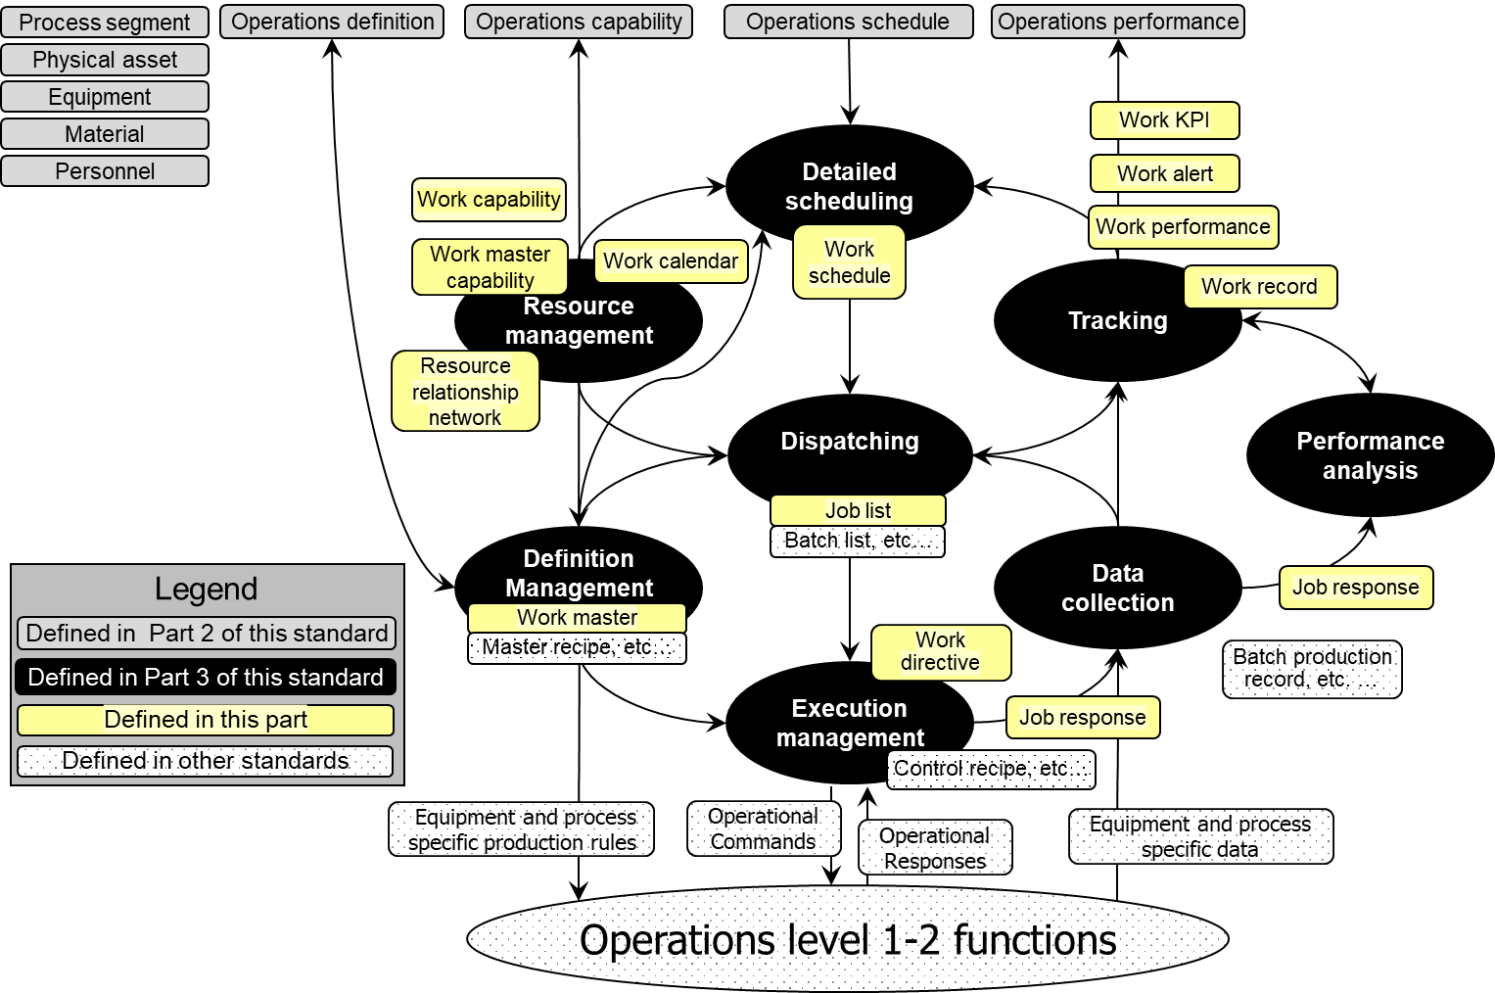

Figure 1 – Information exchange between manufacturing operations management activities

NOTE ISA-88 defines object models that relate to the lower elements of the Level 3 activities and defines the information used to create and manage master recipes, control recipes, batch lists, and batch production records. Equivalent structures, or ISA-88 structures, could be used for other types of production. This standard does not redefine these objects.

### Process segment, operations segment, and work master information models

Part 2 operations information models of this standard define the business view of manufacturing as seen by Level 4 business operations planning and logistics functions. This business view of manufacturing is defined using the *process segment* and *operations segment* objects. The information models of this part of this standard define the work view of manufacturing as seen by Level 3 MOM scheduling and execution functions. This work view of the manufacturing processes is defined using in the *work master* object.

*A work master* defines the resources and workflow specification for a *job order* that is scheduled, displayed, executed, and tracked by Level 3 MOM activities.

NOTE Part 2 information models of this standard are used to exchange information from the *process segment* and *operations segment* (business) view for Level 4 planning. Models such as *operations definition* and *operations schedule* support the allocation of resources and scheduling activities to the plant. Information models in this part of this standard are used to exchange information for Level 3 execution.  Models such as *work master* reference the *operations definition* exchanged with Level 4, but the *work master* has the details needed for actual execution of Level 3 activities. See Annex B for additional discussion of Part 2 of this standard, this part of this standard, and IEC 61512 model relationships.

### Common resource definitions

The information models in this part of the standard use the personnel, equipment, physical asset, and material information defined in Part 2 of this standard. When used with Level 3 work objects, the personnel, equipment, physical asset, and material information may include information required for Level 3 activities in addition to the information required to be shared with Level 4 activities.

EXAMPLE 1 The personnel information required for Level 3 activities can include detailed experience and qualification levels that are not shared with a Level 4 personnel or training management system.

EXAMPLE 2 The material information maintained for Level 3 activities can include sublot information which is not shared with Level 4 material management systems.

EXAMPLE 3 Delivery, usage and emission of energy units can be handled as material information.

### Work information models

The following information models are defined in this part of this standard.

1. resource relationship network: r*esource relationship network* is created by tasks in resource management and definition management activities.
2. work definition:
   1. work master: w*ork master* is created by an engineering activity defined in part of this standard and to be managed by a task in definition management activities.
   2. Work directive: *work directive* is created by a task in execution management activities.
3. work schedule: w*ork schedule* is created by a task in detailed scheduling activities.
4. job list: *job list* is created by a task in dispatching activities.

NOTE 1 In this part of this standard, the term, job, can sometimes be used instead of *job order* when referring to an entry in a *job list*.

1. work performance: *work performance* is created by a task in tracking activities.
2. work capability: *work capability* is created by a task in resource management activities.
3. work master capability: *work master capability* is created by a task in resource management activities.
4. work alert: *work alert* may be created by any activity in the activity model.
5. work calendar: *work calendar* may be created by a task in resource management activities.

NOTE 2 *Work calendars* can be created by a task in a Level 4 activity.

1. work record: *work record* is created by a task in tracking activities.

# Resource relationship network information

## Resource relationship network model

*Resource relationship networks* shall be used to describe relationships between two or more resources in order to represent information that may be required for detailed scheduling activities, dispatching activities, execution activities, or other Level 3 activities.

Each *resource relationship network* is a collection of *resource network connections*, as shown in Figure 2.

Table 1 lists the relationships of the objects in the *resource relationship network* model. Annex A.3 provides examples for applying resource relationship network.

Each *resource network connection* shall be represented as a directed connection between a *to resource reference* and a *from resource reference*.

NOTE 1 Relationships are represented as directed multi-graphs in graph theory. Each relationship represents an “edge” with the resource references represented as vertices.

NOTE 2 The properties of the resource relationship elements are used to represent constraints in the network, such as constraints in flow, direction, set or ordering.

EXAMPLE 1 A “route” *resource network connection* between *equipment* can include properties that include the material transport time between the *equipment* and the material transfer rate between the *equipment.*

EXAMPLE 2 An “approved for use” *resource network connection* between *equipment* and *material definitions* can define which specific *equipment* has been approved for use with specific *materials.* A property of the *resource network connection* can be the date at which the approval for use is expired or revoked.

EXAMPLE 3 A “material substitution” *resource network connection* can define a primary *material* and the list of possible alternate *materials*.

Each *resource network connection* is defined by a *resource network connection type*. The *resource network connection type* may include *resource network connection type properties*, which define the allowable *resource network connection properties*.

NOTE 3 The *resource relationship network* model is conceptually similar to the MIMOSA CCOM network model. See bibliography.

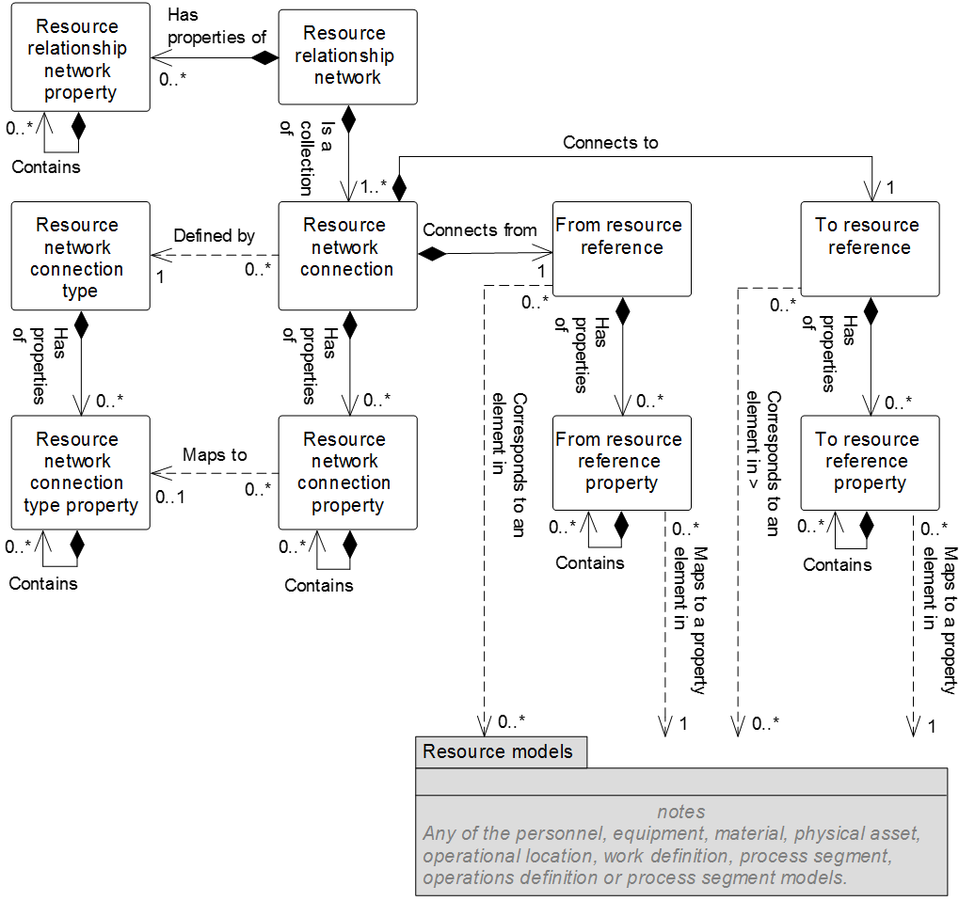

Figure 2 – Resource relationship network model

NOTE 4 The object color convention used in the Part 2 and Part 4 UML diagrams for information models is as shown in Clause 3.3.3.

Table 1 – Resource relationship network model relationships

| From | To | Type | Relationship Name |
| --- | --- | --- | --- |
| Resource relationship network | Resource relationship network property | Composition whole | Has properties of |
| Resource relationship network | Resource network connection | Composition whole | Is a collection of |
| Resource relationship network property | Resource relationship network property | Composition hierarchy | Contains |
| Resource network connection | Resource network connection type | Dependency | Defined by |
| Resource network connection | From resource reference | Composition whole | Connects from |
| Resource network connection | To resource reference | Composition whole | Connects to |
| Resource network connection | Resource network connection property | Composition whole | Has properties of |
| Resource network connection type | Resource network connection type property | Composition whole | Has properties of |
| From resource reference | From resource reference property | Composition whole | Has properties of |
| To resource reference | To resource reference property | Composition whole | Has properties of |
| Resource network connection property | Resource network connection property | Composition hierarchy | Contains |
| Resource network connection type property | Resource network connection type property | Composition hierarchy | Contains |
| From resource reference property | From resource reference property | Composition hierarchy | Contains |
| To resource reference property | To resource reference property | Composition hierarchy | Contains |
| From resource reference | [Resource] class | Association (A) | Corresponds to |
| From resource reference | [Resource] | Association (C) | Corresponds to |
| From resource reference property | [Resource] class property | Dependency (B) | Maps to |
| From resource reference property | [Resource] property | Dependency (D) | Maps to |
| To resource reference | [Resource] class | Association (A) | Corresponds to |
| To resource reference | [Resource] | Association (C) | Corresponds to |
| To resource reference property | [Resource] class property | Dependency (B) | Maps to |
| To resource reference property | [Resource] property | Dependency (D) | Maps to |

In Table 1, [Resource] shall apply to the similar object in the following models: *personnel, equipment, material, physical asset, operational location, work definition, process segment, operations definition or process segment*.

In Table 1, [Resource] class shall apply to objects that identify classes of resources or similar resource grouping objects (e.g. *material definition*).

## Resource relationship network

A resource relationship network shall be a composition of one or more resource network connections.

Table 2 defines the relationships roles for the *resource relationship network*.

Table 3 defines the attributes for the *resource relationship network*.

Table 2 – Resource relationship network relationships roles

| Related Object | Role | Multiplicity | Relationship Name | Description |
| --- | --- | --- | --- | --- |
| Resource network connection | Resource network connection | 1..* | Is a collection of | The *resource network connections* related to this *resource relationship network* as a whole. |
| Resource relationship network property | Resource relationship network property | 0..* | Has properties of | The *resource relationship network property(s)* of this *resource relationship network*. |

Table 3 – Resource relationship network attributes

| Attribute name | Description | Production examples | Maintenance examples | Quality examples | Inventory examples |
| --- | --- | --- | --- | --- | --- |
| ID | A unique identification of a *resource relationship network.*  Required attribute. | BN5FP | B5EN | B5RS | BFFTR |
| Description | A description of the *resource relationship network*. | Building 5 flow path | Building 5 electrical network | Building 5 receive signoff | Building 5 fork truck route |
| Relationship type | Defines the type of the relationship.  Defined types are   * physical: the elements of the relationship are physically connected or in the same area; and * logical: the elements of the relationship are not necessarily physically connected or in the same area. | Physical | Physical | Logical | Logical |
| Relationship form | Defines the form of the relationships.  Defined types are   * permanent: the relationship is not intended to be split or changed during operations processes; and * transient: the relationship can be spilt or changed during operations processes. | Permanent | Permanent | Permanent | Transient |

## Resource relationship network property

A property of a *resource relationship network* shall be defined as a *resource relationship network property*.

A *resource relationship network property* may contain nested *resource relationship network property(s)*.

Table 4 defines the relationship roles for *resource relationship network property* objects.

Table 5 defines the attributes for *resource relationship network property* objects.

Table 4 – Resource relationship network property relationship roles

| Related Object | Role | Multiplicity | Relationship Name | Description |
| --- | --- | --- | --- | --- |
| Resource relationship network | NA | 1 | Has properties of | The *resource relationship network* to which this *resource relationship network property* belongs. |
| Resource relationship network property | Resource relationship network property child | 0..* | Contains | The nested *resource relationship network properties* of this *resource relationship network property*. |

Table 5 – Resource relationship network property attributes

| Attribute name | Description | Production examples | Maintenance examples | Quality examples | Inventory examples |
| --- | --- | --- | --- | --- | --- |
| ID | A unique identification of a *resource relationship network property.*  Required attribute. | P&ID document reference | Resource relationship network type | Last updated date | Approver |
| Description | Additional information about the *resource relationship network property*. | Reference to the P&ID document for this resource relationship network. | The type of resource relationship network | The date of the last update to the resource relationship network. | The approver of the resource relationship network. |
| Value | The value, set of values, or range of the property. | http://… | Dependency model | 3 March 2015 | J. Smith. |
| Value unit of measure | The unit of measure of the associated property value. | N/A | N/A | N/A | N/A |

## Resource network connection

The directed relationship between two resources in a *resource relationship network* shall be defined as a *resource network connection*.

A *resource network connection* shall be composed of the following:

1. a *from resource reference* relationship defining one resource reference (as the starting point of a directed connection or the tail of an arrow that graphically represents the relationship);
2. a *to resource reference* relationship defining one resource reference (as the ending point of a directed connection or the head of an arrow that graphically represents the relationship);
3. zero or more resource network connection properties;
4. an associated resource network connection type.

Table 6 defines the relationship roles for the resource network connection.

Table 7 defines the attributes for the *resource network connection*.

Table 6 – Resource network connection relationship roles

| Related Object | Role | Multiplicity | Relationship Name | Description |
| --- | --- | --- | --- | --- |
| Resource relationship network | NA | 1 | Is a collection of | The *resource relationship networ*k defined in part by this *resource network connection*. |
| Resource network connection type | Resource network connection type | 1 | Defined by | The *resource network connection type* defining this *resource network connection*. |
| To resource reference | To resource reference | 1 | Connects to | The *to resource reference* to which this *resource network connection* connects*.* |
| From resource reference | From resource reference | 1 | Connects from | The *from resource reference* from which this *resource network connection* connects. |
| Resource network connection property | Resource network connection property | 0..* | Has properties of | The *resource network connection property(s)* related to this *resource network connection.* |

Table 7 – Resource network connection attributes

| Attribute name | Description | Production examples | Maintenance examples | Quality examples | Inventory examples |
| --- | --- | --- | --- | --- | --- |
| ID | A unique identification of a *resource network connection.*  Required attribute. | 7685 | 6383290 | Hyuwq9 | TT28623 |
| Description | A description of a *resource network connection*. | Piping | Wiring | Next signer | Next stop |

## Resource network connection property

A property of a *resource network connection* shall be defined as a *resource network connection property*.

*Resource network connection properties* are used to contain property values that are associated with the specific connection.

A *Resource network connection property* may contain nested *resource network connection property(s)*.

Table 8 defines the relationship roles of the *resource network connection property*.

Table 9 defines the attributes of *resource network connection property*.

Table 8 – Resource network connection property relationship roles

| Related Object | Role | Multiplicity | Relationship Name | Description |
| --- | --- | --- | --- | --- |
| Resource network connection | NA | 1 | Has properties of | The *resource network connection* defined in part by this *resource network connection property.* |
| Resource network connection type property | Resource network connection type property | 0..1 | Maps to | The *resource network connection type property*(s) of the *resource network connection* *type* defines this *resource network connection property(s)* when derived from a specific *resource network connection type*. |
| Resource network connection property | Resource network connection property child | 0..* | Contains | The nested *resource network connection properties* of this *resource network connection property*. |

Table 9 – Resource network connection property attributes

| Attribute name | Description | Production examples | Maintenance examples | Quality examples | Inventory examples |
| --- | --- | --- | --- | --- | --- |
| ID | A unique identification of a *resource network connection property.*  Required attribute. | Pipe type | Gauge | N/A | Inside |
| Description | Additional information about the *resource network connection property*. | Type of piping | Wire type | N/A | Location |
| Value | The value, set of values, or range of the property. | 53 | 20 | N/A | TRUE |
| Value unit of measure | The unit of measure of the associated property value. | Steel grade | AWG | N/A | Boolean |

## From resource reference

A “from” reference to a resource shall be defined as a *from resource reference*.

A *from resource reference* may be composed of zero or more *from resource reference properties*.

A property of a *from resource reference* shall be defined as a *from resource reference property*. A *from resource reference property* may contain nested *from resource reference property(s)*.

Table 10 defines the relationship roles for the *from resource reference*.

Table 11 defines the attributes for the *from resource reference*.

Table 10 – From resource reference relationship roles

| Related Object | Role | Multiplicity | Relationship Name | Description |
| --- | --- | --- | --- | --- |
| Resource network connection | NA | 1 | Connects from | The *resource network connection* defined in part by this *from resource reference*. |
| From resource reference property | From resource reference property | 0..* | Has properties of | The *from resource reference property*(s) defines in part this *from resource reference property*. |
| [Resource]** class | [Resource] class | 0..* | Corresponds to | A cross-model association to element in the [resource] model as explained in Clause 3.3.8. |
| [Resource]** | [Resource] | 0..* | Corresponds to | A cross-model association to element in the [resource] model as explained in Clause 3.3.8. |

In Table 10, [Resource] shall apply to the similar object in the following models: *personnel, equipment, material, physical asset, operational location, work definition, process segment, operations definition or process segment.*

Table 11 – From resource reference attributes

| Attribute Name | Description | Production Examples | Maintenance Examples | Quality Examples | Inventory Examples |
| --- | --- | --- | --- | --- | --- |
| ID | A unique identification of a *from resource reference.*  Required attribute. | 12345 | 12346 | A123 | S7728 |
| Resource type | The type of the resource.  Defined types are   * *personnel class,* * *person,* * *equipment class,* * *equipment,* * *physical asset class,* * *physical asset,* * *material class,* * *material definition,* * *material lot,* * *material sublot,* * *work master,* * *process segment,* * *operation definition,* * *operational location,* * *operations segment,* * *test specification,* and * *test result.* | Equipment | Physical asset | Personnel class | Equipment |

## From resource reference property

A property of a from resource reference shall be defined as a from resource reference property.

A *from resource reference* with one or more *from resource reference properties* shall define the subset of the *resource* that has the defined *resource property* values.

Table 12 defines the relationships for the *from resource reference property*.

Table 13 defines the attributes for the *from resource reference property*.

Table 12 – From resource reference property relationships roles

| Related Object | Role | Multiplicity | Relationship Name | Description |
| --- | --- | --- | --- | --- |
| From resource reference | NA | 1 | Has properties of | The *from resource reference* defined in part by this *from resource reference property*. |
| From resource reference property | From resource reference property child | 0..* | Contains | The nested *from resource reference properties* of this *from resource reference property*. |
| [Resource]class property | [Resource] class property | 0..* | Maps to | A cross-model dependency to element in the [Resource] model as explained in Clause 3.3.8. |
| [Resource] property | [Resource] property | 0..* | Maps to | A cross-model dependency to element in the [Resource] model as explained in Clause 3.3.8. |

In Table 12, [Resource] shall apply to the similar object in the following models: *personnel, equipment, material, physical asset, operational location, work definition, process segment, operations definition or process segment.*

Table 13 – From resource reference property attributes

| Attribute name | Description | Production examples | Maintenance examples | Quality examples | Inventory examples |
| --- | --- | --- | --- | --- | --- |
| ID | A unique identification of a *from* *resource reference property.*  Required attribute. | A7872 | CB101 | Hhjw78 | Tye8 |
| Value | A value of a property that is used to identify the subset of the resources that are referenced. | 200 | 40 | First | 42 |
| Value unit of measure | The unit of measure of the associated property value. | L/min | A | N/A | N/A |

## To resource reference

A “to” reference to a resource shall be defined as a *to resource reference*.

A *to resource reference* may be composed of zero or more *to resource reference property(s)*.

Table 14 defines the relationship roles for the *to resource reference*.

Table 15 defines the attributes for the *to resource reference*.

Table 14 – To resource reference relationships roles

| Related Object | Role | Multiplicity | Relationship Name | Description |
| --- | --- | --- | --- | --- |
| Resource network connection | NA | 1 | Connects to | The *resource network connection* defined in part by this *to resource reference*. |
| To resource reference property | To resource reference property | 0..* | Has properties of | The *to resource reference property*(s) defines in part this *to resource reference property*. |
| [Resource] class | [Resource] class | 0..* | Corresponds to | A cross-model association to element in the [resource] model as explained in Clause 3.3.8. |
| [Resource] | [Resource] | 0..* | Corresponds to | A cross-model association to element in the [resource] model as explained in Clause 3.3.8. |

In Table 14, [Resource] shall apply to the similar object in the following models: *personnel, equipment, material, physical asset, operational location, work definition, process segment, operations definition or process segment.*

Table 15 – To resource reference attributes

| Attribute name | Description | Production examples | Maintenance examples | Quality examples | Inventory examples |
| --- | --- | --- | --- | --- | --- |
| ID | A unique identification of a *to resource reference.*  Required attribute. | 12345 | 12346 | A123 | S7728 |
| Resource ID | The ID of a resource. | B5Tank08 | B5V480Box | Supervisor | Line3EndOfLine |
| Resource type | The type of the resource.  Defined types are:   * *personnel class,* * *person,* * *equipment class,* * *equipment,* * *physical asset class,* * *physical asset,* * *material class,* * *material definition,* * *material lot,* * *material sublot,* * *work master,* * *process segment,* * *operation definition,* * *operational location,* * *operations segment,* * *test specification, and* * *test result* | Equipment | Physical asset | Personnel class | Equipment |

## To resource reference property

A property of a to resource reference shall be defined as a to resource reference property.

A *to resource reference* with one or more *to resource reference property(s)* shall define the subset of the *resource* that has the defined *resource property* values.

A *to resource reference property* may contain nested to *resource reference property(s)*.

Table 16 defines the relationship roles for the *to resource reference property*.

Table 17 defines the attributes for the *to resource reference property*.

Table 16 – To resource reference property relationships roles

| Related Object | Role | Multiplicity | Relationship Name | Description |
| --- | --- | --- | --- | --- |
| To resource reference | NA | 1 | Has properties of | The *to resource reference* defined in part by this *to resource reference property*. |
| To resource reference property | To resource reference property child | 0..* | Contains | The nested *from resource reference properties* of this *from resource reference property*. |
| [Resource] class property | [Resource] class property | 0..* | Maps to | A cross-model dependency to element in the [Resource] model as explained in Clause 3.3.8. |
| [Resource] property | [Resource] property | 0..* | Maps to | A cross-model dependency to element in the [Resource] model as explained in Clause 3.3.8. |

In Table 16, [Resource] shall apply to the similar object in the following models:

*Personnel, equipment, material, physical asset, operational location, work definition, process segment, operations definition or process segment.*

Table 17 – To resource reference property attributes

| Attribute name | Description | Production examples | Maintenance examples | Quality examples | Inventory examples |
| --- | --- | --- | --- | --- | --- |
| ID | A unique identification of a *to* *resource reference property.*  Required attribute. | A7872 | CB101 | Hhjw78 | N/A |
| Value | A value of a property that is used to identify the subset of the resources that are referenced. | 200 | 40 | First | N/A |
| Value unit of measure | The unit of measure of the associated property value. | L/min | A | N/A | Boolean |

## Resource network connection type

A definition of a type of a *resource network connection* shall be defined as a *resource network connection type*.

A resource network connection type may be composed of zero or more resource network connection type properties.

Table 18 defines the relationship roles of the *resource network connection type*.

Table 19 defines the attributes of the *resource network connection type*.

Table 18 – Resource network connection type relationship roles

| Related Object | Role | Multiplicity | Relationship Name | Description |
| --- | --- | --- | --- | --- |
| Resource network connection | NA | 0..* | Defined by | The *resource network connection(s)* derived from this *resource network connection type*. Only applied, if navigation is required. |
| Resource network connection type property | Resource network connection type property | 0..* | Has properties of | The *resource network connection type property(s)* related to this *resource network connection type.* |

Table 19 – Resource network connection type attributes

| Attribute name | Description | Production examples | Maintenance examples | Quality examples | Inventory examples |
| --- | --- | --- | --- | --- | --- |
| ID | A unique identification of a *resource network connection type.*  Required attribute. | PC01 | ME1 | QE1 | IE1 |
| Description | A description of a *resource network connection type*. | Distribution piping | 40 A breakers | N/A | WIP replenishment stops |
| Type | The connection type. | Piping connection | Electrical connection | N/A | WIP-STOPS |

## Resource network connection type property

A property of a *resource network connection type* shall be defined as a *resource* *network connection type property*.

*Resource network connection type properties* may be used to specify the defined properties that can be associated with the specific *resource network connection type*.

A *resource network connection type property* may contain nested *resource network connection type property(s)*.

Table 20 defines the relationship roles of the *resource network connection type property*.

Table 21 defines the attributes of the *resource network connection type property*.

Table 20 – Resource network connection type property relationship roles

| Related Object | Role | Multiplicity | Relationship Name | Description |
| --- | --- | --- | --- | --- |
| Resource network connection type | NA | 1 | Has properties of | The *resource network connection type* defined in part by this *resource network connection type property*. |
| Resource network connection property | NA | 0..* | Maps to | The *resource network connection property(s)* derived from this *resource network connection type property* supporting its parent object. Only applied, if navigation is required. |
| Resource network connection type property | Resource network connection type property child | 0..* | Contains | The nested *resource network connection type properties* of this *network connection type property*. |

Table 21 – Resource network connection type property attributes

| Attribute name | Description | Production examples | Maintenance examples | Quality examples | Inventory examples |
| --- | --- | --- | --- | --- | --- |
| ID | A unique identification of a *resource network connection type property.*  Required attribute. | Pipe type | LowArc | N/A | Inside |
| Description | Additional information about the *resource network connection type property*. | Type of piping | Breaker low arc | N/A | Location |
| Value | The default value, set of values, or range of the property. | 53 | 1 | N/A | TRUE |
| Value unit of measure | The unit of measure of the associated property value. | Steel grade | Type | N/A | Boolean |

# Work definition information

## Work definition model

An identification of the resources and workflow required to perform a specified unit of work shall be defined as a *work definition*. The *work definition* may apply to production, maintenance, quality test, and inventory operations activities.

Figure 3 below is the common work definition model; objects shown as gray boxes are defined in Part 2 of this standard.

Table 22 lists the relationships of the objects in the work definition model.

*Work definitions* are modeled as an abstract class. There are two types of *work definitions* that are modeled as non-abstract classes: *work master* and *work directives*.

*Work masters* are template information not associated with any specific *job order*. *Work directives* start as copies of *work masters* and are augmented with information for a specific *job order*.

A *work master* may have a reference to one or more *operations definitions or operations segments*. In this situation, the *work master* defines the detailed steps needed to accomplish all or part of the operation.

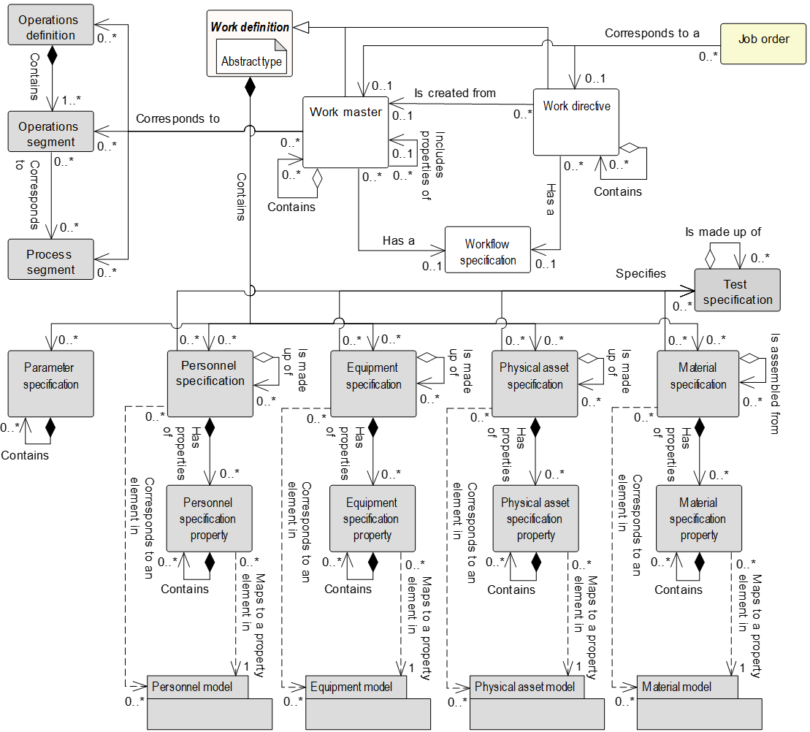

Figure 3 – Work definition model

NOTE The object color convention used in the Part 2 and Part 4 UML diagrams for information models is as shown in Clause 3.3.3.

To simplify Figure 3, the following relationships between *work definition* objects and the operations test model objects are not shown. For the complete contextual view of these relationships, each relationship is listed in Table 22 with the relationship roles defined in each object subclause in their relationship role table.

1. resource specification objects and *test specification* (defined in Part 2)*,*
2. resource specification objects and *test result* (defined in Part 2)*,*
3. *work definition* (*work master* and *work directive*) and *evaluated property* (defined in Part 2), and
4. *work definition* (*work master* and *work directive*) and *property measurement* (defined in Part 2).

All *work definition* relationships to *test specification* and *test result* are shown in Part 2 of this standard in Figure 16 – Operations test model and listed in Table 99 – Operations test requirement relationship roles.

Table 22 – Work definition model relationships

| From | To | Type | Relationship Name |
| --- | --- | --- | --- |
| Work master | Work definition |  | (Abstract type) |
| Work directive | Work definition |  | (Abstract type) |
| Work definition | Parameter specification | Composition whole | Contains |
| Work definition | Personnel specification | Composition whole | Contains |
| Work definition | Equipment specification | Composition whole | Contains |
| Work definition | Physical asset specification | Composition whole | Contains |
| Work definition | Material specification | Composition whole | Contains |
| Work master | Operations definition | Association | Corresponds to |
| Work master | Operations segment | Association | Corresponds to |
| Work master | Process segment | Association | Corresponds to |
| Work master | Work master | Association | Includes properties of |
| Work master | Work master | Composition hierarchy | Contains |
| Work master | Workflow specification | Association | Corresponds to |
| Work directive | Work master | Association | Is created from |
| Work directive | Work directive | Composition hierarchy | Contains |
| Work directive | Workflow specification | Association | Corresponds to a |
| Job order | Work master | Association | Corresponds to a |
| Job order | Work directive | Association | Corresponds to a |
| Personnel specification,  equipment specification,  physical asset specification, and  material specification. | Test specification  (Defined in Part 2) | Association | Specifies |
| Test specification  (Defined in Part 2) | Personnel specification,  equipment specification,  physical asset specification, and  material specification. | Association | Specifies test for |
| Test result  (Defined in Part 2) | Personnel specification,  equipment specification,  physical asset specification, and  material specification. | Association | Generated in context of |
| Evaluated property  (Defined in Part 2) | Work definition | Association | Measured with method of |
| Property measurement  (Defined in Part 2) | Work definition | Association | Measured with method of |
| Parameter specification | Parameter specification | Composition hierarchy | Contains |
| Personnel specification | Personnel specification | Aggregation hierarchy | Is made up of |
| Personnel specification | Personnel specification property | Composition whole | Has properties of |
| Personnel specification property | Personnel specification property | Composition hierarchy | Contains |
| Personnel specification | Personnel class | Association (A) | Corresponds to |
| Personnel specification | Person | Association (C) | Corresponds to |
| Personnel specification property | Personnel class property | Dependency (B) | Maps to |
| Personnel specification property | Person property | Dependency (D) | Maps to |
| Equipment specification | Equipment specification | Aggregation hierarchy | Is made up of |
| Equipment specification | Equipment specification property | Composition whole | Has properties of |
| Equipment specification property | Equipment specification property | Composition hierarchy | Contains |
| Equipment specification | Equipment class | Association (A) | Corresponds to |
| Equipment specification | Equipment | Association (C) | Corresponds to |
| Equipment specification property | Equipment class property | Dependency (B) | Maps to |
| Equipment specification property | Equipment property | Dependency (D) | Maps to |
| Physical asset specification | Physical asset specification | Aggregation hierarchy | Is made up of |
| Physical asset specification | Physical asset specification property | Composition whole | Has properties of |
| Physical asset specification property | Physical asset specification property | Composition hierarchy | Contains |
| Physical asset specification | Physical asset class | Association (A) | Corresponds to |
| Physical asset specification | Physical asset | Association (C) | Corresponds to |
| Physical asset specification property | Physical asset class property | Dependency (B) | Maps to |
| Physical asset specification property | Physical asset property | Dependency (D) | Maps to |
| Material specification | Material specification | Aggregation hierarchy | Is assembled from |
| Material specification | Material specification property | Composition whole | Has properties of |
| Material specification property | Material specification property | Composition hierarchy | Contains |
| Material specification | Material class | Association (A) | Corresponds to |
| Material specification | Material definition | Association (A) | Corresponds to |
| Material specification | Material lot | Association (C) | Corresponds to |
| Material specification | Material sublot | Association (C) | Corresponds to |
| Material specification property | Material class property | Dependency (B) | Maps to |
| Material specification property | Material definition property | Dependency (B) | Maps to |
| Material specification property | Material lot property | Dependency (D) | Maps to |

## Work master

The resources and instructions required to perform a unit of work without reference to a specific *job order* shall be defined as a *work master*. A *work master*

* identifies *material classes* or *material definitions*,
* identifies nominal production run sizes (standard job order size),
* identifies *equipment classes* for work centers and work units, and
* may identify other information required to execute the *work definition* for a *job order*.

EXAMPLE 1 Instructions, automation procedures, SOPs, recipes, drawings, CNC programs, packaging specifications, label specifications, and transition specification.

A *work master* may contain zero or more *work masters* defining a hierarchy of *work masters* with the hierarchy defined through *workflow specification nodes* in the *workflow specification*.

A *work master* may include properties of another *work master* as a parent type.

A *work master* shall be defined as pattern or instance. A pattern *work master* defines a ‘template’, upon which other pattern or instance *work masters* may be based. Unlike instance *work masters,* pattern *work masters* shall not be directly scheduled or executed. Therefore, *job orders, job responses* and *work directives* shall not reference pattern *work masters*.

The *parameter, personnel, equipment, physical asset* and *material specifications* of a *work master* may map to those of any pattern *work master* upon which the *work master* is based.

EXAMPLE 2 A pattern *work master* can contain *material specifications* that reference *material classes*, while a instance *work master* based on this pattern *work master* can contain *material specifications* that reference *material definitions* belonging to those *material classes.*

EXAMPLE 3 A mining organization could define the following pattern and instance *work masters*.

1. Extraction (pattern)

2. Coal extraction (pattern), specialization of extraction (pattern)

3. Iron ore extraction (pattern), specialization of extraction (pattern)

4. Coal site S1 extraction (instance), specialization of coal extraction (pattern)

5. Iron ore site S2 extraction (instance), specialization of iron ore extraction (pattern)

Pattern *work masters* provide a basis for standardization and reuse of pattern *work masters* across many instance *work masters* across and between plants.

## Work directive

The resources and instructions required to perform a unit of work for a specific *job order* shall be defined as a *work directive*. A *work directive*

* is created as a copy of a *work master*,
* is used to control one *job order* or part of a *job order*,
* defines exact batch sizes or production run sizes,
* may identify *material lots* or *material sublots* for the *job order*,
* may identify specific work centers and/or work units for the *job order*,
* may identify specific *personnel* for the *job order*, and
* contains the actual executed information after execution of the *job order*.

A *work directive* may contain zero or more *work directives*, defining a hierarchy of *work directives* with the hierarchy defined through *workflow specification nodes* in the *workflow specification*.

There is one *work directive* for each *job order*. It contains the specific information required to perform the *job order* and the *workflow specification* associated with the *job order*. Figure 4 illustrates the recursive nature of *work masters* and *work directives*.



Figure 4 – Relationship of work master to work directive

NOTE 1 The dashed vertical line in Figure 4 represents the tasks in o*perations execution management* that create a *work directive* from a *work master* based on the requirements of the *job list*.

NOTE 2 A common scenario is where ad hoc work is performed with no *work master* or *operations definition* associated such as a material spills or unplanned and undefined movements of *material* or use of *equipment*. This scenario requires a 0..1 relationships between a *work master* and *work directive* / *job order*. The process of ad hoc work can be recorded in a *work directive* to an ad hoc *job order.*

Table 23 defines two addition attributes for *material specification* objects to support the *material lot* and *material sublot* information used in *work directives*.

Table 23 – Additional material specification attributes

| Attribute name | Description |
| --- | --- |
| Material lot | Identifies the associated *material lot* or set of *material lots* of the specification for a *work directive.* |
| Material sublot | Identifies the associated *material sublot* or set of *material sublots* of the specification for a *work directive.* |

## Work definition

Table 24 defines the relationship roles for the work definition that are common to both *work master* and *work directive*.

Table 25 defines the attributes for work definition.

The *work master* and *work directive* objects are specialized types of the super class of *work definition*, and the *work definition* attributes shall be included in the *work master* and *work directive* attributes.

The *work definition* is an abstract object that cannot be instantiated. Only the specialized objects (*work master and work directive*) can be instantiated and, therefore, is referenced within a relationship.

Table 24 – Work definition relationship roles

| Related Object | Role | Multiplicity | Relationship Names | Description |
| --- | --- | --- | --- | --- |
| Parameter specification | Parameter specification | 0..* | Contains | The *parameter specifications* related to this *work definition.* |
| Personnel specification | Personnel specification | 0..* | Contains | The *personnel specifications* related to this *work definition.* |
| Equipment specification | Equipment specification | 0..* | Contains | The *equipment specifications* related to this *work definition.* |
| Physical asset specification | Physical asset specification | 0..* | Contains | The *physical asset specifications* related to this *work definition.* |
| Material specification | Material specification | 0..* | Contains | The *material specifications* related to this *work definition.* |
| Evaluated property  (Defined in Part 2) | NA | 0..* | Measured with method of | This work master ID or work directive ID which is applied test method to obtain the measurement of the *evaluated property* for *test specification* of the testable object property ID. |
| Property measurement  (Defined in Part 2) | NA | 0..* | Measured with method of | This work master ID or work directive ID which is applied test method to obtain the measurement of the *property measurement* for *test specification* of the testable object property ID. |

Table 25 – Work definition attributes (common in work master and work directive)

| Attribute name | Description | Production examples | Maintenance examples | Quality examples | Inventory examples |
| --- | --- | --- | --- | --- | --- |
| ID | A unique identification as the *work master* ID or *work directive ID.*  Required attribute. | Export quality widget | Medium size AC motor overhaul | Potency test procedure | Tank transfer procedure |
| Version | An identification of the version of the *work master version or work directive version*.  In cases where there are multiple versions of a *work definition*, then the version attribute shall contain the additional identification information to differentiate each version. | 1.0 | 1.4 | 1.1 | 1.1 |
| Description | Contains additional information and descriptions of the *work master or directive.* | “Information defining resources required for work of a single ‘export quality widget’” | For overhauls of motors less than 200 HP. | Test for potency of product | Movement of material from one tank to another |
| Hierarchy scope | Identifies where the exchanged information fits within the role based equipment hierarchy. | East Wing manufacturing line #2 | CNC Machine  Asset ID 13465 | Test cell 4  Receiving | Warehouse B |
| Work type | Describes the category of work.  Defined values are   * production, * maintenance, * quality, * inventory, or * mixed.   “Mixed” can be used when the *work definition* contains resources and routing information required to perform several types of work. | Production | Maintenance | Quality | Inventory |
| Duration | Duration, if known. | 25 | 4 | 1 | 40 |
| Duration unit of measure | The units of measure of the duration, if defined. | Minutes | Hours | Day | Minutes |
| Published date | The date and time on which the *work master or work directive* was published or generated. | 12-30-1951 18:30 UTC | 10-17-2005  18:30 UTC | 10-17-2005  18:30 UTC | 10-17-2005  18:30 UTC |

NOTE A MIMOSA *solution package* is the equivalent of a work definition for maintenance.

## Work master relationship roles and attributes

Table 26 – Work master relationship roles, in combination with Table 24 – Work definition relationship roles, defines the complete set of relationship role for the *work master*.

Table 27 – Work master attributes, in combination with Table 25 – Work definition attributes (common in work master and work directive), defines the complete set of attributes for the *work master*.

A *work master* may contain *work masters*, defining a hierarchy of *work masters*. A *work master* may be defined as pattern or instance. An instance *work master* may include some of the properties of a pattern *work master*.

Table 26 – Work master relationship roles

| Related Object | Role | Multiplicity | Relationship Name | Description |
| --- | --- | --- | --- | --- |
| Work master | Work master child | 0..* | Contains | The related object(s) makes up part of this *work master* as the whole. |
| Work directive | NA | 0..* | Is created from | The *work directive(s)* created from this *work master*.  in cases where there are multiple *work directive versions* of a *work directive*, then the *work directive version* attribute shall contain the additional identification information to differentiate each version. The multiplicity of 0..1. |
| Work master | Work master parent type | 0..1 | Includes properties of | This *work master(s) includes properties of the parent work master.*. |
| Process segment | Process segment | 0..* | Corresponds to | The *process segment(s)* associated to this *work master*. |
| Operations definition | Operations definition | 0..* | Corresponds to | The *operations definition(s)* associated to this *work master*. |
| Operations segment | Operations segment | 0..* | Corresponds to | The *operations segment(s)* associated to this *work master*.  If the *operations segment* reference is insufficient to identify the *operations segment*, then this *work master* should also identify the *operations definition* reference. |
| Workflow specification | Workflow specification | 0..1 | Corresponds to | This *work master* defined in part by the *workflow specification(s).*  The version attribute of the *work specification* may be specified. In cases where used in multiple *workflow master* versions, then the *version* attribute shall contain the additional identification information to differentiate each version. |

Table 27 – Work master attributes

|  |  |  |  |  |  |
| --- | --- | --- | --- | --- | --- |
| Attribute  Name | Description | Production  Examples | Maintenance  Examples | Quality  Examples | Inventory  Examples |
| Definition type | Defines the type of the *work master*.  Defined types are   * pattern: a *work master* used as a template for other *work masters*; * instance: a *work master* directly scheduled, dispatched and executed. | Pattern | Instance | Instance | Pattern |

## Work directive relationship roles and attributes

Table 28 – Work directive relationship roles, in combination with Table 24 – Work definition relationship roles, defines the complete set of relationship roles for a *work directive.*

Table 25 defines the attributes for the *work directive.* A *work directive* may contain *work directives*, defining a hierarchy of *work directives*.

Table 28 – Work directive relationship roles

| Related Object | Role | Multiplicity | Relationship Name | Description |
| --- | --- | --- | --- | --- |
| Work master | Work master | 0..1 | Is created from | The *work master* used to create this *work directive*.  in cases where there are multiple *work master versions*, then the *work master version* attribute shall contain the additional identification information to differentiate each version |
| Work directive | Work directive child | 0..* | Contains | The related object(s), *work directive*, makes up part of this *work directive* as the whole. |
| Workflow specification | Workflow specification | 0..1 | Corresponds to | This *work directive* defined in part by the *workflow specification(s).*  The version of the *work directive* may be specified in the attribute of this object. |
| Job order | NA | 0..* | Corresponds to | A unique identification of the *job order* associated with this *work directive*.  The ID is used in other parts of the model when the *job order* needs to be identified. |

## Parameter specification

The definition of this object, the relationship roles, and the attributes for this object are defined in Part 2 of this standard.

A *parameter specification* may be made up of zero or more nested *parameter specifications*.

## Personnel specification

The definition of this object, the relationship roles, and the attributes for this object are defined in Part 2 of this standard.

## Personnel specification property

The definition of this object, the relationship roles, and the attributes for this object are defined in Part 2 of this standard.

## Equipment specification

The definition of this object, the relationship roles, and the attributes for this object are defined in Part 2 of this standard.

## Equipment specification property

The definition of this object, the relationship roles, and the attributes for this object are defined in Part 2 of this standard.

## Physical asset specification

The definition of this object and the attributes for this object, the relationship roles, are defined in Part 2 of this standard.

## Physical asset specification property

The definition of this object, the relationship roles, and the attributes for this object are defined in Part 2 of this standard.

## Material specification

The definition of this object, the relationship roles, and the attributes for this object are defined in Part 2 of this standard.

A *material specification* may be an assembly of zero or more nested *material specifications*.

## Material specification property

The definition of this object, the relationship roles, and the attributes for this object are defined in Part 2 of this standard.

## Workflow specification information

### Workflow specification model

A *workflow specification* is represented as a collection of nodes and connections. Each node is defined by a type definition, and each connection is defined by a type definition. A node may contain a reference to a *work definition*.

Different workflow representations are described as collections of node types and connection types. See Annex C and Annex D for examples of *workflow specifications* for different formats.

NOTE 1 Workflows are not unique to the manufacturing operations management domain. See the business process model and notation (BPMN) at http://www.omg.org/spec/BPMN/ as a possible structure for a workflow format. BPMN is an example of a suitable specification available commercially. This information is given for the convenience of users of this standard and does not constitute an endorsement by IEC of BPMN products.

NOTE 2 The IEC 61512-1 recipe definitions are a workflow format. See the IEC 61512-2 definition for the recipe structure.

NOTE 3 Flowcharts are a workflow format.

NOTE 4 An IDEF (Integrated DEFinition) diagram is a workflow format.

The workflow specification model is shown in Figure 5. Table 29 lists the relationships of the objects in the work specification model. The model is a general model for exchanging workflows and is not unique to any specific workflow format. It represents the workflow as a collection of nodes and connections. The meaning of the nodes and connections is determined by the workflow format.

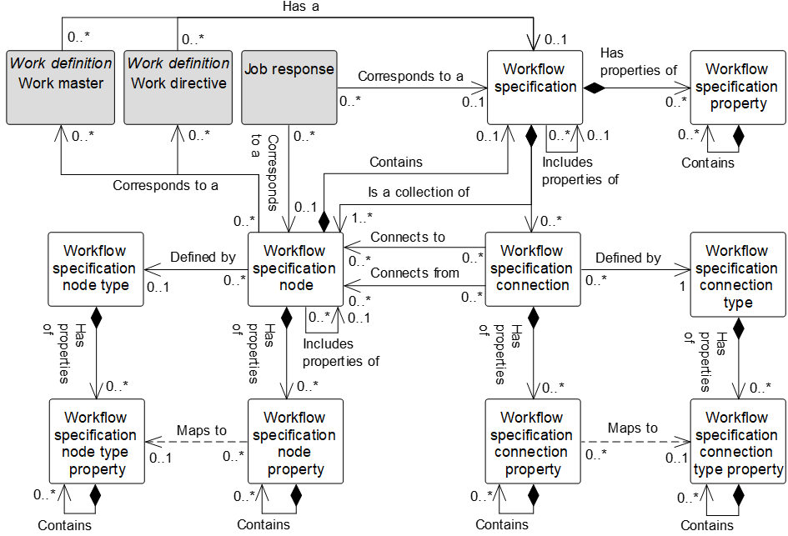

Figure 5 – Workflow specification model

NOTE 5 The object color convention used in the Part 2 and Part 4 UML diagrams for information models is as shown in Clause 3.3.3.

Table 29 – Workflow specification model relationships

| From | To | Type | Relationship Name |
| --- | --- | --- | --- |
| Workflow specification | Workflow specification property | Composition whole | Has properties of |
| Workflow specification | Workflow specification | Association | Includes properties of |
| Workflow specification property | Workflow specification property | Composition hierarchy | Contains |
| Workflow specification | Workflow specification node | Composition whole | Is a collection of |
| Workflow specification | Workflow specification connection | Composition whole | Is a collection of |
| Workflow specification node | Workflow specification | Composition whole | Contains |
| Work master | Workflow specification | Association | Corresponds to a |
| Work directive | Workflow specification | Association | Corresponds to a |
| Job response | Workflow specification | Association | Corresponds to a |
| Job response | Workflow specification node | Association | Corresponds to a |
| Workflow specification node | Work master | Association | Corresponds to a |
| Workflow specification node | Work directive | Association | Corresponds to a |
| Workflow specification node | Workflow specification node property | Composition whole | Has properties of |
| Workflow specification node | Workflow specification node | Association | Includes properties of |
| Workflow specification node property | Workflow specification node property | Composition hierarchy | Contains |
| Workflow specification node | Workflow specification node type | Association | Defined by |
| Workflow specification node type | Workflow specification node type property | Composition whole | Has properties of |
| Workflow specification node type property | Workflow specification node type property | Composition hierarchy | Contains |
| Workflow specification node property | Workflow specification node type property | Dependency | Maps to |
| Workflow specification connection | Workflow specification node | Association | Connects to |
| Workflow specification connection | Workflow specification node | Association | Connects from |
| Workflow specification connection | Workflow specification connection property | Composition whole | Has properties of |
| Workflow specification connection property | Workflow specification connection property | Composition hierarchy | Contains |
| Workflow specification connection | Workflow specification connection type | Association | Defined by |
| Workflow specification connection type | Workflow specification connection type property | Composition whole | Has properties of |
| Workflow specification connection type property | Workflow specification connection type property | Composition hierarchy | Contains |
| Workflow specification connection property | Workflow specification connection type property | Dependency | Maps to |

A *workflow specification* may include the properties of another *workflow specification* as parent type.

A *workflow specification* shall be defined as pattern or instance. A pattern *workflow specification* defines a ‘template’, upon which other pattern or instance w*orkflow specifications* may be based. Unlike instance *workflow specifications*, pattern *workflow specifications* shall not be directly executed. Therefore, a *work directive* shall only reference a instance *workflow specification*.

A pattern *work master* may reference either a pattern or instance *workflow specification*, while an instance *work master* shall only reference an instance *workflow specification*.

A pattern *work master* may reference an instance *workflow specification* where all *work masters (*directly or indirectly) specializing that pattern *work master* shall reference the same instance *workflow specification*. This allows a standard instance *workflow specification* to be defined for a pattern *work master*, which is then specialized to a number of pattern or instance *work masters*, each corresponding to the same instance *workflow specification*.

*Workflow specification nodes* shall assume the definition type (pattern or instance) of the *workflow specification* to which they belong. Therefore, all *workflow specification nodes* contained within a pattern *workflow specification* shall be assumed to be pattern, while all *workflow specification nodes* contained within a instance *workflow specification* shall be assumed to be instance.

Where a *workflow specification node* contains a more detailed *workflow specification*, the definition type of the contained *workflow specification* shall have the same value as that of the *workflow specification* to which the *workflow specification node* belongs.

Where a *workflow specification node* references a *work master*, the definition type of the referenced *work master* shall have the same value as that of the *workflow specification* to which the *workflow specification node* belongs. A *workflow specification node* shall only reference a *work directive* where the node belongs to an instance *workflow specification*.

EXAMPLE 1 Where a *workflow specification* WSC1 is based upon a pattern *workflow specification* WSA1, any given node in WSC1 can specialize a node in WSA1. Therefore, a *workflow specification node* can contain a reference to the node within a pattern *workflow specification* that it specializes.

*Job response* is fully defined in work performance model. *Work master* and *work directive* are fully defined in the work definition model. These objects are shown in the workflow specification model to show *workflow specification* relationships.

EXAMPLE 2 Figure 6 is a *workflow specification* described in a BPMN format.

EXAMPLE 3 Examples of representation in a *workflow specification* include:

1. a *workflow specification* containing two *workflow specification nodes*; one for the MES (manufacturing execution system) and one for the ERP (enterprise resource planning). The MES and ERP nodes are of *workflow specification node type* = POOL**;**
2. the MES node contains a *workflow specification* (identified here as MES_01);
3. MES_01 contains 6 *workflow specification nodes* and 6 *workflow specification connections*;
4. the Scan Material *workflow specification node* is of *workflow specification node type* = TASK;
5. the connection between scan material and planned contains a FROM link to scan material and a TO link to planned. The connection is of type SEQUENCE FLOW;
6. the ERP node contains a *workflow specification* (identified here as ERP_01);
7. ERP_01 contains 1 *workflow specification node* and 1 *workflow specification connection*; and
8. the connection between Get ERP Lot ID and store material contains a FROM link to Get ERP Lot ID and a TO link to store material. The connection is of type SEQUENCE FLOW;



Figure 6 – Example, a workflow specification in BPMN format

EXAMPLE 4 Figure 7 is a workflow described in a flowchart notation.

EXAMPLE 5 Examples of representation in flowchart notation of a *workflow specification* include:

1. a *workflow specification* contains 7 *workflow specification nodes* and 7 *workflow specification* *connections;*
2. the scan material *workflow specification node* is of *workflow* *specification node type* = ACTIVITY;
3. the connection between scan material node and planned node contains a FROM link to scan material and a TO link to planned. The connection is of type SEQUENCE;
4. the connection between Get ERP Lot ID and store material contains a FROM link to Get ERP Lot ID and a TO link to store material. The connection is of type SEQUENCE.



Figure 7 – Example, workflow specification in flowchart format

### Workflow specification

A *workflow specification* shall be defined as a collection of *workflow specification nodes* and *workflow specification connections*.

A *workflow specification* shall contain at least one *workflow specification node*.

Table 30 defines the relationship roles for the *workflow specification*.

Table 31 defines the attributes for the *workflow specification*.

Table 30 – Workflow specification relationship roles

| Related Object | Role | Multiplicity | Relationship Name | Description |
| --- | --- | --- | --- | --- |
| Workflow specification | Workflow specification parent type | 0..1 | Includes properties of | This *workflow specification(s)* includes fo the properties of the parent *workflow specification*. |
| Work master | NA | 0..1 | Corresponds to | The *work master* defined in part by this *workflow specification.*  The version attribute of the *work master* may be specified. In cases where there are multiple versions of a *work master,* then the version attribute shall contain the additional identification information to differentiate each version. |
| Work directive | NA | 0..1 | Corresponds to | The *work directive* defined in part by this *workflow specification.*  The version of the *work directive* may be specified in the attribute of this *workflow specification.* |
| Job response | NA | 0..1 | Corresponds to | This *workflow specification* related to the *job response*. |
| Workflow specification node | NA | 1 | Contains | Identifies the associated *workflow specification node* defined in part by this *workflow specification.* This relationship applies for case where this *child workflow specification* defines the *parent workflow specification node*. |
| Workflow specification node | Workflow specification node | 1..* | Is a collection of | This *workflow specification defined in part by* this *workflow specification node*. |
| Workflow specification connection | Workflow specification connection | 0..* | Is a collection of | This *workflow specification* defined in part by the *workflow specification connection.* |
| Workflow specification property | Workflow specification property | 0..* | Has properties of | The *workflow specification property(s)* in part defines of this *workflow specification*. |

Table 31 – Workflow specification attributes

| Attribute name | Description | Production examples | Maintenance examples | Quality examples | Inventory examples |
| --- | --- | --- | --- | --- | --- |
| ID | Uniquely identifies the *workflow specification*.  Required attribute. | Make commercial grade widgets | Repair 20 HP water pump | Test receiving material | Receiving materials |
| Description | Contains additional information and descriptions of the *workflow specification.* | Instructions for making commercial grade widgets | Instructions for rebuild of 20 HP water pump | Instructions for SOP33456 | Hazardous materials receiving SOP |
| Hierarchy scope | Identifies where the exchanged information fits within the role based equipment hierarchy. | East Wing manufacturing line #2 | CNC Machine  Asset ID 13465 | Test cell 4  Receiving | Warehouse B |
| Definition type | Defines the type of the *workflow specification*.  Defined types are   * pattern: A *workflow specification* that is used as a template for other *workflow specifications*; * instance: a *workflow specification* that may be directly executed. | Pattern | Instance | Instance | Pattern |

### Workflow specification property

A property of a *workflow specification* shall be defined as a *workflow specification property.* A *workflow specification property* may contain nested *workflow specification property(s).*

Table 32 defines the relationship roles for the *workflow specification property*.

Table 33 defines the attributes for the *workflow specification property*.

Table 32 – Workflow specification property relationship roles

| Related Object | Role | Multiplicity | Relationship Name | Description |
| --- | --- | --- | --- | --- |
| Workflow specification | NA | 1 | Has properties of | *This workflow specification specializes the pattern workflow specification.* |
| Workflow specification property | Workflow specification property child | 0..* | Contains | The *work directive* defined in part by this *workflow specification.*  The version of the *work directive* may be specified in the attribute of this *workflow specification.* |

Table 33 – Workflow specification property attributes

| Attribute name | Description |
| --- | --- |
| ID | A unique identification of the property. Required attribute. |
| Description | Additional information about the property. |
| Value | The default value, set of values, or range of the property. |
| Value unit of measure | The unit of measure of the associated property value. |

### Workflow specification node

A *workflow specification node* is a step in a workflow. It may have a reference to an activity executed in Level 2, a reference to a *work definition*, a nested *workflow specification*, or an entity used in the represented format (such as a decision element, transition condition, or starting point).

NOTE Nested *workflow specifications*, such as the ISA-88.00.03 recipe hierarchy, can be represented *through workflow specification nodes* that contain other *workflow specifications* (a unit procedure contains the operation definition).

Table 34 defines the relationship roles for the *workflow specification node*.

defines the attributes for the *workflow specification node*.

See Annex C and Annex D for examples.

Table 34 – Workflow specification node relationship roles

| Related Object | Role | Multiplicity | Relationship Name | Description |
| --- | --- | --- | --- | --- |
| Workflow specification | Workflow specification | 0..1 | Contains | The *workflow specification* defines in part by this *workflow specification node* as the whole*.* |
| Workflow specification | NA | 1..* | Is a collection of | The *workflow specification* as the whole is defined in part by this *workflow specification node* as the part*.* |
| Workflow specification node | Workflow specification node parent type | 0..1 | Includes properties of | This *workflow specification(s) node* includes properties the parent *workflow specification node.* |
| Work master | Work master | 0..* | Corresponds to a | The *work master* defined in part by this *workflow specification node.*  The *version* attribute of the *work master* may be specified. In cases where there are multiple versions of a *work master,* then the *version* attribute shall contain the additional identification information to differentiate each version. |
| Work directive | Work directive | 0..* | Corresponds to a | The *work directive* defined in part by this *workflow specification node.*  The version of the *work directive* may be specified in the *version* attribute of this *workflow specification node.* |
| Job response | NA | 0..* | Corresponds to a | The *workflow specification node* related to this *job response*. |
| Workflow specification node type | Workflow specification node type | 0..1 | Defined by | This *workflow specification node* defined by this *workflow specification node type*. |
| Workflow specification node property | Workflow specification node property | 0..* | Has properties of | This *workflow specification* nodedefined in part the *workflow specification node property(s)*. |
| Workflow specification connection | To Workflow specification connection | 0..* | Connects to | This *workflow specification node(s)* to the *workflow* *specification connection(s).* |
| Workflow specification connection | From Workflow specification connection | 0..* | Connects from | The *workflow specification connection(s)* from this *workflow* *specification node(s).* |

Table 35 – Workflow specification node attributes

| Attribute name | Description |
| --- | --- |
| ID | Uniquely identifies the *workflow specification node*. Required attribute. |
| Description | Contains additional information and descriptions of the *workflow specification node.* |
| Hierarchy scope | Identifies where the exchanged information fits within the role based equipment hierarchy. |

### Workflow specification node property

A property of a *workflow specification node* shall be defined as a *workflow specification node property*.

*A workflow specification node property* may contain nested *workflow specification node property(s)*.

*Workflow specification node property(s)* may be used to specify the defined properties that can be associated with the specific node type.

Table 36 defines the relationship roles for the *workflow specification node property*.

Table 37 defines the attributes for the *workflow specification node property*.

See Annex C and Annex D for examples.

Table 36 – Workflow specification node property relationship roles

| Related Object | Role | Multiplicity | Relationship Name | Description |
| --- | --- | --- | --- | --- |
| Workflow specification node | NA | 1 | Has properties of | The *workflow specification node* defined in part by this *workflow specification node property(s).* |
| Workflow specification node type property | Workflow specification node type property | 0..1 | Maps to | If the *workflow specification node* supports a *workflow specification node type*, the *workflow specification node type property* is applied in this *workflow specification node property(s).*  This *workflow specification node property* maps to the corresponding *workflow specification node type property.* |
| Workflow specification node property | Workflow specification node property child | 0..* | Contains | The child *workflow specification node properties* of this *workflow specification node property*. |

Table 37 – Workflow specification node property attributes

| Attribute name | Description |
| --- | --- |
| ID | A unique identification of the property. Required attribute. |
| Description | Additional information about the property. |
| Value | The default value, set of values, or range of the property. |
| Value unit of measure | The unit of measure of the associated property value. |

### Workflow specification connection

A *workflow specification connection* represents a many-to-many link between *workflow specification nodes*.

The *workflow specification connection type* defines the allowed multiplicity of the “connects to” and “connect from” relationships.

Table 38 defines the relationship roles for the *workflow specification connection*.

defines the attributes for the *workflow specification connection*.

See Annex C and Annex D for examples.

Table 38 – Workflow specification connection relationship roles

| Related Object | Role | Multiplicity | Relationship Name | Description |
| --- | --- | --- | --- | --- |
| Workflow specification | NA | 1 | Is collection of | The *workflow specification* defined in part by this *workflow specification connection.* |
| Workflow specification connection type | Workflow specification connection type | 1 | Defined by | The *workflow specification connection* defined by this *workflow specification connection type*. |
| Workflow specification connection property | Workflow specification connection property | 0..* | Has properties of | The *workflow specification connection property(s)* defines in part of this *workflow specification connection*. |
| Workflow specification node | NA | 0..* | Connects to | The *workflow specification node* connected to this *workflow specification connection.* |
| Workflow specification node | Workflow specification node from | 0..* | Connects from | The *workflow specification node* connected from this *workflow specification connection.* |

Table 39 – Workflow specification connection attributes

| **Attribute name** | **Description** |
| --- | --- |
| ID | Uniquely identifies the *workflow specification connection*. Required attribute. |
| Description | Contains additional information and descriptions of the *workflow specification connection.* |
| Dependency type | Defines the execution dependency constraints of one workflow specification node to another workflow specification node as the type of the execution or dependency factor between the them.  Defined values are (explained using dependency type between workflow specification node A and workflow specification node B)   * at start: start B at A start; * after start: start B after A start; * after end: start B after A end; * not follow: B cannot follow A; * possible parallel: B may run in parallel to A; * not in parallel: B may not run in parallel to A; * no later after start: start B no later than dependency factor after A start: * no earlier after start: start B no earlier than dependency factor after A start; * no later after end: start B no later than dependency factor after A end; * no earlier after end: B no earlier than dependency factor after A end. |
| Dependency factor | Factor used by dependency |
| Dependency factor unit of measure | The units of measure of the dependency factor |

NOTE In Part 2 of this standard, the *process segment* and *operations segment* both use the “has an execution dependency to” association class relationship with the *segment dependency* to represent equivalent concepts to the “connects to” and “connects from” association relationships between the *workflow specification node* and *workflow specification connection*. The *segment dependency* and the *workflow specification connection* have the same attributes of dependency type, dependency factor, and dependency factor unit of measure.

In a data exchange implementation, the *segment dependency* of the *process segment* or the *operations segment* can be mapped to the *workflow specification* relationships between the *workflow specification node* and *workflow specification connection* contained in *work masters* used in associated *work schedules* and *job orders.*

EXAMPLE  In a BPMN workflow structure, some of the following structuring elements could be represented as *workflow specification connections*: **sequence flow, default flow, and conditional flow.**

### Workflow specification connection property

A property of a *workflow specification connection* shall be defined as a *workflow specification connection property*.

A *workflow specification connection property* may contain nested *workflow specification connection property(s)*.

*Workflow specification connection property(s)* may be used to specify the defined properties that can be associated with the specific connection.

Table 40 defines the relationship roles for the *workflow specification connection property*.

Table 41 defines the attributes for the *workflow specification connection property*.

See Annex C and Annex D for examples.

Table 40 – Workflow specification connection property relationship roles

| Related Object | Role | Multiplicity | Relationship Name | Description |
| --- | --- | --- | --- | --- |
| Workflow specification connection | NA | 1 | Has properties of | The *workflow specification connection defined in part by* this *workflow specification connection property(s)*. |
| Workflow specification connection type property | Workflow specification connection type property | 0..1 | Maps to | If the *workflow specification connection* supports a *workflow specification connection type*, the *workflow specification connection type property(s)* is applied in this *workflow specification connection property(s)*.  This *workflow specification connection property* maps to the corresponding *workflow specification connection type property.* |
| Workflow specification connection property | Workflow specification connection property child | 0..* | Contains | The child *workflow specification connection properties* of this *workflow specification connection property*. |

Table 41 – Workflow specification connection property attributes

| Attribute name | Description |
| --- | --- |
| ID | A unique identification of the property. Required attribute. |
| Description | A unique identification of the property.  Additional information about the property. |
| Value | The default value, set of values, or range of the property. |
| Value unit of measure | The unit of measure of the associated property value. |

### Workflow specification node type

A *workflow specification node type* defines the properties that can be associated with a specific *workflow specification node*.

Table 42 defines the relationship roles for the *workflow specification node type*.

defines the attributes for the *workflow specification node type*.

See Annex C and Annex D for examples.

Table 42 – Workflow specification node type relationship roles

| Related Object | Role | Multiplicity | Relationship Name | Description |
| --- | --- | --- | --- | --- |
| Workflow specification  node | NA | 0..* | Defined by | The *workflow specification node(s)* defined in part by this *workflow specification node type*. |
| Workflow specification node type property | Workflow specification node type property | 0..* | Has properties of | The *workflow specification node type property(s)* defines in part this *workflow specification node type*. |

Table 43 – Workflow specification node type attributes

| Attribute name | Description |
| --- | --- |
| ID | Uniquely identifies the *workflow specification node type*. Required attribute. |
| Description | Contains additional information and descriptions of the *workflow specification node.* |

### Workflow specification node type property

A property of a *workflow specification node type* shall be defined as a *workflow specification node type property*. A *workflow specification connection type property* may contain nested *workflow specification connection type property(s).*

*Workflow specification node properties* types specify the allowed properties that can be associated with a specific *workflow specification node*.

Table 44 defines the relationship roles for the *workflow specification node type property*.

defines the attributes for the *workflow specification node type property*.

See Annex C and Annex D for examples.

Table 44 – Workflow specification node type property relationship roles

| Related Object | Role | Multiplicity | Relationship Name | Description |
| --- | --- | --- | --- | --- |
| Workflow specification node type | NA | 1 | Has properties of | The *workflow specification node* type is defined in part by this *workflow specification node type property*. |
| Workflow specification node property | NA | 0..* | Maps to | If the *workflow specification node* supports a *workflow specification node type*, this *workflow specification node type property(s)* is applied in the *workflow specification node property(s)*.  This *workflow specification node property* maps to the corresponding *workflow specification node type property.* |
| Workflow specification connection type property | Workflow specification connection property child | 0..* | Contains | The child *workflow specification connection type properties* of this *workflow specification connection type property*. |

Table 45 – Workflow specification node type property attributes

| Attribute name | Description |
| --- | --- |
| ID | A unique identification of the property. Required attribute. |
| Description | Additional information about the property. |
| Value | The default value, set of values, or range of the property. |
| Value unit of measure | The unit of measure of the associated property value. |

### Workflow specification connection type

A *workflow specification connection type* specifies the permissible information on a connection.

Table 46 defines the relationship roles for the *workflow specification connection*.

defines the attributes for the *workflow specification connection*.

See Annex C and Annex D for examples.

Table 46 – Workflow specification connection type relationship roles

| Related Object | Role | Multiplicity | Relationship Name | Description |
| --- | --- | --- | --- | --- |
| Workflow specification connection | NA | 0..* | Defined by | The *workflow specification connection(s)* defined in part by this *workflow specification connection type.* |
| Workflow specification connection type property | Workflow specification connection type property | 0..* | Has properties of | The *workflow specification connection type property(s)* defines in part this *workflow specification connection type*. |

Table 47 – Workflow specification connection type attributes

| Attribute name | Description |
| --- | --- |
| ID | Uniquely identifies the *workflow specification connection type*. Required attribute. |
| Description | Contains additional information and descriptions of the *workflow specification connection.* |
| From multiplicity | Defines the multiplicity of the “from” connection:  one, one or more, zero or more, or an allowed range. |
| To multiplicity | Defines the multiplicity of the “to” connection:  one, one or more, zero or more, or an allowed range. |

### Workflow specification connection type property

A property of a *workflow specification connection type* shall be defined as a *workflow specification connection type property*.

A *workflow specification connection type property(s)* specify the allowed properties that can be associated with specific *workflow specification connections*.

Table 48 defines the relationship roles for the *workflow specification connection property*.

defines the attributes for the *workflow specification connection property*.

See Annex C and Annex D for examples.

Table 48 – Workflow specification connection type property relationship roles

| Related Object | Role | Multiplicity | Relationship Name | Description |
| --- | --- | --- | --- | --- |
| Workflow specification connection  type | NA | 1 | Has properties | The *workflow specification connection type* defined in part by this *workflow specification connection type property.* |
| Workflow specification connection property | Workflow specification connection property | 0..* | Maps | If the *workflow specification connection* supports a *workflow specification connection type*, this *workflow specification connection type property(s)* is applied in the *workflow specification connection property(s).*  This *workflow specification connection property* maps to the corresponding *workflow specification connection type property.* |
| Workflow specification connection property | NA | 0..* | Contains | If the *workflow specification connection* supports a *workflow specification connection type*, this *workflow specification connection type property(s)* is applied in the *workflow specification connection property(s)*.  This *workflow specification connection` property* maps to the corresponding *workflow specification connection type property.* |

Table 49 – Workflow specification connection type property attributes

| Attribute name | Description |
| --- | --- |
| ID | A unique identification of the property. Required attribute. |
| Description | Additional information about the property. |
| Value | The default value, set of values, or range of the property. |
| Value unit of measure | The unit of measure of the associated property value. |

# Work schedule information

## Work schedule model

A request for work shall be listed as a *work schedule*. A *work schedule* shall be made up of one or more *work requests*.

The *work schedule* may apply to scheduling of production, maintenance, quality test and inventory operations, or to other extended categories of activities.

A *work schedule* may be defined for any specific category of work: production, maintenance, quality, or inventory operations, or it may be defined for a combination of categories. When a combination is selected, then the *work requests* or *segment requirement* specifies the category of the work.

Figure 8 is the work schedule model; objects shown as gray boxes are defined in part of this standard. Table 50 lists the relationships of the objects in the work schedule model.

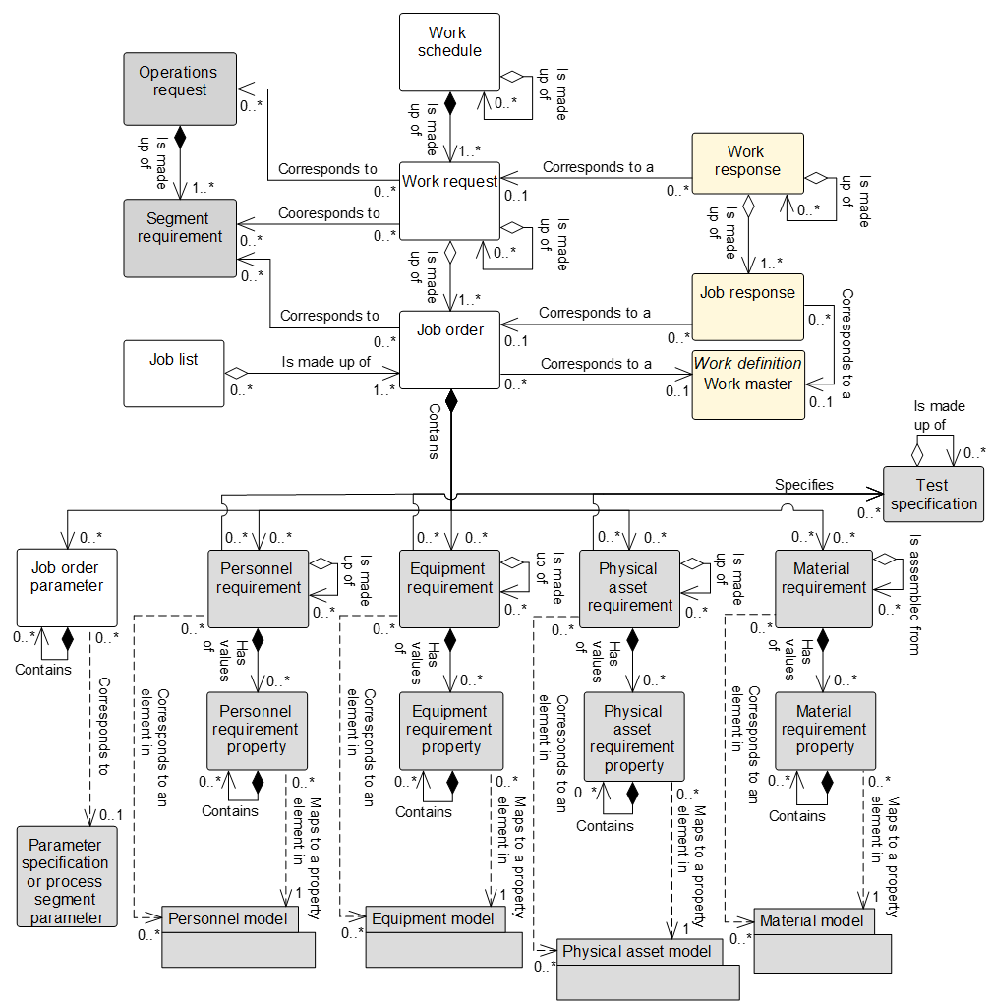

Figure 8 – Work schedule model

NOTE The object color convention used in the Part 2 and Part 4 UML diagrams for information models is as shown in Clause 3.3.3.

To simplify Figure 8, the relationships between the resource requirement objects and *test specification* are shown but not their relationships to the *test result.* For the complete contextual view of the information model, Table 50 does lists the all relationships between the resource requirement objects and *test specification* and *test result* with all relationship roles defined in each object sub clause in their relationship role table.

All relationships to *test specification* and *test result* are shown in Part 2 of this standard in Figure 16 – Operations test model and listed in Table 99 – Operations test requirement relationship roles.

Table 50 – Work schedule model relationships

| From | To | Type | Relationship Name |
| --- | --- | --- | --- |
| Work schedule | Work request | Composition whole | Is made up of |
| Work schedule | Work schedule | Aggregation hierarchy | Is made up of |
| Work request | Job order | Aggregation whole | Is made up of |
| Work request | Work request | Aggregation hierarchy | Is made up of |
| Work response | Work request | Association | Corresponds to |
| Work request | Operations request (Defined in Part 2) | Association | Corresponds to |
| Work request | Segment requirement  (Defined in Part 2) | Association | Corresponds to |
| Job order | Work master | Association | Corresponds to a |
| Job response | Job order | Association | Corresponds to a |
| Job list | Job order | Aggregation whole | Is made up of |
| Job order | Job order parameter | Composition whole | Contains |
| Job order parameter | Job order parameter | Composition hierarchy | Contains |
| Job order parameter | Parameter specification | Dependency | Corresponds to |
| Job order parameter | Process segment parameter | Dependency | Corresponds to |
| Job order | Personnel requirement | Composition whole | Contains |
| Job order | Equipment requirement | Composition whole | Contains |
| Job order | Physical asset requirement | Composition whole | Contains |
| Job order | Material requirement | Composition whole | Contains |
| Personnel requirement,  equipment requirement,  physical asset requirement, and  material requirement. | Test specification  (Defined in Part 2) | Association | Specifies |
| Test specification  (Defined in Part 2) | Personnel requirement,  equipment requirement,  physical asset requirement, and  material requirement. | Association | Specifies test for |
| Test result  (Defined in Part 2) | Personnel requirement,  equipment requirement,  physical asset requirement, and  material requirement. | Association | Generated in context of |
| Personnel requirement | Personnel requirement | Aggregation hierarchy | Is made up of |
| Personnel requirement | Personnel requirement property | Composition whole | Has values of |
| Personnel requirement | Test specification | Association | Specifies |
| Personnel requirement property | Personnel requirement property | Composition hierarchy | Contains |
| Personnel requirement | Personnel class | Association (A) | Corresponds to |
| Personnel requirement | Person | Association (C) | Corresponds to |
| Personnel requirement property | Personnel class property | Dependency (B) | Maps to |
| Personnel requirement property | Person property | Dependency (D) | Maps to |
| Equipment requirement | Equipment requirement | Aggregation hierarchy | Is made up of |
| Equipment requirement | Equipment requirement property | Composition whole | Has values of |
| Equipment requirement | Test specification | Association | Specifies |
| Equipment requirement property | Equipment requirement property | Composition hierarchy | Contains |
| Equipment requirement | Equipment class | Association (A) | Corresponds to |
| Equipment requirement | Equipment | Association (C) | Corresponds to |
| Equipment requirement property | Equipment class property | Dependency (B) | Maps to |
| Equipment requirement property | Equipment property | Dependency (D) | Maps to |
| Physical asset requirement | Physical asset requirement | Aggregation hierarchy | Is made up of |
| Physical asset requirement | Physical asset requirement property | Composition whole | Has values of |
| Physical asset requirement | Test specification | Association | Specifies |
| Physical asset requirement property | Physical asset requirement property | Composition hierarchy | Contains |
| Physical asset requirement | Physical asset class | Association (A) | Corresponds to |
| Physical asset requirement | Physical asset | Association (C) | Corresponds to |
| Physical asset requirement property | Physical asset class property | Dependency (B) | Maps to |
| Physical asset requirement property | Physical asset property | Dependency (D) | Maps to |
| Material requirement | Material requirement | Aggregation hierarchy | Is assembled from |
| Material requirement | Material requirement property | Composition whole | Has values of |
| Material requirement | Test specification | Association | Specifies |
| Material requirement property | Material requirement property | Composition hierarchy | Contains |
| Material requirement | Material class | Association (A) | Corresponds to |
| Material requirement | Material definition | Association (A) | Corresponds to |
| Material requirement | Material lot | Association (C) | Corresponds to |
| Material requirement | Material sublot | Association (C) | Corresponds to |
| Material requirement property | Material class property | Dependency (B) | Maps to |
| Material requirement property | Material definition property | Dependency (B) | Maps to |
| Material requirement property | Material lot property | Dependency (D) | Maps to |

EXAMPLE 1 Figure 9 is an example of an *operations schedule* for a site.



Figure 9 – Example, operations schedule for a site

EXAMPLE 2 Figure 10 is an example of a *work schedule* for an area in which one *operation request* is implemented in multiple *work requests*. In this example, each *work request* is made up of multiple *job orders*.



Figure 10 – Example, work schedule for an area

EXAMPLE 3 Figure 11 is an example of a *work request* with nested *job orders* and the associated *work master* for a *job order*. Each *job order* is associated with a *work master*.



Figure 11 – Example, work request, job order, and job list

EXAMPLE 4 Figure 12 illustrates the use of a *work request* in a continuous process, where there can be no unused time between activities and where the *job list* can be the *job orders* required to perform a product slate switchover.



Figure 12 – Example, Work request for continuous processing

## Work schedule

Table 51 defines the relationship roles for the *work schedule*.

Table 52 defines the attributes for the *work schedule*.

A *work schedule* may be made up of zero or more nested *work schedule(s)*.

Table 51 – Work schedule relationship roles

| Related Object | Role | Multiplicity | Relationship Name | Description |
| --- | --- | --- | --- | --- |
| Work request | Work request | 1..* | Is made up of | *The work request(s)* that make up this *work schedule*. |
| Work schedule | Work schedule child | 0..* | Is made up of | The related object(s), *work schedule*, makes up part of this *work schedule* as the whole. |

Table 52 – Work schedule attributes

| Attribute name | Description | Production examples | Maintenance examples | Quality examples | Inventory examples |
| --- | --- | --- | --- | --- | --- |
| ID | A unique identification of the *work schedule* and could include version and revision identification.  Required attribute.  The ID is used in other parts of the model when the *work schedule* needs to be identified. | PMMFUF | MWOIDND | QNFKVUV | IECBDU |
| Work type | Describes the category of work.  Defined values are   * production, * maintenance, * quality, * inventory, and * mixed.   “Mixed” can be used when the *work schedule* contains several types of *work requests* and/or *segment requirements.* | Production | Maintenance | Quality | Inventory |
| Description | Contains additional information and descriptions of the *work schedule.* | “Widget manufacturing schedule” | “Daily planned maintenance” | “Widget raw material testing schedule” | “Widget raw material staging schedule” |
| Start time | The starting time for the associated *work schedule*. | 10-28-2006 | 10-28-2006 | 10-28-2006 | 10-28-2006 |
| End time | The ending time for the associated *work schedule*. | 10-30-2006 | 10-30-2006 | 10-30-2006 | 10-30-2006 |
| Published date | The date and time on which the *work schedule* was published or generated. | 12-30-1951 18:30 UTC | 10-17-2005  18:30 UTC | 10-17-2005  18:30 UTC | 10-17-2005  18:30 UTC |
| Hierarchy scope | Identifies where the exchanged information fits within the role based equipment hierarchy. | East Wing manufacturing line #2 | CNC Machine  Asset ID 13465 | Test cell 4  Receiving | Warehouse B |
| Schedule state | Indicates the state of the *work schedule.*  Defined values are   * forecast, * released, * cancelled, * waiting, * ready, * running, * completed, * aborted, * held, * suspended, and * closed. | Completed | Closed | Running | Paused |

NOTE 1 A MIMOSA *segment request for work* and an *asset request for work* are the equivalent of a *work request* for either *equipment* or for a *physical asset*. The MIMOSA table of *request for work* is the equivalent of the *work schedule*.

NOTE 2 The defined values for state attributes for the following objects can be clarified as the “principal name” per Part 7 of this standard, Enterprise/control system integration – Alias service model: *Work schedule, work request, job order, work performance, work response*, and *job response*.

The defined values for the schedule state attribute of the *work schedule* object and request state attribute for the *work request* object have the following definitions:

1. waiting: necessary pre-conditions have not been met and the job orders or activities are not ready to run;
2. forecast: the requirements have not been released for use;

EXAMPLE This can be a schedule, which is an estimate derived from a finite capacity algorithm for line balancing, backward scheduling or forward scheduling to derive best possible alternatives for a *work schedule* and associated *work request*. The best alternative work schedule is released to the dispatching function as a “Released” *work schedule* when the schedule is approved and released to production.

1. released: the requirements have been released for use;
2. cancelled a scheduling decision has been taken to cancel the requirements prior to commencement of execution;
3. ready: necessary pre-conditions have been met and the *job order* or activities are ready to run;
4. running: *job order* or activities are in execution;
5. completed: *job order* or activities have been completed and are no longer in execution;
6. aborted: an execution decision has been taken to terminate the *job order* or activities that may, or may not, have been previously commenced;
7. held: *job order* or activities have been temporarily stopped due to a constraint of some form;
8. suspended: *job order* or activities have been temporarily stopped due to a deliberate decision within execution; and
9. closed: *job order* or activities have been completed and fully reconciled. No further changes, or restatement of actuals is expected;

## Work request

A request for work defined by a set of *job orders* shall be defined as a *work request*. A *work request* contains the information required by manufacturing to fulfill scheduled work. This may be a subset of the business information, or it may contain additional information not normally used by the business system.

A *work request* shall contain at least one *job order*.

A *work request* may include

1. when to start work, typically used if a scheduling system controls the schedule;
2. when the work is to be finished, typically used if the manufacturing operations system controls its internal schedule to meet deadlines; and
3. the priority of the request, typically used if exact ordering of production is not externally scheduled.

Additional information may be described in the associated *job order’s* *parameters, personnel requirements, equipment requirements,* and *material requirements.*

A *work request* may be made up of zero or more nested *work requests*.

A *work request* may be reported on by one or more *work responses*.

Table 53 defines the relationship roles for the *work request*.

Table 54 defines the attributes for the *work request*.

Table 53 – Work request relationship roles

| Related Object | Role | Multiplicity | Relationship Name | Description |
| --- | --- | --- | --- | --- |
| Work request | Work request child | 0..* | Is made up of | The related object(s), *work request*, makes up part of this *work request* as the whole. |
| Work schedule | NA | 1 | Is made up of | The *work schedule* defined in part by this *work request.* |
| Job order | Job order | 1..* | Is made up of | The related object(s) *job order*, makes up part of this *work request* as the whole. Often shared with *job list*. |
| Operations request | Operations request | 0,,* | Corresponds to | The *operations request(s)* related to this *work request.* |
| Segment requirement | Segment requirement | 0,,* | Corresponds to | The *operations request(s)* related to this *work request.* |
| Work response | NA | 0,,* | Corresponds to | The *work response(s)* related to this *work request.* |

Table 54 – Work request attributes

| Attribute name | Description | Production examples | Maintenance examples | Quality examples | Inventory examples |
| --- | --- | --- | --- | --- | --- |
| ID | A unique identification of the *work request*.  Required attribute.  The ID is used in other parts of the model when the *work request* needs to be identified. | 1001091 | CNC-PM-F1 | SAMP#1A | BLEND KIT 101 |
| Work type | Describes the category of work.  Defined values are   * production, * maintenance, * quality, * inventory, and * mixed.   “Mixed” can be used when the *work request c*ontains several types of *job orders*. | Production | Maintenance | Quality | Inventory |
| Description | Contains additional information and descriptions of the *work request.* | “Work request for export quality widgets for October 29, 1999” | Preventive maintenance of CNC machine for runtime exceeding 1 500 h | Take batch sample at end of batch | Prepare dispense kit for batch |
| Start time | When work is to be started. | 1999-10-27 8:00 UTC | 2011-03-07 | N/A | 8:00 AM |
| End time | When work is to be completed. | 1999-10-27 17:00 UTC | 2011-03-10 | N/A | 8:30 AM |
| Priority | The priority of the *work request*. | Highest | Low | High | N/A |
| Hierarchy scope | Identifies where the exchanged information fits within the role based equipment hierarchy. | East Wing manufacturing line #2 | CNC machine  Asset ID 13465 | Test cell 4  Receiving | Warehouse B |
| Segment requirement ID | A unique identification of the *segment requirement* within the scope of an *operations request* that specifically relates to the *work request*.  EXAMPLE  The *segment requirement(s)* corresponding to the *work request*). | A6646 | KU492 | 48283 | 4883DV |
| Request state | Indicates the state of the *work request.*  Defined values are   * waiting, * released, * cancelled, * ready, * running, * completed, * aborted, * held, * suspended, and * closed. | Completed | Closed | Running | Paused |

## Job list definition

A *job list* shall be defined as a collection of *job orders* for a specific period of time and selected work centers or other resources. A *job list* may be considered as a slice of *work schedules*.

A *job list* may contain *job orders* from multiple *work requests* and *work schedules*. The model for *job lists* is shown in Figure 8; objects shown as gray boxes are defined in Part 2 of this standard.

NOTE 1 The determination of how to specify a slice of work *schedules* is not defined in this standard.

EXAMPLE 1 Slices can be by time:

* all *job orders* for the first shift for a specific day;
* all *job orders* by *equipment* and time such as all *job orders* for production line 1 for the next week.

EXAMPLE 2 Slices can be by resource; for example, all *job orders* for a specific work cell for some period of time.

NOTE 2 The level of granularity of a *job list* can be determined by the applications. It can be very granular and refer to level 2 *equipment,* or it can be less granular and refer to *equipment* at the planning level.

*Job lists* may contain a sequence of *job orders*. In this case, the sequence is embedded in the *job list* entry start rules.

## Job list

*Job list* has the same attributes as *work requests*, because it is a slice of a *work schedule*.

Table 55 lists the relationship roles of the *job list.*

Table 56 lists the attributes of the *job list.*

Table 55 – Job list relationship roles

| Related Object | Role | Multiplicity | Relationship Name | Description |
| --- | --- | --- | --- | --- |
| Job order | Job order | 1..* | Is made up of | The j*ob orders* contained by this *job list*. |

Table 56 – Job list attributes

| Attribute name | Description | Production examples | Maintenance examples | Quality examples | Inventory examples |
| --- | --- | --- | --- | --- | --- |
| ID | A unique identification of the *job list* and could include version and revision identification.  Required attribute.  The ID is used in other parts of the model when the *job list* needs to be identified. | PMMFUF | MWOIDND | QNFKVUV | IECBDU |
| Work type | Describes the category of work.  Defined values are   * production, * maintenance, * quality, * inventory, and * mixed.   “Mixed” can be used when the *job list* contains several types of *job orders*. | Production | Maintenance | Quality | Inventory |
| Description | Contains additional information and descriptions of the *job list.* | “Widget manufacturing schedule” | “Daily planned maintenance” | “Widget raw material testing schedule” | “Widget raw material staging schedule” |
| Start time | The starting time for the associated *job list*. | 10-28-2006 | 10-28-2006 | 10-28-2006 | 10-28-2006 |
| End time | The ending time for the associated *job list*. | 10-30-2006 | 10-30-2006 | 10-30-2006 | 10-30-2006 |
| Published date | The date and time on which the *job list* was published or generated. | 12-30-1951 18:30 UTC | 10-17-2005  18:30 UTC | 10-17-2005  18:30 UTC | 10-17-2005  18:30 UTC |
| Hierarchy scope | Identifies where the exchanged information fits within the role based equipment hierarchy. | East Wing manufacturing line #2 | CNC machine  Asset ID 13465 | Test cell 4  Receiving | Warehouse B |

## Job order

The unit of work requested for execution in a *job list* and a *work request* shall be defined as a *job order*. A *job order* references an associated *work master*.

A *job order* may be reported by one or more *job responses*. It has attributes to contain information added by the dispatching activities.

Table 57 lists the relationship roles of the *job order.*

Table 58 lists the attributes of the *job order.*

Table 57 – Job order relationship roles

| Related Object | Role | Multiplicity | Relationship Name | Description |
| --- | --- | --- | --- | --- |
| Work request | NA | 0..1 | Is made up of | The *work request* containing this *job order*. |
| Job list | NA | 0..* | Is made up of | The *job list(s)* make up part of this *job order*. |
| Work master | Work master | 0..1 | Corresponds to | *The work master* applied to *this job order*. |
| Job response | NA | 0..* | Corresponds to | This *job order* related to the *job response* |
| Segment requirement | Segment requirement | 0..* | Corresponds to | The *segment requirement(s)* within the scope of an *operations request* that specifically relates to this *job order*  EXAMPLE 1  The s*egment requirement(s)* corresponding to the *job order*. |
| Job order parameter | Job order parameter | 0..* | Contains | The *job order parameter* related to this *job order*. |
| Personnel requirement | Personnel requirement | 0..* | Contains | The *personnel requirements* related to this *job order.* |
| Equipment requirement | Equipment requirement | 0..* | Contains | The *equipment requirements* related to this *job order.* |
| Physical asset requirement | Physical asset requirement | 0..* | Contains | The *physical asset requirements* related to this *job order.* |
| Material requirement | Material requirement | 0..* | Contains | The *material requirements* related to this *job order.* |

Table 58 – Job order attributes

| Attribute name | Description | Production examples | Maintenance examples | Quality examples | Inventory examples |
| --- | --- | --- | --- | --- | --- |
| ID | A unique identification of the *job order*.  Required attribute.  The ID is used in other parts of the model when the *job order* needs to be identified. | 1001091 | DO4833-A | EE9O989 | 38483ED |
| Work type | Describes the category of work.  Defined values are   * production, * maintenance, * quality, * inventory, and * mixed.   “Mixed” can be used when the *job order* contains several types of work. | Production | Maintenance | Quality | Inventory |
| Description | Contains additional information and descriptions of the *job order.* | “Work request for export quality widgets for October 29, 1999” | “Work order to repair shear” | “Ambient temperature sampling procedure” | “Stage material for production” |
| Work master ID | Identifies the associated *work master* to be used. | Export quality widget | Repair shear | Raw material sampling procedure | Kit assembly |
| Work master version | Identifies the version of the associated *work master* to be used. | V010 |  | 943 | A84 |
| Start time | When work is to be started. | 1999-10-27 8:00 UTC | 2014-03-07 10:00 UTC | 2010-04-27 20:30 | 2011-01-20 14:45 UTC-10:00 |
| End time | When work is to be completed. | 1999-10-27 17:00 UTC | 2014-03-08 08:00 UTC | 2010-06-27 17:00 | 2011-01-27 09:30 UTC-10:00 |
| Priority | The priority of the *job order.* | Highest | 3 | A | Medium |
| Hierarchy scope | Identifies where the exchanged information fits within the role based equipment hierarchy. | East Wing manufacturing line #2 | Lid press  Asset ID 13465 | Test cell 4  Receiving | Warehouse B |
| Segment requirement ID | A unique identification of the *segment requirement* within the scope of an *operations request* that specifically relates to the *job order.*  EXAMPLE 2  The s*egment requirement(s)* corresponding to the *job order*. | A6646 | KU492 | 48283 | 4883DV |
| Command | Identifies the action the execution management activity is to perform on the *job order.* | Start  Hold  Cancel  Abort  Stop | Start  Hold  Cancel  Abort  Stop | Start  Hold  Cancel  Abort  Stop | Start  Hold  Cancel  Abort  Stop |
| Dispatch status | Identifies the status of the entry from the perspective of the dispatch activity.  Defined values are   * waiting, * pending, * cancelled, * dispatched, * ready, * running, * completed, * aborted, * held, * suspended, and * closed.   NOTE Dispatch status is similar to what planners can write on their whiteboard to track a *job order*. | Pending | Dispatched | Running | Closed |
| Command rule | Instruction to execution management activities specifying conditions to execute the command. | Equipment is clean.  After *job order* WED89 is complete | Parts available and equipment not in production. | Request from production.  Request from receiving. | Stock out condition |

The defined values for the *dispatch status* attribute of the *job order* object has the following definitions.

1. waiting: *job order* or activities are scheduled but are not yet dispatched to work center for execution.
2. cancelled: a scheduling decision has been taken to cancel the requirements prior to commencement of execution.
3. dispatched: *job order* or activities have been dispatched to work center for execution.
4. ready: necessary pre-conditions have been met and the *job order* or activities are ready to run.
5. running: *job order* or activities are in execution.
6. completed: *job order* or activities have been completed and are no longer in execution.
7. aborted: an execution decision has been taken to terminate the *job order* or activities that may, or may not, have been previously commenced.
8. held: *job order* or activities have been temporarily stopped due to a constraint of some form.
9. suspended: *job order* or activities have been temporarily stopped due to a deliberate decision within execution.
10. closed: *job order* or activities have been completed and fully reconciled. No further changes, or restatement of actuals is expected.

## Job order parameter

Information to be exchanged which cannot be mapped as *personnel, equipment, physical asset* or *material properties* shall be defined as *job order parameters*.

The attributes for a *job order parameter* are the same as those for a *segment parameter* defined in Part 2 of this standard.

A *job order parameter* may be made up of zero or more nested *job order parameters*.

A *job order parameter* should include a set of limits that apply to any change to the value, such as quality limits and safety limits.

Table 59 lists the relationship roles of the *job order parameter.*

Table 59 – Job order parameter relationship roles

| Related Object | Role | Multiplicity | Relationship Name | Description |
| --- | --- | --- | --- | --- |
| Job order | NA | 1 | Contains | The *job order* containing this *job order parameter*. |
| Job order parameter | Job order parameter child | 0..* | Contains | The child *job order parameter(s)* that are part of this *job order parameter.* |
| Parameter specification | Parameter specification | 0..1 | Corresponds to | This *segment parameter(s)* corresponds to the *parameter specification(s)* in the *operations definition*. |
| Process segment parameter | Process segment parameter | 0..1 | Corresponds to | This *segment parameter(s)* corresponds to the *process segment parameter(s)* in the *process segment*. |

## Personnel requirement

The definition of this object and the attributes for this object are defined in Part 2 of this standard.

## Personnel requirement property

The definition of this object and the attributes for this object are defined in Part 2 of this standard.

## Equipment requirement

The definition of this object and the attributes for this object are defined in Part 2 of this standard.

## Equipment requirement property

The attributes for *equipment requirement property* are defined in Part 2 of this standard.

## Physical asset requirement

The definition of this object and the attributes for this object are defined in Part 2 of this standard.

## Physical asset requirement property

The attributes for *physical asset requirement property* are defined in Part 2 of this standard.

## Material requirement

The definition of this object and the attributes for this object are defined in Part 2 of this standard.

A *material requirement* may be an assembly of zero or more nested *material requirements*.

## Material requirement property

The definition of this object and the attributes for this object are defined in Part 2 of this standard.

## Job order to work master relationship

Figure 13 illustrates an example of how a *job order* references a *work master*, and how steps in the *work master’s workflow specification* may request additional *job orders* that have their own references to other *work masters*.



Figure 13 – Example, job orders and work master relationships

# Work performance information

## Work performance model

*Work performance* shall be defined as a collection of *work responses* that is a report on requested manufacturing information. *Work responses* are responses from manufacturing that are associated with a *work request*. There may be one or more *work responses* for a single *work request* if the manufacturing facility needs to split the *work request* into smaller elements.

Figure 14 is the work performance model; objects shown as gray boxes are defined in Part 2 of this standard. Table 60 lists the relationships of the objects in the work performance model.

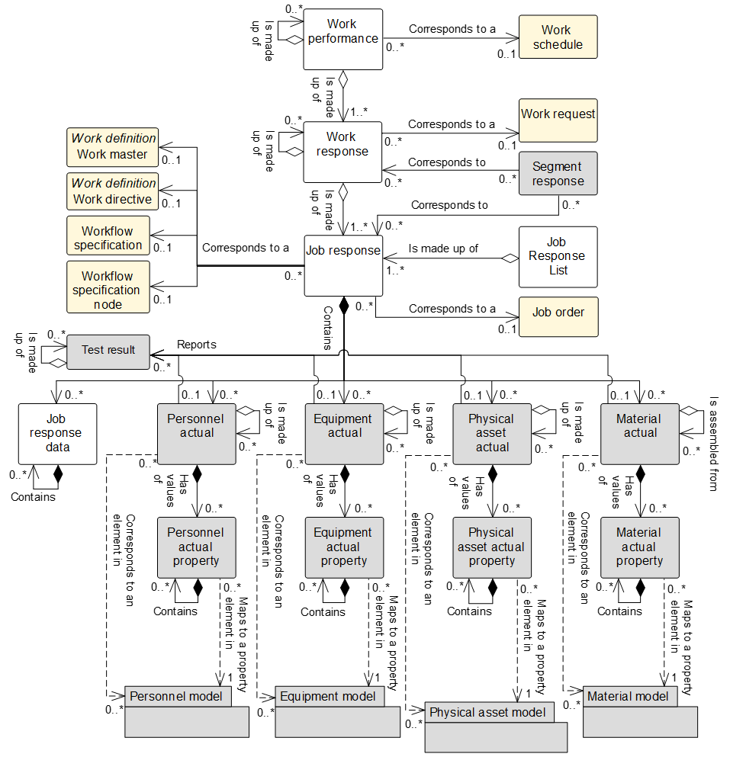

Figure 14 – Work performance model

NOTE 1 The object color convention used in the Part 2 and Part 4 UML diagrams for information models is as shown in Clause 3.3.3..

Table 60 – Work performance model relationships

| From | To | Type | Relationship Name |
| --- | --- | --- | --- |
| Work performance | Work schedule | Association | Corresponds to a |
| Work performance | Work response | Aggregation whole | Is made up of |
| Work performance | Work performance | Aggregation hierarchy | Is made up of |
| Work response | Work request | Association | Corresponds to |
| Work response | Work response | Aggregation hierarchy | Is made up of |
| Work response | Job response | Aggregation whole | Is made up of |
| Segment response (Defined in Part 2) | Work response | Association | Corresponds to a |
| Segment response (Defined in Part 2) | Job response | Association | Corresponds to a |
| Job response list | Job response | Aggregation whole | Is made up of |
| Job response | Workflow specification | Association | Corresponds to |
| Job response | Workflow specification node | Association | Corresponds to |
| Job response | Job order | Association | Corresponds to a |
| Job response | Work master | Association | Corresponds to a |
| Job response | Work directive | Association | Corresponds to a |
| Job response | Job response data | Composition whole | Contains |
| Job response data | Job response data | Composition hierarchy | Contains |
| Job order | Personnel actual | Composition whole | Contains |
| Job order | Equipment actual | Composition whole | Contains |
| Job order | Physical asset actual | Composition whole | Contains |
| Job order | Material actual | Composition whole | Contains |
| Personnel actual | Personnel actual | Aggregation hierarchy | Is made up of |
| Personnel actual | Personnel actual property | Composition whole | Has values of |
| Personnel actual property | Personnel actual property | Composition hierarchy | Contains |
| Personnel actual | Test result | Association | Reports |
| Personnel actual | Personnel class | Association (A) | Corresponds to |
| Personnel actual | Person | Association (C) | Corresponds to |
| Personnel actual property | Personnel class property | Dependency (B) | Maps to |
| Personnel actual property | Person property | Dependency (D) | Maps to |
| Equipment actual | Equipment actual | Aggregation hierarchy | Is made up of |
| Equipment actual | Equipment actual property | Composition whole | Has values of |
| Equipment actual property | Equipment actual property | Composition hierarchy | Contains |
| Equipment actual | Test result | Association | Reports |
| Equipment actual | Equipment class | Association (A) | Corresponds to |
| Equipment actual | Equipment | Association (C) | Corresponds to |
| Equipment actual property | Equipment class property | Dependency (B) | Maps to |
| Equipment actual property | Equipment property | Dependency (D) | Maps to |
| Physical asset actual | Physical asset actual | Aggregation hierarchy | Is made up of |
| Physical asset actual | Physical asset actual property | Composition whole | Has values of |
| Physical asset actual property | Physical asset actual property | Composition hierarchy | Contains |
| Physical asset actual | Test result | Association | Reports |
| Physical asset actual | Physical asset class | Association (A) | Corresponds to |
| Physical asset actual | Physical asset | Association (C) | Corresponds to |
| Physical asset actual property | Physical asset class property | Dependency (B) | Maps to |
| Physical asset actual property | Physical asset property | Dependency (D) | Maps to |
| Material actual | Material actual | Aggregation hierarchy | Is assembled from |
| Material actual | Material actual property | Composition whole | Has values of |
| Material actual property | Material actual property | Composition hierarchy | Contains |
| Material actual | Test result | Association | Reports |
| Material actual | Material class | Association (A) | Corresponds to |
| Material actual | Material definition | Association (A) | Corresponds to |
| Material actual | Material lot | Association (C) | Corresponds to |
| Material actual | Material sublot | Association (C) | Corresponds to |
| Material actual property | Material class property | Dependency (B) | Maps to |
| Material actual property | Material definition property | Dependency (B) | Maps to |
| Material actual property | Material lot property | Dependency (D) | Maps to |

NOTE 2 *Segment response* is defined in the operations performance model in Part 2 of this standard.

## Work performance

Table 61 defines the relationship roles for the *work performance*.

Table 62 defines the attributes for the *work performance*.

A *work performance* may be made up of zero or more nested *work performances*.

Table 61 – Work performance relationship roles

| Related Object | Role | Multiplicity | Relationship Name | Description |
| --- | --- | --- | --- | --- |
| Work response | Work response | 1..* |  | The *work response(s)* related to this *work performance*. |
| Work performance | Work performance child | 0..* | Is made up of | The related object(s) makes up part of this *work performance* as the whole. |
| Work schedule | Work schedule | 0..1 | Corresponds to | An identification of the associated *work schedule*.  *Work performance* may not relate to a *work schedule*; it may be a report on work for a specific time or a report plant floor events. |

Table 62 – Work performance attributes

| Attribute name | Description | Production examples | Maintenance examples | Quality examples | Inventory examples |
| --- | --- | --- | --- | --- | --- |
| ID | A unique identification of the *work performance* and could include version and revision identification.  Required attribute.  The ID is used in other parts of the model when the *work performance* needs to be identified. | 1999-10-27-A15 | CNC-PM-20110307-13465 | B12345-S01 | B12345-KIT101-A |
| Work type | Describes the category of work.  Defined values are   * production, * maintenance, * quality, * inventory, or * mixed.   “Mixed” can be used when the *work performance* contains resources and routing information required to perform several types of work. | Production | Maintenance | Quality | Inventory |
| Description | Contains additional information and descriptions of the *work performance.* | “Work performance report on October 27, 1999 work schedule.” | Preventive maintenance performed on CNC machine | Production sample for batch 12345 | Dispense kit for batch 12345 |
| Start time | The starting time of the associated *work performance*. | 10-28-1999 | 2011-03-07 09:31 | N/A | 2011-03-07 08:01 |
| End time | The ending time of the associated *work performance*. | 10-30-1999 | 2011-03-10 11:15 | N/A | 2011-03-07 08:31 |
| Published date | The date and time in which the *work performance* was published or generated. | 10-27-1999 13:42 EST | 2011-03-10 13:21 | 2009-12-14 13:31 PT | 2011-03-07 08:33 |
| Hierarchy scope | Identifies where the exchanged information fits within the role based equipment hierarchy. | East Wing manufacturing line #2 | CNC machine  Asset ID 13465 | Test cell 4  Receiving | Warehouse B |
| Work state | Indicates the state of the *work performance*.  Defined values are   * waiting, * ready, * running, * completed, * aborted, * held, * suspended, and * closed. | Completed | Closed | Running | Paused |

The defined values for the *work state* attribute of the *work performance* object, the *response state* attribute for the *work response* object, and the *job state* attribute of the *job response* object have the following definitions.

1. waiting: necessary pre-conditions have not been met and the job orders or activities are not ready to run.
2. ready: necessary pre-conditions have been met and the *job order* or activities are ready to run.
3. running: *job order* or activities are in execution.
4. completed: *job order* or activities have been completed and are no longer in execution.
5. aborted: an execution decision has been taken to terminate the *job order* or activities that may, or may not, have been previously commenced.
6. Held: *job order* or activities have been temporarily stopped due to a constraint of some form.
7. paused: *job order* or activities have been temporarily stopped due to a deliberate decision within execution.
8. closed: *job order* or activities have been completed and fully reconciled. No further changes, or restatement of actuals is expected.

## Work response

The responses from manufacturing that are associated with a *work request* shall be defined as *work responses*. There may be one or more *work responses* for a single *work request* if the manufacturing facility needs to split the *work request* into smaller elements of work.

A *work response* may include the status of the request, such as the percentage complete, a finished status, or an aborted status.

A *work response* may be made up of zero or more nested *work responses*.

Table 63 defines the relationship roles for the *work response*.

Table 64 defines the attributes for the *work response*.

Table 63 – Work response relationship roles

| Related Object | Role | Multiplicity | Relationship Name | Description |
| --- | --- | --- | --- | --- |
| Work performance | NA | 1 | Is made up of | The *work performance* contains in part this *work response*. |
| Work response | Work response child | 0..* | Is made up of | The related object(s) makes up part of this *work response* as the whole. |
| Work request | Work request | 0..1 | Corresponds to a | An identification of the associated *work request*.  *Work response* may not relate to a *work request*, it may be a report on all work for a specific time or reported on by plant floor events. |
| Job response | Job response | 1..* | Is made up of | The *job responses* that make up this *work response*. |
| Segment response (Defined in Part 2) | NA | 0..1 | Corresponds to | The *segment response* contains in part this *work response*. |

NOTE *Segment response* defined in the operations performance model in Part 2 of this standard.

Table 64 – Work response attributes

| Attribute name | Description | Production examples | Maintenance examples | Quality examples | Inventory examples |
| --- | --- | --- | --- | --- | --- |
| ID | An identification within the associated *work performance*.  Required attribute.  The ID is used in other parts of the model when the *work response* needs to be identified. | 1001091 | R-CNC-PM-20110307-13465 | B12345-S01-RESP | B12345-KIT101-R |
| Work type | Describes the category of work.  Defined values are   * production, * maintenance, * quality, * inventory, or * mixed.   “Mixed” can be used when the *job response* contains resources and routing information required to perform several types of work. | Production | Maintenance | Quality | Inventory |
| Start time | The starting time of this *work response*. | 1999-10-27 8:33 UTC | 2011-03-07 09:31 | 2011-03-10 15:12 | 2011-03-07 08:01 |
| End time | The ending time of this *work response*. | 1999-10-27 16:55 UTC | 2011-03-10 11:15 | 2011-03-10 18:00 | 2011-03-07 08:31 |
| Hierarchy scope | Identifies where the exchanged information fits within the role based equipment hierarchy. | East Wing manufacturing line #2 | CNC machine  Asset ID 13465 | Test cell 4  Receiving | Zone B |
| Response state | Indicates the state of the *work response.*  Defined values are   * waiting, * ready, * running, * completed, * aborted, * held, * suspended, * closed. | Completed | Closed | Running | Paused |

## Job response list

A *job response* list shall be defined as a collection of *job responses* for a specific period of time and selected work centers or other resources. A *job response list* may be considered as a slice of *work performances*.

A *job response list* may contain *job responses* from multiple *work responses* and *work performances*.

Table 65 defines the relationship roles for the *job response list*.

Table 66 defines the attributes for the *job response list*.

Table 65 – Job response list relationship roles

| Related Object | Role | Multiplicity | Relationship Name | Description |
| --- | --- | --- | --- | --- |
| Job response | Job response | 1..* | Is made up of | The *job response(s)* that make up this *job response list*. |

Table 66 – Job response list attributes

| Attribute name | Description | Production examples | Maintenance examples | Quality examples | Inventory examples |
| --- | --- | --- | --- | --- | --- |
| ID | A unique identification of the *job response list*.  Required attribute.  The ID is used when the *job response list* needs to be identified in other objects. | Area51/Line2 | R-CNC-PM-20110307-13465 | B12345-S01-RESP | B12345-KIT101-R |
| Version | An identification of the version of the *job response list*.  In cases where there are multiple versions of a *job response list*, then the version attribute shall contain the additional identification information to differentiate each version. | 1.0 | 1.4 | 1.1 | 1.1 |
| Work type | Describes the category of work.  Defined values are   * production, * maintenance, * quality, * inventory, or * mixed.   “Mixed” can be used when the *job response list* contains resources and routing information required to perform several types of work. | Production | Maintenance | Quality | Inventory |
| Start time | The starting time of this *job response list*. | 1999-10-27 8:33 UTC | 2011-03-07 09:31 | 2011-03-10 15:12 | 2011-03-07 08:01 |
| End time | The ending time of this *job response list*. | 1999-10-27 16:55 UTC | 2011-03-10 11:15 | 2011-03-10 18:00 | 2011-03-07 08:31 |
| Hierarchy scope | Identifies where the exchanged information fits within the role based equipment hierarchy. | East Wing manufacturing line #2 | CNC machine  Asset ID 13465 | Test cell 4  Receiving | Zone B |

## Job response

The responses from manufacturing that are associated with a *job order* shall be defined as a *job response*. There may be one or more *job responses* for a single *job order* if the manufacturing facility needs to split the *job order* into smaller elements of work. Where smaller elements of work are reported, the *job response* may be for a specific *workflow specification* or a *workflow specification node*.

A *job order* may include the status of the request, such as the percentage complete, a finished status, or an aborted status.

Table 67 defines the relationship roles for the *job response*.

Table 68 defines the attributes for the *job response*.

Table 67 – Job response relationship roles

| Related Object | Role | Multiplicity | Relationship Name | Description |
| --- | --- | --- | --- | --- |
| Work response | NA | 1 | Is made up of | The *work response* aggregated in this *job response*. |
| Segment response (Defined in Part 2) | NA | 0..1 | Corresponds to | The *segment response* contains in part this *job response*. |
| Work master | Work master | 0..1 | Corresponds to a | The *work master (s)* related to this *job response*.  The *version* of the *work master* may be specified in the attribute of this *job response*. |
| Work directive | Work directive | 0..1 | Corresponds to a | The *work directive(s)* related to this *job response*.  The *version* of the *work directive* may be specified in the attribute of this *job response*. |
| Workflow specification | Workflow specification | 0..1 | Corresponds to a | The *workflow specifications* related to this *job response*. |
| Workflow specification node | Workflow specification node | 0..1 | Corresponds to a | The *workflow specification node* related this *job response*. |
| Job order | Job order | 0..1 | Corresponds to a | The *job order* related to this *job response*, |
| Job response list | NA | 0..1 | Is made up of | The *job response list(s)* referenced in this *job response*. |
| Personnel actual | Personnel actual | 0..* | Contains | The *personnel actual(s)* related to this *job response.* |
| Equipment actual | Equipment actual | 0..* | Contains | The *equipment actual(s)* related to this *job response.* |
| Physical asset actual | Physical asset actual | 0..* | Contains | The *physical asset actual(s)* related to this *job response.* |
| Material actual | Material actual | 0..* | Contains | The *material actual(s)* related to this *job response.* |
| Job response data | Job response data | 0..* | Contains | Data associated with this *job response.* |

NOTE *Segment response* is defined in the operations performance model in Part 2 of this standard.

Table 68 – Job response attributes

| Attribute name | Description | Production examples | Maintenance examples | Quality examples | Inventory examples |
| --- | --- | --- | --- | --- | --- |
| ID | An identification within the associated *job response*.  Required attribute.  The ID is used in other parts of the model when the *job response* needs to be identified. | 1001091 | R-CNC-PM-20110307-13465 | B12345-S01-RESP | B12345-KIT101-R |
| Work type | Describes the category of work.  Defined values are   * production, * maintenance, * quality, * inventory, or * mixed.   “Mixed” can be used when the *job response* contains resources and routing information required to perform several types of work. | Production | Maintenance | Quality | Inventory |
| Job order | An identification of the associated *job order*.  *Job responses* may not relate to a *job order*, it may be a report on all work for a specific time or reported on by plant floor events. | 1001091 | CNC-PM-20110307-13465 | B12345-S01 | B12345-KIT101-A |
| Start time | The actual starting time of information in the *job response*. | 1999-10-27 8:33 UTC | 2011-03-07 09:31 | 2011-03-10 15:12 | 2011-03-07 08:01 |
| End time | The actual ending time of information in the *job response*. | 1999-10-27 16:55 UTC | 2011-03-10 11:15 | 2011-03-10 18:00 | 2011-03-07 08:31 |
| Hierarchy scope | Identifies where the exchanged information fits within the role based equipment hierarchy. | East Wing manufacturing line #2 | CNC machine  Asset ID 13465 | Test cell 4  Receiving | Zone B |
| Job state | Indicates the state of the *work response.*  Defined values are:   * waiting, * ready, * running, * completed, * aborted, * held, * suspended, and * closed. | Completed | Closed | Running | Paused |

## Job response data

Other information related to the actual work made shall be presented as *job response data*.

The attributes for *job response* data are defined in Part 2 of this standard as *segment data*.

A *job response data* object may be made up of zero or more nested *job response data* objects.

Table 69 defines the relationship roles for the *job response data*.

Table 69 – Job response data relationship roles

| Related Object | Role | Multiplicity | Relationship Name | Description |
| --- | --- | --- | --- | --- |
| Job response | Job response | 1 | Contains | The *job response* contains in part this *job response data(s)*. |

## Personnel actual

The definition of this object and the attributes for this object are defined in Part 2 of this standard.

## Personnel actual property

The definition of this object and the attributes for this object are defined in Part 2 of this standard.

## Equipment actual

The definition of this object and the attributes for this object are defined in Part 2 of this standard.

## Equipment actual property

The definition of this object and the attributes for this object are defined in Part 2 of this standard.

## Physical asset actual

The definition of this object and the attributes for this object are defined in Part 2 of this standard.

## Physical asset actual property

The definition of this object and the attributes for this object are defined in Part 2 of this standard.

## Material actual

The definition of this object and the attributes for this object are defined in Part 2 of this standard.

A *material actual* may be an assembly of zero or more nested *material actuals*.

## Material actual property

The definition of this object and the attributes for this object are defined in Part 2 of this standard.

## Test result

The definition of this object and the attributes for this object are defined in Part 2 of this standard.

# Work capability information

## Work capability model

The collection of information about the resources for work for selected future and past times shall be defined as *work capability*. This is made up of information about committed, available, and unattainable *equipment, material, personnel, physical assets*, and *work master capabilities*. *Work capability* describes the names, terms, statuses, and quantities of which the manufacturing operations and control system has knowledge.

NOTE 1 *Work capability* is used when the capability and capacity do not vary based on the product being produced or any specific *work master* used.

Figure 15 is the *work capability* model that applies to the production, maintenance, quality, and inventory operations; objects shown as gray boxes are defined in Part 2 of this standard. Table 70 lists the relationships of the objects in the work capability model.

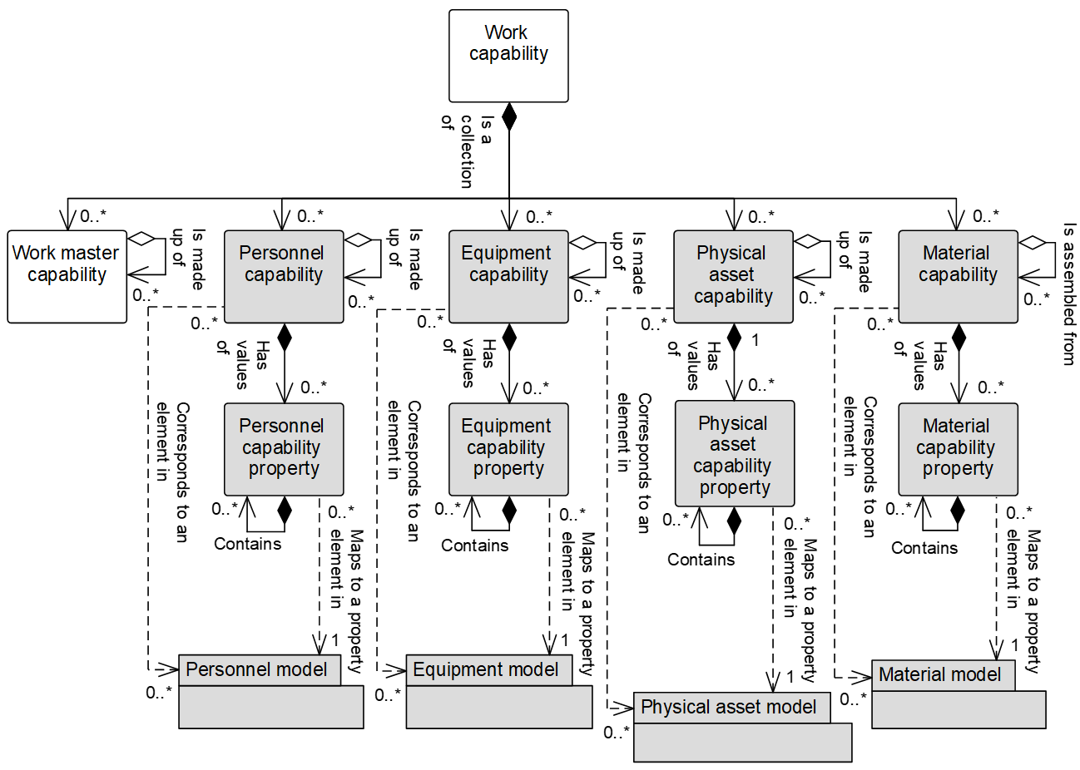

Figure 15 – Work capability model

NOTE 2 The object color convention used in the Part 2 and Part 4 UML diagrams for information models is as shown in Clause 3.3.3.

Table 70 – Work capability model relationships

| From | To | Type | Relationship Name |
| --- | --- | --- | --- |
| Work capability | Work master capability | Composition whole | Is collection of |
| Work capability | Personnel capability | Composition whole | Is collection of |
| Work capability | Equipment capability | Composition whole | Is collection of |
| Work capability | Physical asset capability | Composition whole | Is collection of |
| Work capability | Material capability | Composition whole | Is collection of |
| Work master capability | Work master capability | Aggregation hierarchy | Is made up of |
| Personnel capability | Personnel capability | Aggregation hierarchy | Is made up of |
| Personnel capability | Personnel capability property | Composition whole | Has values of |
| Personnel capability property | Personnel capability property | Composition hierarchy | Contains |
| Personnel capability | Personnel class | Association (A) | Corresponds to |
| Personnel capability | Person | Association (C) | Corresponds to |
| Personnel capability property | Personnel class property | Dependency (B) | Maps to |
| Personnel capability property | Person property | Dependency (D) | Maps to |
| Equipment capability | Equipment capability | Aggregation hierarchy | Is made up of |
| Equipment capability | Equipment capability property | Composition whole | Has values of |
| Equipment capability property | Equipment capability property | Composition hierarchy | Contains |
| Equipment capability | Equipment class | Association (A) | Corresponds to |
| Equipment capability | Equipment | Association (C) | Corresponds to |
| Equipment capability property | Equipment class property | Dependency (B) | Maps to |
| Equipment capability property | Equipment property | Dependency (D) | Maps to |
| Physical asset capability | Physical asset capability | Aggregation hierarchy | Is made up of |
| Physical asset capability | Physical asset capability property | Composition whole | Has values of |
| Physical asset capability property | Physical asset capability property | Composition hierarchy | Contains |
| Physical asset capability | Physical asset class | Association (A) | Corresponds to |
| Physical asset capability | Physical asset | Association (C) | Corresponds to |
| Physical asset capability property | Physical asset class property | Dependency (B) | Maps to |
| Physical asset capability property | Physical asset property | Dependency (D) | Maps to |
| Material capability | Material capability | Aggregation hierarchy | Is assembled from |
| Material capability | Material capability property | Composition whole | Has values of |
| Material capability property | Material capability property | Composition hierarchy | Contains |
| Material capability | Material class | Association (A) | Corresponds to |
| Material capability | Material definition | Association (A) | Corresponds to |
| Material capability | Material lot | Association (C) | Corresponds to |
| Material capability | Material sublot | Association (C) | Corresponds to |
| Material capability property | Material class property | Dependency (B) | Maps to |
| Material capability property | Material definition property | Dependency (B) | Maps to |
| Material capability property | Material lot property | Dependency (D) | Maps to |

## Work capability

Table 71 defines the relationship roles for the *work capability*.

Table 72 defines the attributes for the *work capability*.

Table 71 – Work capability relationship roles

| Related Object | Role | Multiplicity | Relationship Name | Description |
| --- | --- | --- | --- | --- |
| Personnel capability | Personnel capability | 0..* | Is a collection of | The *personnel capability(s)* related to this *work capability.* |
| Equipment capability | Equipment capability | 0..* | Is a collection of | The *equipment capability(s)* related to this *work capability.* |
| Physical asset capability | Physical asset capability | 0..* | Is a collection of | The *physical asset capability(s)s* related to this *work capability.* |
| Material capability | Material capability | 0..* | Is a collection of | The *material capability(s)* related to this *work capability.* |
| Work master capability | Work master capability | 0..* | Is a collection of | *Work master capability(s)* associated with this *work capability.* |

Table 72 – Work capability attributes

| Attribute name | Description | Production examples | Maintenance examples | Quality examples | Inventory examples |
| --- | --- | --- | --- | --- | --- |
| ID | Defines a unique instance of a *work capability* for a specified element of the equipment hierarchy model defined in Part 1 of this standard (*enterprise, site, area, work center, or work unit*).  Required attribute. | 1999/12/30-HPC52 | HHG6778 | LAB6678 | AGV556 |
| Description | Contains additional information and descriptions of the *work capability*. | “One day’s work capacity for the Boston Widget Company.” | Motor shop capacity, week 15 | Lab centrifuge capacity | Pallet movement capacity |
| Operations type | Describes the category of the activity.  Defined values are   * production, * maintenance, * quality, * inventory, or * mixed.   “Mixed” can be used when the activity contains several categories of *work masters*. | Production | Maintenance | Quality | Inventory |
| Capability type | Defines the type of capability.  Defined values are   * committed: capacity that is committed for future productive use. * unattainable: capacity that is not attainable for future productive use given the equipment condition, equipment utilization, personnel availability or material availability. * available: capacity that is available for additional future productive use. * Used: a historical value that defines the portion of the capacity with acceptable quality. * unused: a historical value that defines the portion of the capacity that was not used or had unacceptable quality. * total: the sum of used and unused capability or the sum of available, unattainable and committed capability. | Available | Total | Committed | Available |
| Reason | Defines the reason for the capability type.  EXAMPLE 1  If capability unused, then the reason is for why the capability was unused, such as a specific equipment failure or unacceptable product quality. | Available for work | Total hours of motor maintenance | Stability tests | Uncommitted AGVs |
| Confidence factor | A measure of the confidence of the capacity value.  EXAMPLE 2  A percentage value representing the confidence of the capacity. | 90 % | 100 % | 100 % | 75 % |
| Hierarchy scope | Identifies where the exchanged information fits within the role based equipment hierarchy.  Zero or more as required to identify the specific scope of the *work capability definition*. | Boston Widget Company | Boston Widget Company | Boston Widget Company | Boston Widget Company |
| Start time | The starting date and time of the *work capability*. | 2015-12-29 11:59 | 2011-04-03 12:00 | 2011-04-03 12:00 | 2011-04-03 12:00 |
| End time | The ending date and time of the *work capability*. | 2015-12-30 12:00 | 2011-04-09 11:59 | 2011-04-09 11:59 | 2011-04-09 11:59 |
| Published date | The date and time on which the *work capability* was published or generated. | 2015-11-03 13:55 | 2011-04-01 8:00 | 2011-04-01 8:00 | 2011-04-01 8:00 |

## Personnel capability

The definition of this object and the attributes for this object are defined in Part 2 of this standard.

## Personnel capability property

The definition of this object and the attributes for this object are defined in Part 2 of this standard.

## Equipment capability

The definition of this object and the attributes for this object are defined in Part 2 of this standard.

## Equipment capability property

The definition of this object and the attributes for this object are defined in Part 2 of this standard.

## Physical asset capability

The definition of this object and the attributes for this object are defined in Part 2 of this standard.

## Physical asset capability property

The definition of this object and the attributes for this object are defined in Part 2 of this standard.

## Material capability

The definition of this object and the attributes for this object are defined in Part 2 of this standard.

A *material capability* may be an assembly of zero or more nested *material capabilities*.

## Material capability property

The definition of this object and the attributes for this object are defined in Part 2 of this standard.

# Work master capability information

## Work master capability model

A representation of a logical grouping of personnel resources, equipment resources, physical asset resources, and material that is available, unattainable, committed, used, unused, or total for a given *work master* for a specific time shall be defined as a *work master capability*, as shown in Figure 16; objects shown as gray boxes are defined in Part 2 of this standard. Table 73 lists the relationships of the objects in the work master capability model.

NOTE 1 *Work master capability* can be used when the capability and capacity vary based on the product being produced or the specific *work master* used.

The *work master capability* shall identify

1. the capability type: available, unattainable, committed, used, unused, and total;
2. the time associated with the capability;

EXAMPLE 1 Third shift on a specific date.

The *work master capabilities* shall be made up of

1. *personnel segment capabilities*, which list specific properties required in *personnel segment capability properties*;
2. *equipment segment capabilities*, which list specific properties required in *equipment capability properties*;
3. *physical asset segment capabilities*, which list specific properties required in *physical asset capability properties*; and
4. *material segment capabilities*, which list specific properties required in *material segment capability properties.*

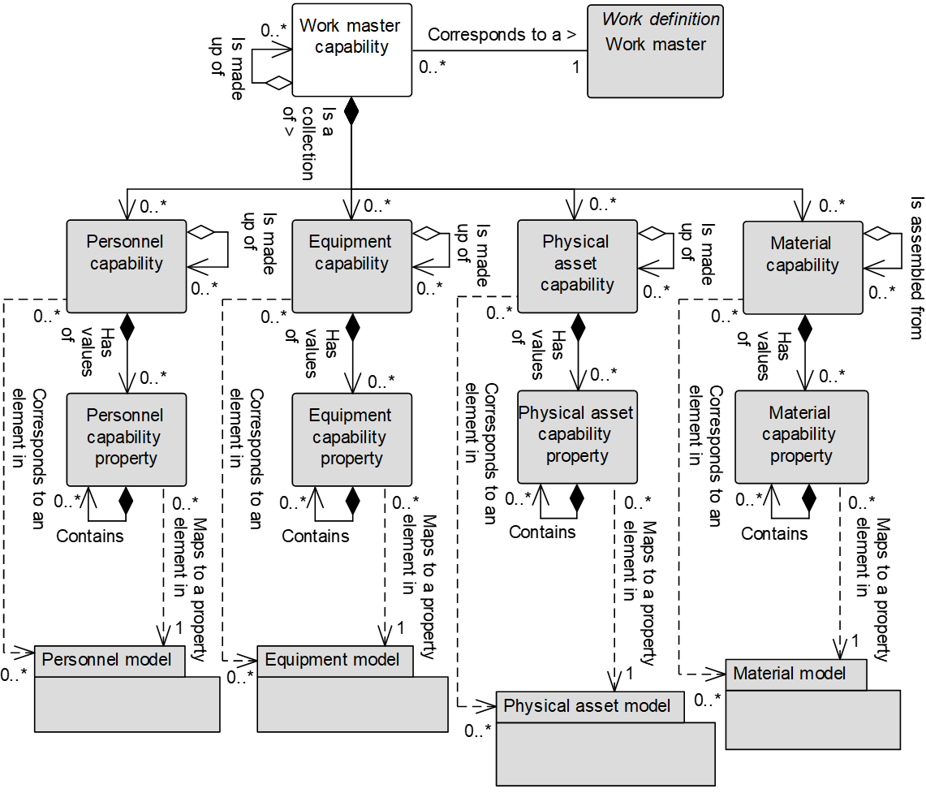

Figure 16 – Work master capability model

NOTE 2 The object color convention used in the Part 2 and Part 4 UML diagrams for information models is as shown in Clause 3.3.3.

Table 73 – Work master capability model relationships

| From | To | Type | Relationship Name |
| --- | --- | --- | --- |
| Work master capability | Work master | Association | Corresponds to |
| Work master capability | Work master capability | Aggregation hierarchy | Is made up of |
| Work master capability | Personnel capability | Composition whole | Is a collection of |
| Work master capability | Equipment capability | Composition whole | Is a collection of |
| Work master capability | Physical asset capability | Composition whole | Is a collection of |
| Work master capability | Material capability | Composition whole | Is a collection of |
| Personnel capability | Personnel capability | Aggregation hierarchy | Is made up of |
| Personnel capability | Personnel capability property | Composition whole | Has values of |
| Personnel capability property | Personnel capability property | Composition hierarchy | Contains |
| Personnel capability | Personnel class | Association (A) | Corresponds to |
| Personnel capability | Person | Association (C) | Corresponds to |
| Personnel capability property | Personnel class property | Dependency (B) | Maps to |
| Personnel capability property | Person property | Dependency (D) | Maps to |
| Equipment capability | Equipment capability | Aggregation hierarchy | Is made up of |
| Equipment capability | Equipment capability property | Composition whole | Has values of |
| Equipment capability property | Equipment capability property | Composition hierarchy | Contains |
| Equipment capability | Equipment class | Association (A) | Corresponds to |
| Equipment capability | Equipment | Association (C) | Corresponds to |
| Equipment capability property | Equipment class property | Dependency (B) | Maps to |
| Equipment capability property | Equipment property | Dependency (D) | Maps to |
| Physical asset capability | Physical asset capability | Aggregation hierarchy | Is made up of |
| Physical asset capability | Physical asset capability property | Composition whole | Has values of |
| Physical asset capability property | Physical asset capability property | Composition hierarchy | Contains |
| Physical asset capability | Physical asset class | Association (A) | Corresponds to |
| Physical asset capability | Physical asset | Association (C) | Corresponds to |
| Physical asset capability property | Physical asset class property | Dependency (B) | Maps to |
| Physical asset capability property | Physical asset property | Dependency (D) | Maps to |
| Material capability | Material capability | Aggregation hierarchy | Is assembled from |
| Material capability | Material capability property | Composition whole | Has values of |
| Material capability property | Material capability property | Composition hierarchy | Contains |
| Material capability | Material class | Association (A) | Corresponds to |
| Material capability | Material definition | Association (A) | Corresponds to |
| Material capability | Material lot | Association (C) | Corresponds to |
| Material capability | Material sublot | Association (C) | Corresponds to |
| Material capability property | Material class property | Dependency (B) | Maps to |
| Material capability property | Material definition property | Dependency (B) | Maps to |
| Material capability property | Material lot property | Dependency (D) | Maps to |

## Work master capability

*Work master capability* has an equivalent structure to the *personnel, equipment* and *material* structure of *work capability*, except the *work master capability* is defined for a specific *work master*.

Table 74 lists the relationship roles of *work master capability.*

Table 75 lists the attributes of *work master capability.*

Table 74 – Work master capability relationship roles

| Related Object | Role | Multiplicity | Relationship Name | Description |
| --- | --- | --- | --- | --- |
| work master capability | work master capability child | 0..* | Is made up of | The related object(s) makes up part of this *work master capability* as the whole. |
| Personnel capability | Personnel capability | 0..* | Is a collection of | The *personnel capability(s)* related to this *work master capability.* |
| Equipment capability | Equipment capability | 0..* | Is a collection of | The *equipment capability(s)* related to this *work master capability.* |
| Physical asset capability | Physical asset capability | 0..* | Is a collection of | The *physical asset capability(s)s* related to this *work master capability.* |
| Material capability | Material capability | 0..* | Is a collection of | The *material capability(s)* related to this *work master capability.* |
| Work master | Work master | 0..* | Corresponds to | *Work master* associated with this *work master capability.* |

Table 75 – Work master capability attributes

| Attribute name | Description | Production examples | Maintenance examples | Quality examples | Inventory examples |
| --- | --- | --- | --- | --- | --- |
| ID | A unique identification of the *work master capability.*  Required attribute. | A7756 | 20121111 | 20121111Q |  |
| Description | Contains additional information and descriptions of the *work master capability*. | “Defines the available capability for the widget assembly process segment” | Calibration of custody transfer gas flow meters | Hazardous material incoming inspection | Movement of hazardous material to warehouse |
| Work master | Identifies the *work master*. | Widget assembly | CTCF calibration | HMII | Fork truck movement |
| Operations type | Describes the category of the activity.  Required attribute.  Defined values are   * production, * maintenance, * quality, * inventory, or * mixed.   “Mixed” can be used when the activity contains several categories of *work master*. | Production | Maintenance | Quality | Inventory |
| Capability type | Defines the type of capability.  Defined values are   * committed: capacity that is committed for future productive use. * unattainable: capacity that is not attainable for future productive use given the equipment condition, equipment utilization, personnel availability or material availability. * available: capacity that is available for additional future productive use. * used: a historical value that defines the portion of the capacity with acceptable quality. * unused: a historical value that defines the portion of the capacity that was not used or had unacceptable quality. * total: the sum of used and unused capability or the sum of available, unattainable and committed capability. | Available | Committed | Available | Available |
| Reason | Defines the reason for the capability type.  EXAMPLE 1  If capability unused, then the reason is for why the capability was unused, such as a specific equipment failure or unacceptable product quality. | Available for production | Required by regulation | Available from scheduling | Available for scheduling |
| Confidence factor | A measure of the confidence of the capacity value.  EXAMPLE 2  A percentage value representing the confidence of the capacity. | 90% | 100% | Medium | 2 |
| Hierarchy scope | Identifies where the exchanged information fits within the role based equipment hierarchy.  If omitted, then the capability is associated to the parent *work capability* hierarchy scope.  Zero or more as required to identify the specific scope of the *operations capability* definition. | Production Line #15 | West production site | Receiving warehouse 13 | Receiving warehouse 13 |
| Start time | The starting time of the time span defining the *capability type*.  If omitted, then the capability is associated to the parent *work capability* start time. | 2013-12-30 11:59 | 2012-11-11 11:59 | 2012-11-11 11:59 | 2012-11-11 11:59 |
| End time | The ending time of the time span defining the *capability type*.  If omitted, then the capability is associated to the parent *work capability* end time. | 2014-01-01 12:00 | 2012-11-12 11:59 | 2012-11-12 11:59 | 2012-11-12 11:59 |
| Published date | The date and time on which the *work master capability* was published or generated. | 1999-11-03 13:55 | 10-25-2006 00:00 UTC | 10-25-2006 00:00 UTC | 10-25-2006 00:00 UTC |

## Personnel capability

The definition of this object and the attributes for this object are defined in Part 2 of this standard.

## Personnel capability property

The definition of this object and the attributes for this object are defined in Part 2 of this standard.

## Equipment capability

The definition of this object and the attributes for this object are defined in Part 2 of this standard.

## Equipment capability property

The definition of this object and the attributes for this object are defined in Part 2 of this standard.

## Physical asset capability

The definition of this object and the attributes for this object are defined in Part 2 of this standard.

## Physical asset capability property

The definition of this object and the attributes for this object are defined in Part 2 of this standard.

## Material capability

The definition of this object and the attributes for this object are defined in Part 2 of this standard.

## Material capability property

The definition of this object and the attributes for this object are defined in Part 2 of this standard.

# Work KPI information

Values that have a business or operational value related to a measure of performance shall be defined as *Work KPIs* (key performance indicators). KPIs are registered and defined. Registered KPI values are exchanged on a regular or event basis. See ISO 22400 for a definition of the KPI object model, attributes, and standard KPIs.

# Work alert information

## Work alert model

A notification of a Level 3 event shall be defined as a *work alert*. Not all events warrant creating a *work alert*. A *work alert* does not require acknowledgement. If acknowledgement is needed, then an alarm model may be used (see ISA-18.00.02 (IEC 62682), for information on alarms). *Work alerts* may be generated by any Level 3 activity.

*Work alert definitions* are descriptions of the available types of *work alerts*.

The detailed configuration data for *work alerts*, such as trigger conditions, registration of recipients and actions to be taken upon receipt are out of the scope of this part of this standard.

*Work alerts* differ from *work KPIs* in that the primary content of a *work alert* is the contextual information required to convey that an event has occurred.

EXAMPLE 1 This is similar to a “gate change alert” emailed to a traveler if an airplane gate change occurs. It indicates a potentially significant event but does not require any response or action.

EXAMPLE 2 A calculation or checking of a *work KPI* can trigger a *work alert*, but other events can also trigger a work alert.

EXAMPLE 3 A *work alert* that indicates the completion of a production run can be a trigger to start the execution of a workflow.

EXAMPLE 4 A workflow event, such as the expiration of a deadline timer, can trigger a *work alert*.

Figure 17 is the *work alert* model. Table 76 lists the relationships of the objects in the work alert model.

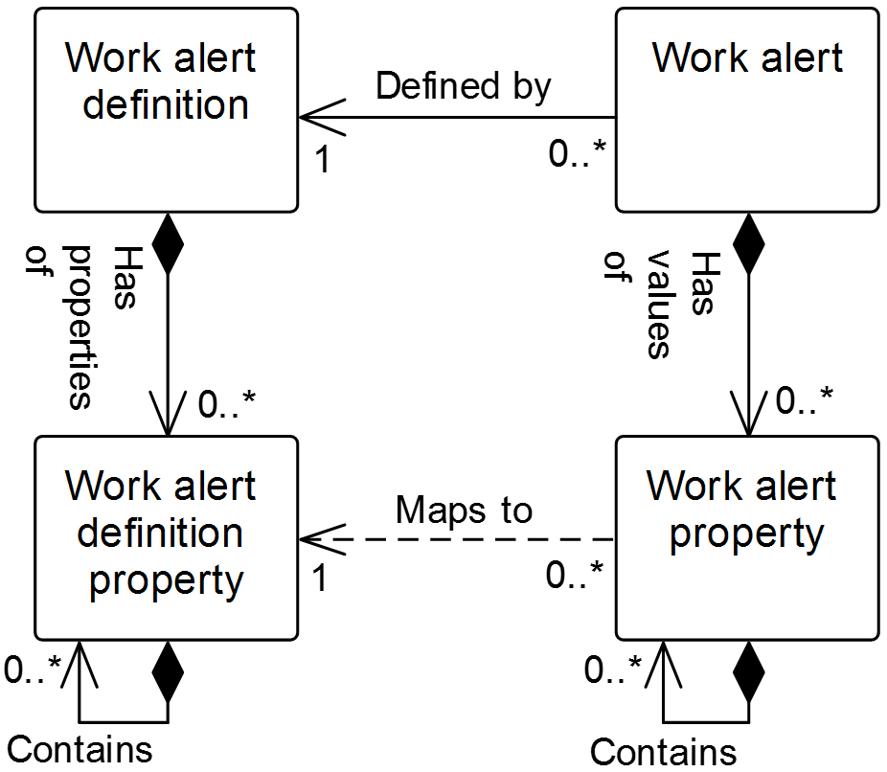

Figure 17 – Work alert model

Table 76 – Work alert model relationships

| From | To | Type | Relationship Name |
| --- | --- | --- | --- |
| Work alert definition | Work alert definition property | Composition whole | Has properties of |
| Work alert definition property | Work alert definition property | Composition hierarchy | Contains |
| Work alert | Work alert definition | Association | Defined by |
| Work alert | Work alert property | Composition whole | Has values of |
| Work alert property | Work alert definition property | Dependency | Maps to |
| Work alert definition property | Work alert definition property | Composition hierarchy | Contains |
| Work alert property | Work alert property | Composition hierarchy | Contains |

## Work alert definition

Table 77 lists the relationship roles of the *work alert definition.*

Table 78 lists the attributes of the *work alert definition.*

Table 77 – Work alert definition relationship roles

| Related Object | Role | Multiplicity | Relationship Name | Description |
| --- | --- | --- | --- | --- |
| Work alert | NA | 0..* | Defined by | The *work alert(s)* defined by this *work alert definition.* |
| Work alert definition property | Work alert definition property | 0..* | Has properties of | The *work alert definition properties* that are part of this *work alert definition.* These properties are supported by *work alerts* defined by the *work alert definition.* |

Table 78 – Work alert definition attributes

| Attribute name | Description | Production examples | Maintenance examples | Quality examples | Inventory examples |
| --- | --- | --- | --- | --- | --- |
| ID | Unique identification of the *work alert definition*.  Required attribute. | P_0004293 | M32D | 834 | Inven88 |
| Description | Contains additional information and descriptions of the *work alert definition*. | Notification of job order started | Reminder that PM is overdue | Test setup complete | Shipment arrived |
| Hierarchy scope | Identifies where the exchanged information fits within the role based equipment hierarchy. | East Wing manufacturing line #2 | CNC Machine  Asset ID 13465 | Test cell 4  Receiving | Warehouse B |
| Priority | List of the priorities that act as a guide to the relative level of importance of a *work alert.* | {1,2,3} | {Low, Medium, High} | {Information, Error} | {1..10} |
| Category | General grouping associated with a *work alert definition*. | Scheduling | PM | Lab | Receiving |

## Work alert definition property

The *work* *alert definition property* shall be defined as property on a *work alert definition property*.

A *work alert definition property* may contain nested *work alert definition property(s)*.

Table 79 lists the relationship roles of the *work alert definition property.*

Table 80 lists the attributes of the *work alert definition property.*

Table 79 – Work alert definition property relationship roles

| Related Object | Role | Multiplicity | Relationship Name | Description |
| --- | --- | --- | --- | --- |
| Work alert definition | NA | 1 | Has properties of | The *work alert definition* defined in part by this *work alert definition property.* |
| Work alert property | NA | 0..* | Maps to | If the parent *work alert* supports a *work alert definition*, this *work alert definition property(s)* is applied in the *work alert property(s)*.  The *work alert property* maps to this corresponding *work alert definition property.* |
| Work alert definition property | Work alert definition property child | 0..* | Contains | The child *work alert definition properties* of this *work alert definition property*. |

Table 80 – Work alert definition property attributes

| Attribute name | Description | Production examples | Maintenance examples | Quality examples | Inventory examples |
| --- | --- | --- | --- | --- | --- |
| ID | An identification of the specific property, unique under the scope of the parent *work alert definition* object.  Required attribute. | Job order ID | Physical asset ID | Test ID | Quantity |
| Description | Additional information and description about the *work alert definition property.* | Identification of the associated job order | Identification of the equipment to be maintained | Identification of the test type | Quantity of material received |
| Value | The value, set of values, or range of the property.  This presents a range of possible numeric values, a list of possible values, or it may be empty if any value is valid. | Not applicable | Not applicable | 0..99999 | 0..20000 |
| Value unit of measure | The unit of measure of the associated property values. | Not applicable | Not applicable | Not applicable | Kg |

EXAMPLE Possible properties for *work alerts* are shown in Table 85:

Table 81 – Examples of work alert properties

|  |  |
| --- | --- |
| Property | Description |
| Asset key | A unique data source identifier of the asset associated with the alert |
| Help | Text to provide additional information about the alert and may include information about the cause of the problem and suggestions on how to fix the problem |

## Work alert

Table 82 lists the relationship roles of the *work alert.*

Table 83 lists the attributes of the *work alert.*

Table 82 – Work alert relationship roles

| Related Object | Role | Multiplicity | Relationship Name | Description |
| --- | --- | --- | --- | --- |
| Work alert definition | Work alert definition | 1 | Defined by | The *work definition* definingthis *work alert.* |
| Work alert property | Work alert property | 0..* | Has values of | This *work alert property(s)* defined in part by the *work alert property(s).* |

Table 83 – Work alert attributes

| Attribute name | Description | Production examples | Maintenance examples | Quality examples | Inventory examples |
| --- | --- | --- | --- | --- | --- |
| ID | Unique identification of the *work alert.*  Required attribute. | 49293847523 | M-53A | ER4232 | INV-FG |
| Message text | Textual content of the *work alert.* | Vacuum gas unit switched to feedstock ABC | Overdue PM on compressor 105, WO # 2843 | Test #88765 ready | Material arrived |
| Timestamp | Timestamp the *work alert* was generated. | Mon August 16 at 01:36 PM | 2014-03-07 10:00 UTC | 2010-04-27 10:30 | 2011-01-20 14:45 UTC-10:00 |
| Hierarchy scope | Identifies where the exchanged information fits within the role based equipment hierarchy. | East Wing manufacturing line #2 | CNC Machine  Asset ID 13465 | Test cell 4  Receiving | Warehouse B |
| Priority | Guide to the relative level of importance of the value for the *work alert.*  NOTE 1  No standard priority types are defined in this standard. | 1 | Medium | Informational | 8 |
| Category | General grouping associated with a *work alert.*  NOTE 2  No standard categories are defined in this standard. | Scheduling | PM | Lab | Receiving |

## Work alert property

The *work alert property* shall be defined as property on a *work alert property.*

A *work alert property* may contain nested *work alert property(s)*.

Table 84 lists the relationship roles of the *work alert property.*

Table 85 lists the attributes of the *work alert.*

Table 84 – Work alert property relationship roles

| Related Object | Role | Multiplicity | Relationship Name | Description |
| --- | --- | --- | --- | --- |
| Work alert definition property | Work alert definition property | 1 | Maps to | If the parent *work alert* supports *a work alert definition*, the *work alert definition property(s)* is applied in this *work alert property(s)*.  This *work alert property* maps to the corresponding *work alert definition property*. |
| Work alert | NA | 1 | Has values of | The *work alert(s) defined in part by* this *work alert property*. |
| Work alert property | Work alert property child | 0..* | Contains | The child *work alert properties* of this *work alert property*. |

Table 85 – Work alert property attributes

| Attribute name | Description | Production examples | Maintenance examples | Quality examples | Inventory examples |
| --- | --- | --- | --- | --- | --- |
| ID | An identification of the specific *work alert property*.  Required attribute. | Job order ID | Physical asset ID | Test ID | Quantity of material received |
| Description | Additional information about the *work alert property*. | On time switch over | Scheduled maintenance | Test ready | Not applicable |
| Value | The value, set of values, or range of the property. | 99387A | 105 | 88765 | 1856 |
| Value unit of measure | The unit of measure of the associated property value. | Not applicable | Not applicable | Not applicable | Kg |

# Work calendar information

## Work calendar model

*Work calendar definitions* define a set of rules that specify specific calendar entries, along with repeat rules, duration, starting and ending dates and times for the entries. The entries can be used to generate a *work calendar*, which is a calendar of specific entries for specific dates (and times).

The work calendar model defines an exchange format for exchanging the rules (*work calendar definition*) or a calendar with specific dates (*work calendar*).

EXAMPLE The information of the *work calendar* can be used for different purposes:

* assigning *personnel* to different shifts and track their work time compared to the assigned shifts;
* use work calendar information in order to correctly calculate and track *operations performance*;
* use work calendar information for detailed operations scheduling;
* determine planned production and non-production times for *equipment* that is used for *operations* *performance* calculations;
* account work hours for *personnel*; and
* compare actual production time with planned production times.

NOTE *Work calendar definitions* and *work calendars* can represent time periods of different dimensions:

* work / non-work time definition: hours or minutes;
* shift definition: day or shifts;
* work day Definition: days or day;
* pattern: months or weeks; and
* work shift calendar: years or months.

Figure 18 is the model for *work calendar definitions* and *work calendars*. Table 89 lists the relationships of the objects in the work calendar model.

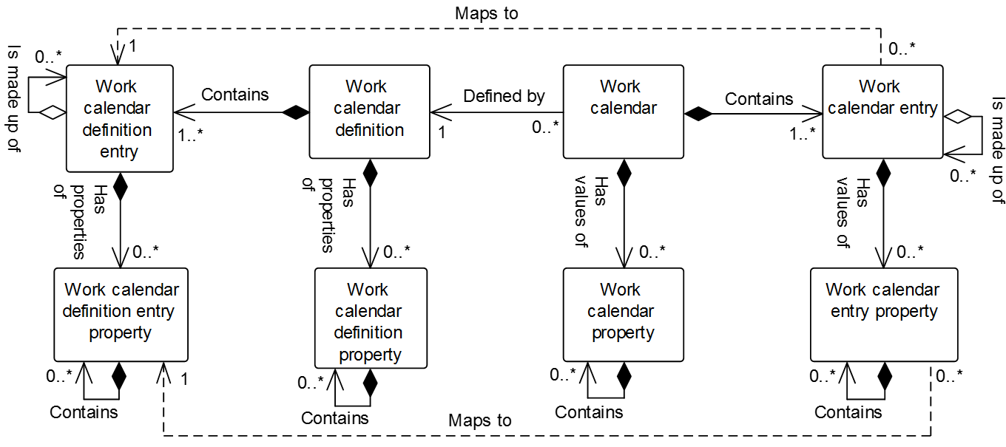

Figure 18 – Work calendar model

Table 86 – Work calendar model relationships

| From | To | Type | Relationship Name |
| --- | --- | --- | --- |
| Work calendar definition | Work calendar definition entry | Composition whole | Contains |
| Work calendar definition | Work calendar definition property | Composition whole | Has properties of |
| Work calendar definition property | Work calendar definition property | Composition hierarchy | Contains |
| Work calendar definition entry | Work calendar definition entry property | Composition whole | Has properties of |
| Work calendar definition entry | Work calendar definition entry | Aggregation hierarchy | Is made up of |
| Work calendar definition entry property | Work calendar definition entry property | Composition hierarchy | Contains |
| Work calendar entry | Work calendar definition entry | Dependency | Maps to |
| Work calendar | Work calendar entry | Composition whole | Contains |
| Work calendar | Work calendar property | Composition whole | Has values of |
| Work calendar property | Work calendar property | Composition hierarchy | Contains |
| Work calendar entry | Work calendar entry property | Composition whole | Has values of |
| Work calendar entry | Work calendar entry | Aggregation hierarchy | Is made up of |
| Work calendar entry property | Work calendar entry property | Composition hierarchy | Contains |
| Work calendar entry property | Work calendar definition entry property | Dependency | Maps to |

## Work calendar definition

The *work calendar definition* shall be defined as a collection of *work calendar definition entries*.

Table 87 lists the relationship roles of the *work calendar definition.*

Table 88 lists the attributes of the *work calendar definition.*

Table 87 – Work calendar definition relationship roles

| Related Object | Role | Multiplicity | Relationship Name | Description |
| --- | --- | --- | --- | --- |
| Work calendar definition entry | Work calendar definition entry | 1..* | Contains | The *work calendar definition entry(s)* that are part of this *work calendar definition.* |
| Work calendar | NA | 0..* | Defined by | The *work calendar(s)* defined by this *work calendar definition.* |
| Work calendar definition property | Work calendar definition property | 0..* | Has properties of | This *work calendar definition* defined in part bythe *work calendar definition property(s)*. |

Table 88 – Work calendar definition attributes

| Attribute name | Description | Production examples | Maintenance examples | Quality examples | Inventory examples |
| --- | --- | --- | --- | --- | --- |
| ID | An identification of the specific *work calendar definition*.  Required attribute. | 7 days | Maintenance | Quality env check | 3 shifts |
| Description | Additional information about the *work calendar definition*. | 7-day fortnight shift pattern | Weekly maintenance | Periodic environmental quality checks | 3-shift pattern |
| Hierarchy scope | Identifies where the exchanged information fits within the role based equipment hierarchy. | East Wing manufacturing line #2 | CNC Machine  Asset ID 13465 | Test cell 4  Receiving | Warehouse B |

## Work calendar definition property

The *work calendar definition property* shall be defined as property on a *work calendar definition property*.

A *work calendar definition property* may contain nested *work calendar definition property(s)*.

Table 89 defines the relationship roles for *work calendar definition property* objects.

Table 90 defines the attributes for *work calendar definition property* objects.

Table 89 – Work calendar definition property relationship roles

| Related Object | Role | Multiplicity | Relationship Name | Description |
| --- | --- | --- | --- | --- |
| Work calendar definition | N/A | 1 | Has properties of | The *work calendar definition* defined in part bythis *work calendar definition property(s)*. |
| Work calendar definition property | Work calendar definition property child | 0..* | Contains | The *work calendar definition properties* of this *work calendar definition property*. |

Table 90 – Work calendar definition property attributes

| Attribute name | Description | Examples |
| --- | --- | --- |
| ID | A unique identification of the property.  Required attribute. | Approver |
| Description | Additional information about the property. | The approver of the work calendar definition. |
| Value | The default value, set of values, or range of the property. | Stephen Smith |
| Value unit of measure | The unit of measure of the associated property value. | n/a |

## Work calendar definition entry

The *work calendar* shall be defined as a set of start, duration, and recurrence rules that can be used to create *work calendar entries* of a specific type.

A *work calendar definition entry* may be made up of zero or more nested *work calendar definition entries*.

Table 91 lists the relationship roles of the *work* *calendar definition entry.*

Table 92 lists the attributes of the *work* *calendar definition entry.*

Table 91 – Work calendar definition entry relationship roles

| Related Object | Role | Multiplicity | Relationship Name | Description |
| --- | --- | --- | --- | --- |
| Work calendar definition | NA | 1 | Contains | The w*ork calendar definition* defined in part by this w*ork calendar definition entry*. |
| Work calendar definition entry | Work calendar definition entry child | 0..* | Is made up of | The related object(s) makes up part of this *work calendar definition entry* as the whole. |
| Work calendar entry | Work calendar entry | 0..* | Maps to | This *work calendar definition entry defines in part* the *work calendar entry(s).* |
| Work calendar definition entry property | Work calendar definition entry property | 0..* | Has properties of | The *work calendar definition entry property(s)* defines in part this *work calendar definition entry.* |

Table 92 – Work calendar definition entry attributes

| Attribute name | Description | Examples |
| --- | --- | --- |
| ID | An identification of the specific *work calendar definition entry*.  Required attribute. | 123 |
| Description | Additional information about the *work calendar definition entry*. | Drop New Year’s ball |
| Start rule | Defines the starting date and time for the *work calendar definition entry* in ISO 8601 format for a date and time.  The Start Rule may include an ending time, following ISO 8601 format for a time interval. | 2014-01-01T00:00/2114-12-31T00:00:00 |
| Recurrence time interval rule | Defines the rule for recurrence of the entry in ISO 8601 format for recurrences. | R/P1Y |
| Duration rule | Defines the duration of the *work calendar definition entry* in ISO 8601 format for durations. | PT24H |
| Entry type | Defines the type of *work calendar definition entry.* There are no standard entry types defined. | Work shift  Bank holiday  Plant shutdown |

The *start rule* in a *work calendar definition entry* shall be defined in ISO 8601 format for a date and time.

EXAMPLE 1 2014-05-01.

The *start rule* may include an ending time, following ISO 8601 format for a time interval.

EXAMPLE 2 2014-05-01/2015-06-01.

The *recurrence time interval rule* in a *work calendar definition entry* shall be defined in ISO 8601 format for recurrences.

EXAMPLE 3 R2M15D – Recurrence every 2 months and 15 days.

The *duration rule* in a *work calendar definition entry* shall be defined in ISO 8601 format for durations.

EXAMPLE 4 PT15H – 15 hours.

## Work calendar definition entry property

The *work calendar definition entry property* shall be defined as property on a *work calendar definition entry*.

A *work calendar definition entry property* may contain nested *work calendar definition entry property(s)*.

Table 93 lists the relationship roles of the *work* *calendar definition entry property.*

Table 94 lists the attributes of the *work* *calendar definition entry property.*

Table 93 – Work calendar definition entry property relationship roles

| Related Object | Role | Multiplicity | Description |
| --- | --- | --- | --- |
| Work calendar definition entry | NA | 1 | The *work calendar definition entry* defined in part by this *work calendar definition entry property*. |
| Work calendar entry property | N/A | 0..* | The *work calendar entry properties* mapping to this *work calendar definition entry property*. |
| Work calendar definition entry property | Work calendar definition entry property child | 0..* | The *work calendar definition entry properties* of this *work calendar definition entry property*. |

Table 94 – Work calendar definition entry property attributes

| Attribute name | Description |
| --- | --- |
| ID | A unique identification of the property. Required attribute. |
| Description | Additional information about the property. |
| Value | The default value, set of values, or range of the property. |
| Value unit of measure | The unit of measure of the associated property value. |

## Work calendar

The *work calendar* shall be defined as a collection of *work calendar entries*.

Table 95 lists the relationship roles of the *work calendar.*

Table 96 lists the attributes of the *work calendar.*

Table 95 – Work calendar relationship roles

| Related Object | Role | Multiplicity | Description |
| --- | --- | --- | --- |
| Work calendar entry | Work calendar entry | 1..* | The *work calendar entry(s)* that are part of this *work calendar.* |
| Work calendar definition | Work calendar definition | 1 | The *work calendar definition* defines this *work calendar.* |
| Work calendar property | Work calendar property | 0..* | This *work calendar* is defined in part  bythe *work calendar definition property(s)*. |

Table 96 – Work calendar attributes

| Attribute name | Description | Production examples | Maintenance examples | Quality examples | Inventory examples |
| --- | --- | --- | --- | --- | --- |
| ID | An identification of the specific *work calendar*.  Required attribute. | First shift | Planned shutdowns | Reagent order | Tank transfers |
| Description | Additional information about the *work calendar*. | Definition of the first shift with holidays | Planned shutdowns for next year | Schedule to order reagents | Tank transfer calendar |
| Hierarchy scope | Identifies where the exchanged information fits within the role based equipment hierarchy. | East Wing manufacturing line #2 | CNC Machine  Asset ID 13465 | Test cell 4  Receiving | Warehouse B |

## Work calendar property

The *work calendar property* shall be defined as property on a *work definition property*.

A *work calendar property* may contain nested *work calendar property(s)*.

Table 97 defines the relationship roles for *work calendar property* objects.

Table 98 defines the attributes for *work calendar property* objects.

Table 97 – Work calendar property relationship roles

| Related Object | Role | Multiplicity | Description |
| --- | --- | --- | --- |
| Work calendar | NA | 1 | The *work calendar* defined in part bythis *work calendar definition property(s)*. |
| Work calendar property | Work calendar property child | 0..* | The *work calendar property(s)* contained in this *work calendar property*. |

Table 98 – Work calendar property attributes

| Attribute name | Description | Examples |
| --- | --- | --- |
| ID | A unique identification of the property. Required attribute. | Approver |
| Description | Additional information about the property. | The approver of the work calendar. |
| Value | The default value, set of values, or range of the property. | Stephen Smith |
| Value unit of measure | The unit of measure of the associated property value. | n/a |

## Work calendar entry

The *work calendar entry* shall be defined as a calendar entry with a start date and time, a finish date and time, and an entry type.

A *work calendar entry* may be made up of zero or more nested *work calendar entries*.

Table 99 lists the relationship roles of the *work calendar entry.*

Table 100 lists the attributes of the *work calendar entry.*

Table 99 – Work calendar entry relationship roles

| Related Object | Role | Multiplicity | Description |
| --- | --- | --- | --- |
| Work calendar | NA | 1 | The *work calendar* defined in part by this work calendar entry*,* |
| Work calendar entry | Work calendar entry child | 0..* | The *work calendar entry(s)* makes up part of this *work calendar entry* as the whole. . |
| Work calendar definition entry | Work calendar definition entry | 1 | The *work calendar definition entry* that defines this *work calendar entry.* |
| Work calendar entry property | Work calendar entry property | 0..* | The *work calendar entry property(s)* in part defines this *work calendar entry.* |

Table 100 – Work calendar entry attributes

| Attribute name | Description | Examples |
| --- | --- | --- |
| ID | An identification of the specific *calendar entry*.  Required attribute. | 001 |
| Description | Additional information about the *calendar entry*. | May ;;Day Holiday |
| Start date time | Defines the starting date and time of the *work calendar entry.* | 2014-05-01T00H00M00S |
| Finish date time | Defines the ending date and time of the *work calendar entry.* | 2014-05-01T23H59M59S |
| Entry type | Defines the type of *work calendar entry.* There are no standard entry types defined. | Work shift  Bank holiday  Plant shutdown |

## Work calendar entry property

The *work calendar entry property* shall be defined as a property on a *work calendar entry*.

A *work calendar entry property* may contain nested *work calendar entry property(s)*.

Table 101 lists the relationship roles of the *work calendar entry property.*

Table 102 lists the attributes of the *work calendar entry property.*

Table 101 – Work calendar entry property relationship roles

| Related Object | Role | Multiplicity | Description |
| --- | --- | --- | --- |
| Work calendar entry | NA | 1 | The *work calendar entry* defined in part by this *work calendar entry property*. |
| Work calendar definition entry property | Work calendar definition entry property | 1 | The *work calendar entry definition property* to which this *work calendar entry property* maps. |
| Work calendar entry property | Work calendar entry property child | 0..* | The *work calendar entry properties* of this *work calendar entry property*. |

Table 102 – Work calendar entry property attributes

| Attribute name | Description |
| --- | --- |
| ID | A unique identification of the property. Required attribute. |
| Description | Additional information about the property. |
| Value | The default value, set of values, or range of the property. |
| Value unit of measure | The unit of measure of the associated property value. |

# Documents for the scheduling, execution and reporting of work

In manufacturing operations management, it is often necessary to manage work documents as resources necessary to perform specific units of work, like other resources already addressed in this standard.

Work documents should be represented as materials when documents are considered a resource necessary to perform a unit of work.

NOTE 1 Documents are mentioned as a resource in Part 1 of this standard, Clause 5.2.4.2:

“The MOM domain shall include the functionality of managing resources directly associated with control and manufacturing. The resources in the MOM domain include *personnel, equipment,* and *material*, as well as other entities, such as documents, that are required for work to start and to be completed. The management of these resources can include local resource reservation to meet production-scheduling objectives.”

NOTE 2 Documentation is mentioned as a resource in Part 3 of this standard, Clause 7.5:

“Maintenance resource management shall be defined as the collection of activities that manage the information about the state of the resources and relationships between resources used within the domain of control of maintenance. The managed resources can include maintenance equipment, maintenance tools, personnel (with skill sets), documentation and material and energy used in maintenance.”

NOTE 3 Work documents can represent any kind of media, e.g., paper, electronic file, etc.

The work documents discussed in this part of this standard are limited to the documents required for operations.

NOTE 4 *Work masters* and *work performance* can contain references to the work documents.

EXAMPLE Work documents that can need to be managed include

* equipment or system drawings,
* SOPs,
* engineering documentation,
* manuals, and
* instructions.

# Work record information

## Operations record model (abstract)

The operations record model is shown in Figure 19 is specified in Part 2 of this standard. The *operations record template* and *operations record specification template* are abstract types that are not standalone exchange objects. These abstract objects are realized in specialized implementations as occurrences of the *operations event record* in Part 2 and the *work record* in Part 4 of this standard. The operations record model represents a common structure for representing bundled information reported in data exchanges. The *operations record template* bundles *operations record entry template* objects by the type of action in the action attribute with defined values of created, changed, deleted and observed. The *operations record entry template* embeds objects defined in this standard and manufacturing operations profiles or references to external objects. The *operations record specification template* specifies the content and form of objects in an *operations record* within the associated *operations record entry template(s).*

NOTE 1 In an implementation, the *operations record entry template* can be validated against the *operations record specification template*.

Table 103 lists the relationships of the objects in the operations record model.

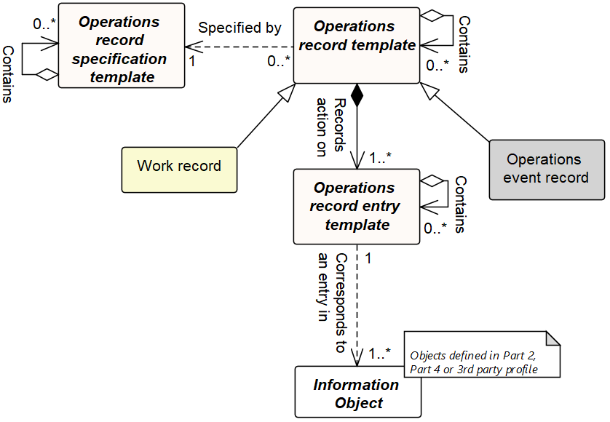

Figure 19 – Operations record model (abstract)

NOTE 2 The object color convention used in the Part 2 and Part 4 UML diagrams for information models is as shown in Clause 3.3.3.

Table 103 – Operations record model relationships

| From | To | Type | Relationship Name |
| --- | --- | --- | --- |
| Operations record template | Operations record specification template | Dependency | Specified by |
| Operations record template | Operations record entry template | Composition | Records action on |
| Operations record entry template | Information object | Dependency | Corresponds to an entry in |
| Operations record template | Operations record template | Aggregation hierarchy | Contains |
| Operations record specification template | Operations record specification template | Aggregation hierarchy | Contains |
| Operations record entry template | Operations record entry template | Aggregation hierarchy | Contains |

## Work record information, an operations record specialization

A work record model is a specialization of the operations record model as defined in Part 2 of this standard. The *work record* shall be defined as a subset of the execution and business information that is retained based upon business requirements identified by a *work record specification*. A *record* consists of data about the manufacture of the product plus all supporting data required to meet the business requirements of the record.

NOTE 1 This information could include the workflow execution information, both specific equipment information, operator comments, alarms, elements related to the definition of a job (such as *work masters*, *work directives*, *work schedule* information), and information important to the operation (such as training logs, maintenance records, and environmental conditions).

NOTE 2 *Work performance* can contain information to a specific set of *job orders*. *Work records* can contain information about multiple *job orders* and information not directly related to any specific *job order*. A *work record* can contain a *work performance* (or *work response*). Generally, a *work performance* is the response to performing the work specified in a *work schedule*. A *work record* contains additional details of all activities involved in operations.

*Work records* are intended to provide a vendor-neutral representation of information in a form suitable for archiving and storage. Figure 20 illustrates the activities and information associated with creating, maintaining, and using *work records*. Only the *work record* and *work record specification* (the white boxes) is defined in this standard; the activities and other information sets (the gray boxes and activities) are shown to illustrate the environment of *work records*. There is an activity of creating *work records*, which uses operations information, usually from multiple sources and in multiple forms and formats which uses a specification of the information to be used to create the *work record*. There is an activity which uses *work records* and work record report specifications to generate work record reports that are suitable for print or display. The work record report specification uses the *work record specification* to identify the data contained in the work record report.

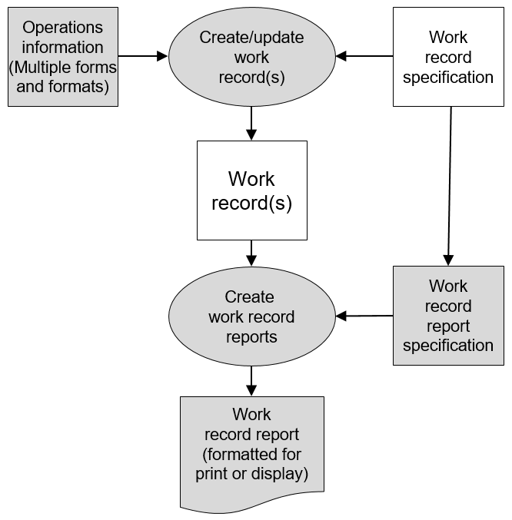

Figure 20 – Work record activities

*A work record specification* is the information that is intended to be used to define a *work record*. The content and format for *work record specifications*.

A *work record report specification* is the information that is intended to be used to define a *work record report.* The *work record report specification* uses the *work record specification* to identify the objects to be reported*.* The content and format for *work record report specifications* are not defined in this part of this standard.

## Work record specification

Specification of the allowed content of *work record* objects shall be defined as *work record specifications*.

*Information object* contents in the *work record* vary depending on the process context of the *work*. The *work record specification* describes and specifies the *information objects* and associated *actions* that are allowed in the *work record* occurrence. The publisher/sender shall follow this specification to construct the message. Subscribers/receivers shall use the *work record specification* to validate the content of the message.

Table 104 defines the relationship roles for the *work record specification*.

Table 105 defines the attributes for the *work record specification*.

Table 119 in Part 2 of this standard, Operations record specification template attributes, are the abstract type definitions that define the attributes for the work record specification.

Table 104 – Work record specification relationship roles

| Related Object | Role | Multiplicity | Relationship Name | Description |
| --- | --- | --- | --- | --- |
| Work record | NA | 0..* | Specified by | The *work record* maps to this corresponding *work record specification.*  Allowed content in the *work record* is defined by this *work record specification.* |
| Work record specification | Work record specification child | 0..* | Contains | This parent *work record specification* is whole of the child *work record specification(s)* as the part. |

Table 105 – Work record specification attributes

| Attribute name | Description | Production examples | Maintenance examples | Quality examples | Inventory examples |
| --- | --- | --- | --- | --- | --- |
| ID | Identification within the associated *work record* *specification*.  Required attribute.  *Work record* instances include this value with their *work record* object to enable recognition / validation of the message contents. | CR-87 | Uuid - 1FCF9DA1-DCC5-4012-BDEF-D76C754F4826 | 2016-03 | AB45 |
| Description | Contains additional information and description of the *work record specification*. |  |  |  |  |
| Information object type | Permitted set of information objectsallowed in the *work* *record* occurrence.  A *work record entry* contains the attributes to the information object for *work record.*  NOTE 1  An unconstrained set of values can be represented with the * entry. | [Equipment, Personnel], | [JobList] | [TestSpecfication, Test Results] | [MaterialLot, MaterialSublot], |
| Information object type multiplicity | The range of the information object(s) in *work record entry* allowed in the *work record* occurrence.  If no limit is explicitly specified, the unbounded keyword is specified.  If no *multiplicity* entry is specified, this is equivalent to no constraint.  EXAMPLE 1  Min: 0, Max: Unbounded | {Min: 1, Max: 1} | {Min:0, Max: 1} | {Min:0, Max: 10} | {Min:1, Max: Unbounded} |
| Action | The permitted set of *actions* applied to the *work record entry* *object* in the *work s record* by the publisher.  Defined values for *action* are   * added, * changed, * deleted, and * observed.   If no *action* is specified, this is equivalent to all *actions* being allowed. | Added, Deleted, Changed, Observed | Changed | Added, Deleted, Changed | Added |
| Action multiplicity | The range of *actions* allowed to be represented in the *work record* occurrence.  If no limit is explicitly specified, the unbounded keyword is specified.  If no *multiplicity* entry is specified, this is equivalent to no constraint.  EXAMPLE 2  Min: 0, Max: Unbounded. | {Min: 1, Max: 1} | {Min:0, Max: 1} | {Min:0, Max: 10} | {Min:1, Max: Unbounded} |

The number of *Information object* occurrences allowed in the *work record entry* occurrences is specified using the *information object multiplicity* attribute. The number of *actions* allowed for each *information object* is represented using the *action* *multiplicity* attribute. Each *work record* represents a single *action*. A *work record specification* may manage the contents of multiple *work records* in an occurrence.

NOTE 2 The ID entries can use the fully qualified name (FQN) syntax to avoid ID collisions.

Annex F describes the specification of ISA-88 batch production record information in a *work record*.

## Work record model

The work record model is shown in Figure 21. The work record model specializes the operations record model to represent to information required to represent a *work record*.

The attributes and relationships for the *work record* include the attributes of the abstract *operations record template*. Similarly, the *work record specification* attributes include the attributes of the abstract *operations record specification template*. Table 106 lists the relationships of the objects in the work record model.

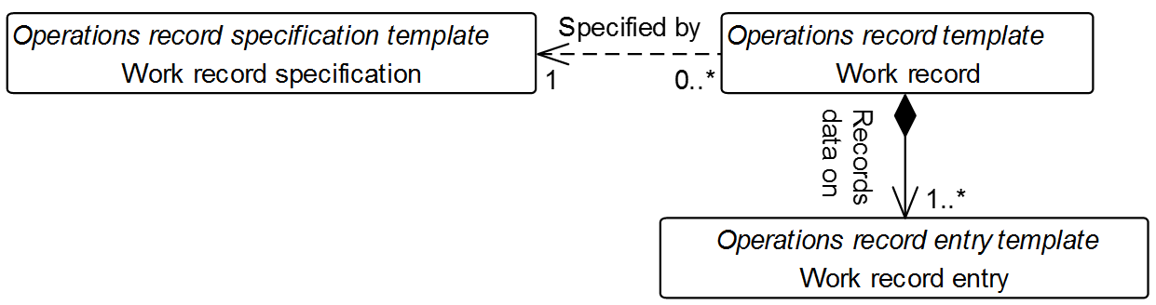

Figure 21 – Work record model

The operations record specification template, operations record template and operations record entry template in italics in Figure 21 are the abstract objects that each object is derived.

Table 106 – Work record model relationships

| From | To | Type | Relationship Name |
| --- | --- | --- | --- |
| Work record | Work record entry | Composition | Records action on |
| Work record | Work record specification | Association | Specified by |
| Work record entry | Information object  (Defined in Part 2) | Dependency | Corresponds to an entry in |
| Work record | Work record | Aggregation hierarchy | Contains |
| Work record specification | Work record specification | Aggregation hierarchy | Contains |
| Work record entry | Work record entry | Aggregation hierarchy | Contains |

The dependency relationship to *information object’s* aggregation hierarchy relationship is not shown in Figure 21 and defined in Part 2 of this standard as part of the operations record model. They are inherited by the specialized instances and not shown in the work record model.

## Work record

A *work record* is defined with its corresponding *work record specification* to represent the combination of objects that are considered relevant to the work being documented.

Table 107 defines the relationship roles for the *work record*.

Table 108 defines the attributes for the *work record*.

The bundle of *work record entr*y *template* objects that are pertinent to the work record information shall be defined as *work records*.

Table 107 – Work record relationship roles

| Related Object | Role | Multiplicity | Relationship Name | Description |
| --- | --- | --- | --- | --- |
| Work record entry | Work record entry | 1..* | Records action on | This *work record* acts as a container for *work record entry (s)* applying a common action attribute for each *work record*. |
| Work record specification | Work record specification | 1 | Specified by | The *work record specification* defines the *information object(s)* allowed to be contained within a *work record entry* in this *work record*. The specified action must match the value in the attribute, action, in this *work record*. |
| Work record | Work record child | 0..* | Contains | This parent *work record* is whole of the child *work record(s)* as the part. |

Table 108 – Work record attributes

| Name | Description | Examples |
| --- | --- | --- |
| ID | A unique identification of the *work record*. This attribute is mandatory.  Required attribute.  The ID is required to provide a *batch production record* per Part 4 of ISA-88 with a unique identity. The ID attribute may be modified over the lifecycle of a *work record*, although it shall not be completely removed. | 492-2931  T59482A4  456 |
| Description | Additional information about the *work record*. | Lot Release  Campaign costing  Compliance  Material tracking data |
| Hierarchy scope | Identifies where the exchanged information fits within the role based equipment hierarchy.  Optionally, hierarchy scope defines the scope of the *person* definition. | South Shore (Site) / Work Line (Area) |
| Creation date | The date of the *work record* was created. | 2003-07-14 1454+0100  01 March 2004 14:25 UTC  April 23, 2002 8:30 AM ET |
| Last changed date | The date of the *work record* was last changed. | 2003-07-14 1454+0100  01 March 2004 14:25 UTC  April 23, 2002 8:30 AM ET |
| Change indication | An indication enabling detection that the *work record* has not been altered.  Also, the change indication enables detection that a *work record* has been altered, although may not identify the specific alterations.  EXAMPLE 1  A string generated by an MD5 algorithm used as a hashing algorithm.  EXAMPLE 2  A string representing a digital key of the entire batch production record.  EXAMPLE 3  A string representing a checksum of the entire batch production record. | E;4J9QJG;RGJAOF0  FKG9GRKGH44FF  KRJG49TJHVSNS |
| Record status | Current status of the *work record*. This reflects the current position in a *work record*’s lifecycle.  NOTE  This standard does not define standard status values. | In Process  Review  Approved |
| Expiration date | Date and time at which the *work record* is no longer relevant. | 2003-07-14 1454+0100  01 March 2004 14:25 UTC  April 23, 2002 8:30 AM ET |
| Version | The current version of the *work record*. | 1.0  11  T |
| Campaign ID | The list of IDs of the campaigns associated with the *work record*. | C4293  923-AKW5.7  832 |
| Lot ID | The list of IDs of the lots associated with the *work record*.  This is a roll up of detailed information about produced and consumed *material lots* that are included in other *work record* entries. | L492840  EOVMW2  84293 |
| Batch ID | The list of IDs of the batches associated with the *work record*.  This is a roll up of detailed information about produced and consumed *material lots* that are included in other *work record* entries. | 59429-35  B-000349  200309041435 |
| Material definition ID | The list of IDs of the products associated with the *work record*.  This is a roll up of detailed information about produced and consumed *material lots* that are included in other *work record* entries. | 459293A1  A4Q59492-5942.1  Polymer56 |
| Equipment ID | The list of *equipment* associated with *work record*.  This is a roll up of detailed information that may be included in other *work record* entries. | Reactor1  Tank 402 |
| Delimiter | Defines the character set to be used in delimiting elements in *equipment IDs* and procedural element reference. | “|”  “/t” |
| Language | The language used in the *work record* should be identified. If multiple languages are used, the primary language should be identified here, and each instance where other languages are used throughout the batch production record a local reference to the language should be made. | English  Spanish  French  Korean |

## Work record entry

The *work record entry* objectshall be a single *information object* as an object defined in Part 2 and Part 4, and any third-party manufacturing operations message profile within an *operations record* *template*. There shall be one or more *work record entry* objectsin a *work* *record*.

EXAMPLE 1 *Work schedule* and *material lot* as *information objects* require two *work record entry* objects in a *work record*.

Table 109 defines the relationship roles for *work record entry*.

Table 110 defines the attributes for *work record entry*.

Table 109 – Work record entry relationships

| Related Object | Role | Multiplicity | Relationship Name | Description |
| --- | --- | --- | --- | --- |
| Operations record template | NA | 1 | Records action on | The *operations record template* applying a single common action (e.g. changed) acts as a container for this work record *entry(s)*. |
| work record entry | Work record entry child | 0..* | Contains | This parent *work record entry* is whole of the child *work record entry(s)* as the part. |
| Information object | Information object | 0..1 | Corresponds to an entry in | An embedded *information object*  If data is referenced in this *work record entry*, the attribute is not used.  The format of the *information object* is specified in the *work record specification.* |
| Information object | External reference | 0..1 | Corresponds to an entry in | The reference to external data *(information object)* which is stored external to this *work record entry*.  If data is embedded in this *work record entry*, the attribute is not used.  The format of the reference is specified in the *work record specification*. |

The relationships and their roles in a *work record entry* are defined in the *work record specification.*

Table 110 – Work record entry attributes

| Attribute name | Description | Production examples | Maintenance examples | Quality examples | Inventory examples |
| --- | --- | --- | --- | --- | --- |
| ID | ID is unique within the scope of *work record entry.*  Required attribute. | 1 | 4A34B | 239432 | A11 |
| Description | Additional information about the *work record entry*. | The control recipe is embedded in this *operations record* *template.* |  |  | Data set time series data is stored in the historian database |
| Information object | An embedded *information object*  If data is referenced in this *work record entry*, the attribute is not used.  The format of the *information object* is specified in this *work record specification*. | Material Lot 11A | Mixer 4 | Work Master QC5001 | Material Lot 59B |
| Information object ID | The reference to external data *(information object)* which is stored external to this *work record entry*.  If data is embedded in this *work record entry,* the attribute is not used.  The format of the reference is specified in this *work record specification*. | Material Lot 11A | Mixer 4 | Work Master QC5001 | Material Lot 59B |
| Effective timestamp | The date and time that the *work record entry* was/is effective.  If no effective timestamp is provided with *work record entry*, the effective timestamp is represented by the effective timestamp attribute in the *work record*. | Mon August 15 at 01:36 PM | 2014-03-06 11:00 UTC | 2010-04-26 10:30 | 2011-01-20 12:45 UTC-10 |
| Record timestamp | The date and time the publisher recorded / transacted the action.  If no entry is provided, the record timestamp is the record timestamp attribute in the *work record*. | Mon August 16 at 01:36 PM | 2014-03-07 10:00 UTC | 2010-04-27 12:30 |  |
| Information object type | Identifies the type of information object type that a work record entry is based upon.  The allowed information object types are defined in the *work record specification.* | Work Master  Control Recipe | Physical Asset | Test Specification | Equipment |

NOTE When multiple *work record entry* is exchanged, the effective timestamps of these *actions* of when each occurred can be relevant to the interpretation of the *work recor*d.

EXAMPLE 2 A *WorkScheduleUpdate* (event) creates requirements for new *material lot* and *person* objects in the source system. The publisher/sender advises that the *work schedule* was created after the new *material lot* and *person* objects were created.

# Inter-relationships between object models

Figure 22 provides an illustration of how some of the object models inter-relate.

The *work alert,* *work calendar, and work record* models are not directly related to the other models.

The *resource relationship network* model is not shown because it relates to the resources (defined in Part 2 of this standard).

The slanted rectangles in Figure 22 represent any of the resources (*personnel, equipment, physical asset*, or *material*) or properties of the resources.

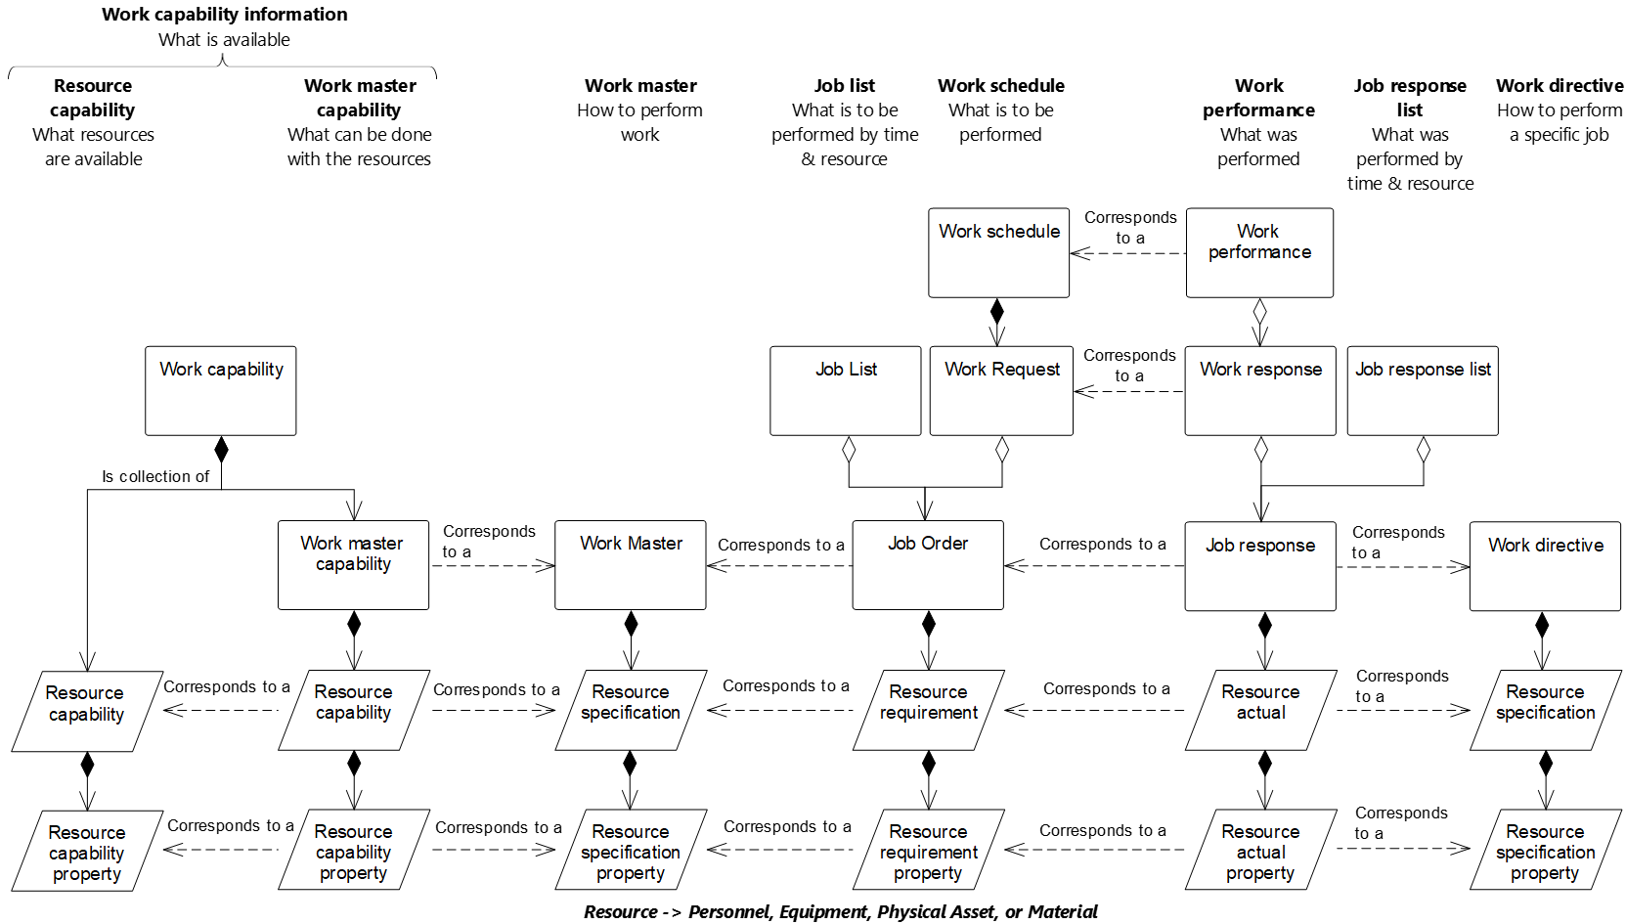

Figure 22 – Relationship between models

Table 111 presents the objects defined in this standard and the associated model.

Table 111 – Objects and models

| Object | Model |
| --- | --- |
| From resource reference | Resource relationship network model |
| From resource reference property | Resource relationship network model |
| Job list | Work schedule model |
| Job order | Work schedule model |
| Job order parameter | Work schedule model |
| Job response | Work performance model |
| Job response data | Work performance model |
| Job response list | Work performance model |
| Resource network connection | Resource relationship network model |
| Resource network connection property | Resource relationship network model |
| Resource network connection type | Resource relationship network model |
| Resource network connection type property | Resource relationship network model |
| Resource relationship network | Resource relationship network model |
| Resource relationship network property | Resource relationship network model |
| To resource reference | Resource relationship network model |
| To resource reference property | Resource relationship network model |
| Work alert | Work alert model |
| Work alert definition | Work alert model |
| Work alert definition property | Work alert model |
| Work alert property | Work alert model |
| Work calendar | Work calendar model |
| Work calendar property | Work calendar model |
| Work calendar definition | Work calendar model |
| Work calendar definition property | Work calendar model |
| Work calendar definition entry | Work calendar model |
| Work calendar definition entry property | Work calendar model |
| Work calendar entry | Work calendar model |
| Work calendar entry property | Work calendar model |
| Work capability | Work capability model |
| Work definition | Work definition model |
| Work directive | Work definition model |
| Work master | Work definition model |
| Work master capability | Work master capability model |
| Work performance | Work performance model |
| Work record | Work record model |
| Work request | Work schedule model |
| Work response | Work performance model |
| Work schedule | Work schedule model |
| Workflow specification | Work definition model, workflow specification model |
| Workflow specification property | Work definition model, workflow specification model |
| Workflow specification connection | Workflow specification model |
| Workflow specification connection property | Workflow specification model |
| Workflow specification connection type | Workflow specification model |
| Workflow specification connection type property | Workflow specification model |
| Workflow specification node | Workflow specification model |
| Workflow specification node property | Workflow specification model |
| Workflow specification node type | Workflow specification model |
| Workflow specification node type property | Workflow specification model |

# Compliance

Any assessment of compliance of a specification shall be qualified by

1. the use of the terminology defined in this part of the standard;
2. support of the object models defined in this part,
3. support the use of objects listed in Table 111 that are supported,
4. support the use of the attributes for each supported object,
5. support the defined relationships between the supported objects, and
6. a statement of the total compliance concerning definitions, objects, attributes, and relationships or, in case of partial compliance, a statement identifying explicitly the areas of noncompliance.
7. a list of additional relationships and roles not covered in this part
8. a list of additional attributes not covered in this part
9. support for the use of values in enumerations
10. a list of additional values in enumerations
11. (informative)  
      
    Questions and answers about object use
    1. How are dependencies in the *work schedule* and *work response* handled?

**Question:**

How are dependencies in the *work schedule* and *work response* handled?

**Answer:**

There are different types of dependencies (resource availability, customer priority, process dependency, and other).

Real applications need to model different types of dependencies between *work requests*.

EXAMPLE An MRP/ERP at Level 4 can produce separate requests for subassemblies or a single request for the final assembly of a given finished product and for the manufacturing of the intermediate materials that are the subassemblies to be assembled. Of course, there is a work process dependency relationship and final assembly shall start after all subassemblies have been manufactured. This is handled in an implementation where an *operations* or *work request* states the start time and/or end time and then the associated *segment requests* specify the earliest start time, latest end time and duration for each segment. The algorithm for the actual dispatching of work can be done at Level 4 or Level 3, but be represented in the *operations schedule* or *work schedule* request.

* 1. Use of hierarchy scope in workflow specification model

**Question:**

What is the purpose of including the *hierarchy scope* attribute in the workflow specification model?

**Answer:**

The use of the *hierarchy scope* attribute in the workflow specification model provides for the ability to restrict (or scope) the applicability of individual *workflow specification* and *workflow specification node* instances to specific *hierarchy scopes*. The *hierarchy scope* defined in the *workflow specification* or *workflow specification node* instances may be applicable to a broader or narrower equipment model scope than the *work definition* for which they are associated.

EXAMPLE The *work master* for load and haul operations in an open pit mining process assumes the *work directive* being used to control one *job order* for the load and haul operations has the *hierarchy scope* for the area known as “Norte Pit”. The Norte Pit area consists of a number of work centers with a work center defined for each bench being mined. The scope of the *work directive* and its associated *job order* covers all the active benches being mined within the Norte Pit. One of the benches (Bench 10) is restricted to being mined using a front end loader due to geotechnical constraints and another (Bench 8) is not subject to this condition and is being mined using a shovel. The *workflow specification* and/or *workflow specification nodes* relevant for the loading from bench 10 will be different to those relevant for Bench 8. In this case, a single *work directive*/*job order* pair can be used to manage and control the work in the Norte Pit, with the appropriate *workflow specification* being applied when loading from each of Bench 8 and Bench 10.

* 1. What are examples of resource relationships?

**Question:**

What are some examples of *resource relationship networks* and how are they important?

**Answer:**

*Resource relationships networks* model resources that have some form of dependency among the resources.

In the examples below, the *resource relationship network* may be annotated with properties that are relevant to the environment. Properties such as optimum paths, rework paths, and selection criteria for scheduling and planning applications could be included.

The resource relationships may be an input to an application indicating configuration properties of the system or an output representing the result of a calculation such as an optimization process that has generated a resource relationship model to indicate its output.

The following example describes three different *resource relationship networks* using the equipment resources shown in Figure A.1.



Figure A.1 – Equipment resources

The first relationship is a material flow routing network as shown in Figure A.2.



Figure A.2 – Routing relationship network

The routing relationship network would be modelled as a set of *resource network connections*:

<Resource Network Connection AC> <From Resource Reference to A> <To Resource Reference to C>

<Resource Network Connection CE> <From Resource Reference to C> <To Resource Reference to E>

<Resource Network Connection EG> <From Resource Reference to E> <To Resource Reference to G>

<Resource Network Connection BD> <From Resource Reference to B> <To Resource Reference to D>

<Resource Network Connection DE> <From Resource Reference to D> <To Resource Reference to E>

<Resource Network Connection DF> <From Resource Reference to D> <To Resource Reference to F>

<Resource Network Connection FG> <From Resource Reference to F> <To Resource Reference to G>

A detailed scheduling package would use the routing network to determine which paths through the *equipment* should be used for each production run.

The next relationship, shown in Figure A.3 with the same *equipment*, illustrates a gas line relationship, showing which *equipment* is connected to a gas main. This relationship could be used by a maintenance scheduling activity to determine which *equipment* is to be shut down when maintenance is performed on the gas main network.



Figure A.3 – Gas main relationship network

The gas main relationship network would be modelled as a set of *resource network connections*:

<Resource Network Connection GM1> <From Resource Reference to GAS_MAIN> <To Resource Reference to C>

<Resource Network Connection GM2> <From Resource Reference to GAS_MAIN> <To Resource Reference to D>

A *resource relationship network* across resource types is shown in Figure A.4. This relationship defines which *equipment* can be used for *material definition* X.



Figure A.4 – “Usable in” relationship network

The “usable in” *relationship network* would be modelled as a set of *resource network connections*, with each relationship containing selection criteria relevant to the selection algorithm:

<Resource Network Connection X1> <From Resource Reference to Material X> <To Resource Reference to B>

<Resource Network Connection X2> <From Resource Reference to Material X> <To Resource Reference to C>

<Resource Network Connection X3> <From Resource Reference to Material X> <To Resource Reference to E>

<Resource Network Connection X4> <From Resource Reference to Material X> <To Resource Reference to G>

This relationship would be used by a detailed scheduler to determine which resources may be used for production of *material* X.

1. (informative)  
     
   Related standards

Level 3 to Level 2 interfaces are defined in IEC 62541.

Standards for recipes are defined in ANSI/ISA-88.00.03.

As shown in Figure B.1, there is a relationship between the information models in Part 2 of this standard, the models in this part of this standard, and the models in ISA-88 (IEC 61512). Part 2 models are used to exchange information based on the Level 4 business view of operations, using *process segments* as the method to define segments of operation as viewed by the business processes. Models such as *operations definition* and *operations schedule* support the business view by defining the allocation of resources and scheduling activities to the site.

Models in this part of this standard are used to exchange information for Level 3 execution. Models such as *work definition* may reference the *operations definition* exchanged with Level 4, but they contain the details needed for actual execution of Level 3 activities. Additionally, *work master* and *work directive* are types of *work definitions* that provide the details needed for work execution.

A single *operations definition* may relate to one or more *work masters*. The *work masters* describe how to perform the work, using the resources identified in the *operations definition*. A *work directive* is created from a *work master* for a specific *job order*. If the step in a *work directive* defines a batch process (or work accomplished through a recipe), then the step in a *work master* may reference a *master recipe* (ANSI/ISA-88.00.01, IEC 61512-1) and a step in the *work directive* may reference a *control recipe* (ANSI/ISA-88.00.01, IEC 61512-1).

An *operations schedule* (Part 2 of this standard) (defining the resource allocation) is used to create a *work schedule* (defining the physical routing and sequencing) in operations scheduling activity (Part 3 of this standard). An operations dispatching activity (Part 3) uses the *job list* view of the *work schedule*. If there are batch processes in the *job list*, then the created batches are maintained in a *batch list* (ANSI/ISA-88.00.01, IEC 61512-1).

Information on the execution of a batch can be maintained in a *batch production record*. This information could then be combined with other information in a *work operations record*. This information can then be used to create *work performance* information (defining the resource usage for the physical routing), which in turn can be used to create *operations performance* information (Part 2) (defining the resource usage as viewed by business activities).

ANSI/ISA-88.00.03 (IEC 61512-3) defines an object model for general and site recipes, which define a research and development view of a product, independent of any specific equipment. There is no direct equivalent for these in the ISA-95 models. However, the ISA-95 models may be used to help define Level 4 operations definitions and/or Level 3 *work masters* by relating process stages (ANSI/ISA-88, IEC 61512) and process operations (ANSI/ISA-88, IEC 61512) to *process segments* and to the routing defined in *operations definitions* and *work masters.*

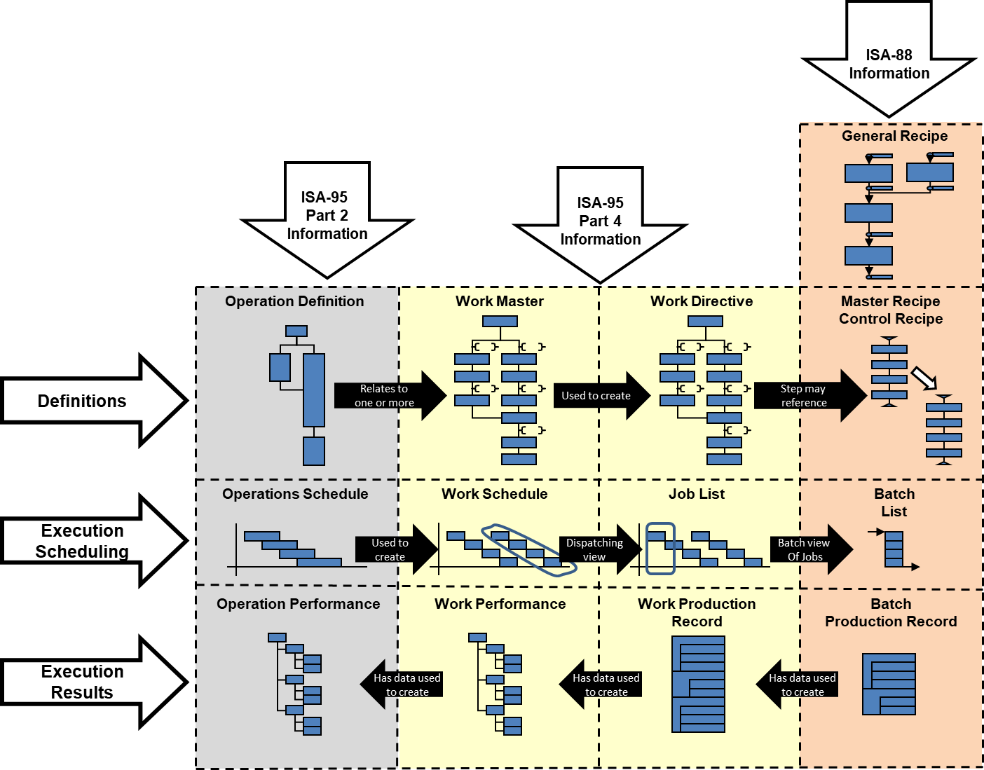

Figure B.1 – Relationship between Part 2, Part 4, and ANSI/ISA-88 (IEC 61512) standards

1. (informative)  
     
   Representing a workflow specification in BPMN

Annex C defines a possible mapping of BPMN 2.0 – business process model and notation to a *workflow specification*.

BPMN defines multiple different elements in a collaboration diagram; these include activities, gateways, events, data, choreographies, and conversations.

In general, the following elements would be represented as *workflow specification connection types*:

|  |  |  |
| --- | --- | --- |
| ****Name**** | ****Symbol**** | ****Description**** |
| Sequence flow |  | Defines the execution order of activities |
| Default flow |  | Defines the default branch chosen if all other conditions evaluate to false. |
| Conditional flow |  | Defines a branch with a condition assigned that defines whether or not the flow is used. |
| Message flow |  | Symbolizes information flow across organizational boundaries. |
| Conversation link |  | Connects communications and participants. |
| Forked conversation link |  | Connects communications and multiple participants. |

The following *workflow specification node types* could be defined to match elements in BPMN. The following is a partial list of all activities, gateways, events, data, choreographies, and conversations types.

|  |  |  |
| --- | --- | --- |
| Name | Symbol | Description |
| Task |  | Represents a unit of work, the job to be performed. May be annotated with different:  – activity markers: sub-process marker, loop marker, parallel MI marker, sequential MI marker, ad hoc marker, compensation marker;  – task types: send task, receive task, user task, manual task, business rule task, service task, script task. |
| Transaction |  | A set of activities that logically belong together. |
| Event sub-process |  | A task that is activated when the start event is triggered. |
| Call activity |  | A wrapper for a globally defined sub-process or task, |
| Exclusive gateway |  | When splitting, it routes the sequence flow to exactly one of the outgoing branches. When merging, it waits for one incoming branch to complete before triggering the outgoing flow. |
| Event-based gateway |  | Is always followed by catching events or receive tasks. |
| Parallel gateway |  | When used to split the sequence flow, all outgoing branches are activated simultaneously. When merging parallel branches it waits for all incoming branches to complete. |
| Inclusive gateway |  | When splitting one or more branches are activated, |
| Complex gateway |  | Complex merging and branching behavior that is not captured in other gateways. |
| Event |  | There are multiple types of events and each event can be defined for a different position in the execution sequence. Special indications:  – message, timer, escalation, conditional, link, error, cancel, compensation, signal, multiple, parallel multiple, terminate.  Sequence indications:  – top-level, start – event sub-process interrupting, start – event sub-process non-interrupting, intermediate catching, intermediate boundary interrupting, intermediate boundary non-interrupting, intermediate throwing, end.  Each event subtype would be represented as a different symbol on a BPMN diagram, as shown with figures to the left. |
| Input |  | An external input for the entire process. |
| Output |  | A variable available as the result of the entire process. |
| Data store |  | A place where the process can read and/or write data. |
| Pool (swimlane) |  | Represents responsibilities for activities in a process. |
| Lane (swimlane) |  | Represents responsibilities for activities in a process. |

The following example is used to illustrate the mapping to a *workflow specification*. The following abbreviations are used: *workflow specification* (WFS), *workflow specification node* (WSN), *workflow specification node property* (WSNP), *workflow specification connection* (WSC), and *workflow specification connection property* (WSCP).



Figure C.1 – Example, workflow specification in BPMN notation

Figure C.2 illustrates the aggregation hierarchy of the *workflow specification model*.

WS: ID=EXAMPLE

+--- WSN: ID=MES, Type=LANE

+---- WSN: ID=Start, Type=EVENT START

+---- WSN: ID=Scan Material, Type=TASK

+---- WSNP: Task Type=MANUAL

+---- WSN: ID=Planned, Type=EXCLUSIVE GATEWAY

+---- WSN: ID= Assign Local Lot ID, Type=TASK

+---- WSNP: Task Type=SERVICE

+---- WSN: ID= Store Material, Type=TASK

+---- WSNP: Task Type=USER TASK

+---- WSN: ID= End, Type=EVENT END

+---- WSC: From=Start, To=Scan Material

+---- WSC: From= Scan Material, To=Planned

+---- WSC: From=Planned, To=Get ERP Lot ID

+---- WSCP: Condition=YES

+---- WSC: From=Planned, To=Assign Local Lot ID

+---- WSCP: Condition=NO

+---- WSC: From= Assign Local Lot ID, To=End

+--- WSN: ID=ERP, Type=LANE

+---- WSN ID=Get ERP Lot ID, Type=TASK

+---- WSNP: Task Type=SERVICE

+---- WSC: From= Get ERP Lot ID, To=Assign Local Lot ID

Figure C.2 – Example workflow process in the workflow specification model

1. (informative)  
     
   Representing a workflow specification in flowchart notation

Annex D defines a possible mapping of flowcharts to a *workflow specification*.

The following *workflow specification node types* can be defined to match elements in a flow chart:

process, decision, data, document, predefined process, stored data, internal storage, sequential data, direct data, manual input, card, paper tape, display, manual operation, preparation, parallel mode, loop limit, terminator

The following *workflow specification connection type* could be defined to match the links between flowchart elements:

control transfer

The following example is used to illustrate the mapping to a workflow specification. The following abbreviations are used: *workflow specification* (WPN), *workflow specification node* (WSN), *workflow specification node property* (WSNP), *workflow specification connection* (WSC), and *workflow specification connection property* (WSCP).



Figure D.1 – Example, workflow specification in flowchart notation

Figure D.2 illustrates the aggregation hierarchy of the *workflow specification model*.

WPN: ID=EXAMPLE

+--- WSN: ID=MES, Type=LANE

+---- WSN: ID=Start, Type=START

+---- WSN: ID=Scan Material, Type=PROCESS

+---- WSN: ID=Planned, Type=DECISION

+---- WSN: ID= Assign Local Lot ID, Type= PROCESS

+---- WSN: ID= Store Material, Type= PROCESS

+---- WSN: ID= Stop, Type=TERMINATOR

+---- WSC: From=Start, To=Scan Material

+---- WSC: From= Scan Material, To=Planned

+---- WSC: From=Planned, To=Get ERP Lot ID

+---- WSCP: Condition=YES

+---- WSC: From=Planned, To=Assign Local Lot ID

+---- WSCP: Condition=NO

+---- WSC: From= Assign Local Lot ID, To=End

+--- WSN: ID=ERP, Type=LANE

+---- WSN ID=Get ERP Lot ID, Type= PROCESS

+---- WSC: From= Get ERP Lot ID, To=Assign Local Lot ID

Figure D.2 – Example workflow process in the workflow specification model

1. (informative)  
     
   Example of work calendars
   1. Four-day 24-hour shift pattern

Table E.1 illustrates a *work calendar* that defines a 4-day, 24-hour work shift pattern, with 24 hours on shift and 48 hours off shift. A is the first shift team, B is the second shift team, C is the third shift team, and D is the fourth shift team. The *work calendar* defines the times that each shift team is working.

Table E.1 – Four-day 24-hour shift pattern example

|  |  |  |  |  |  |  |  |  |  |  |  |  |  |  |  |  |  |  |  |  |  |  |  |  |  |  |  |  |  |
| --- | --- | --- | --- | --- | --- | --- | --- | --- | --- | --- | --- | --- | --- | --- | --- | --- | --- | --- | --- | --- | --- | --- | --- | --- | --- | --- | --- | --- | --- |
| 12/24/12/48 shift example | | | | | | | | | | | | | | | | | | | | | | | | | | | | | |
| Time | | Week 1 | | | | | | | Week 2 | | | | | | | Week 3 | | | | | | | Week 4 | | | | | | |
| Mon | Tue | Wed | Thu | Fri | Sat | Sun | Mon | Tue | Wed | Thu | Fri | Sat | Sun | Mon | Tue | Wed | Thu | Fri | Sat | Sun | Mon | Tue | Wed | Thu | Fri | Sat | Sun |
| Daily | 06:00–18:00 | A | C | D | B | A | C | D | B | A | C | D | B | A | C | D | B | A | C | D | B | A | C | D | B | A | C | D | B |
| Nightly | 18:00–06:00 | B | A | C | D | B | A | C | D | B | A | C | D | B | A | C | D | B | A | C | D | B | A | C | D | B | A | C | D |
| Pattern | | Run 1 | | | | Run 2 | | | | Run 3 | | | | Run 4 | | | | Run 5 | | | | Run 6 | | | | Run 7 | | | |

The *work calendar definition* used to define the shift pattern is illustrated in Table E.2.

Table E.2 – Work calendar definition for 4-day 24–hour shift entry examples

|  |  |
| --- | --- |
| ****Attribute**** | ****Value**** |
| ID | 001 |
| Description | Four-day 24-hour shift pattern |

The *work calendar definition entries* used to define the shift pattern are illustrated in Table E.3.

Table E.3 – Work calendar definition entry for 4-day 24–hour shift example

|  |  |
| --- | --- |
| First entry | |
| ****Attribute**** | ****Value**** |
| ID | Shift team A |
| Description | 24 hours on, 48 hours off shift pattern team A |
| Start rule | 0001-01-01T00:00:00 |
| Recurrence time interval rule | R/P4D |
| Duration rule | PT12H |
| Entry type | Work shift |
| **Second entry** | |
| **Attribute** | **Value** |
| ID | Shift team B |
| Description | 24 hours on, 48 hours off shift pattern team B |
| Start rule | 0001-01-01T00:00:00 |
| Recurrence time interval rule | R/P4D |
| Duration rule | PT24H |
| Entry type | Work shift |
| **Third entry** | |
| Attribute | Value |
| ID | Shift team C |
| Description | 24 hours on, 48 hours off shift pattern team C |
| Start rule | 0001-01-01T00:00:00 |
| Recurrence time interval rule | R/P4D |
| Duration rule | PT24H |
| Entry type | Work shift |
| **Fourth entry** | |
| Attribute | Value |
| ID | Shift team D |
| Description | 24 hours on, 48 hours off shift pattern team D |
| Start rule | 0001-01-01T00:00:00 |
| Recurrence time interval rule | R/P4D |
| Duration rule | P242H |
| Entry type | Work shift |

Some of the *work calendar entries* that define the 2014 shift pattern for the 24 hours on and 48 hours off shift pattern are illustrated in Table E.4.

Table E.4 – Work calendar entries for 2014 shift calendar

|  |  |  |  |  |
| --- | --- | --- | --- | --- |
| ID | Description | Start date time | Finish date time | Entry type |
| 1 | Team A | 2014-01-01T00:00:00 | 2014-01-01T23:59:59 | Work shift |
| 2 | Team B | 2014-01-02T00:00:00 | 2014-01-02T23:59:59 | Work shift |
| 3 | Team C | 2014-01-03T00:00:00 | 2014-01-03T23:59:59 | Work shift |
| 4 | Team D | 2014-01-04T00:00:00 | 2014-01-04T23:59:59 | Work shift |
| 5 | Team A | 2014-01-05T00:00:00 | 2014-01-05T23:59:59 | Work shift |
| 6 | Team B | 2014-01-06T00:00:00 | 2014-01-06T23:59:59 | Work shift |

* 1. Example of ISO 8601 format strings

ISO 8601 format is used to define the start rule, the recurrence time interval rule, and the duration rule. In ISO 8601 format some of these could be represented as a single string. In order to provide the necessary flexibility these are represented as separate ISO 8601 strings in this standard.

An ISO 8601 format string that represents a rule that defines the 15th of every month would be represented as: “R/2000-01-15/P1M”.

This is represented as two separate ISO 8601 strings. The start rule is “2000-01-15”and the recurrence time interval rule is “R/P1M”.

* 1. Bank holiday work calendar

Table E.5 defines a *work calendar definition* for 2014 England bank holidays. This *work calendar definition* could be combined with other *work calendar definitions*, such as company holidays and plant shutdown calendars, to determine working days during the year.

Table E.5 – Work calendar definition for 2014 England bank holidays

|  |  |
| --- | --- |
| Attribute | Value |
| ID | 001 |
| Description | 2014 England bank holidays |

Table E.6 defines the work calendar definition entries for 2014 England bank holidays.

Table E.6 – Work calendar definition entries for 2014 England bank holidays

|  |  |  |  |  |  |
| --- | --- | --- | --- | --- | --- |
| ID | Description | Start rule | Recurrence time interval rule | Duration rule | Entry type |
| 001 | New year’s day | 2014-01-01T00:00 | <na> | P1D | Bank holiday |
| 002 | Good Friday | 2014-18-04T00:00 | <na> | P1D | Bank holiday |
| 003 | Easter Monday | 2014-21-04T00:00 | <na> | P1D | Bank holiday |
| 004 | May Day | 2014-05-05T00:00 | <na> | P1D | Bank holiday |
| 005 | Spring bank holiday | 2014-05-26T00:00 | <na> | P1D | Bank holiday |
| 006 | Summer bank holiday | 2014-08-25T00:00 | <na> | P1D | Bank holiday |
| 007 | Christmas and Boxing day | 2014-12-25T00:00 | <na> | P1D | Bank holiday |

1. (informative)  
     
   Examples of work record implementation

The *work record model* is a logical model which is generic in structure that allows *work record* content to be specified that meet the requirements of a specific implementation (as part of an implementation model).

This annex presents two possible implementations of the *work record* being the ISA-88.00.04 and the initial representation of *work record* developed by IEC WG5 (included in this annex).

ISA-88.00.04 present a batch production record that consists of data about the manufacture of the product plus all supporting data required to meet the business requirements of the record. IEC WG5 extended this representation to generate an initial representation of data in this standard related to the *work* record.

* 1. Representation of ISA-88 production record

The core objects in an ISA-88.00.04 *production record* are the *production record* and *batch production record entry* objects. These objects map to the ISA-95 *work record* and *operations record entry* objects.

The representation of record entry contents is defined in the *work record specification* object as data representing the allowed objects and their multiplicity.

The abstract UML models of this standard do not represent container objects as presented in ISA-88; these container objects are represented in the implementation model as required. The specification of the container object representation is to be captured in an ISA-88 profile if required which will then allow the generation of a message structure that is equivalent to that presented in ISA-88.

The representation of the ISA-88 objects as presented in the *work record specification* is presented in Table F.1.

If an exact replica of the ISA-88 *production record* is required, the *production record* is associated directly.

This standard does not prescribe the allowed contents in a *batch production record*. Refer to ISA-88 Part 4 for current updates on the content of a production record.

Table F.1 – ISA-88 objects as presented in the work record specification

|  |  |  |  |
| --- | --- | --- | --- |
| **Information object** | **Information object multiplicity** | **Action(s)** | **Action(s) multiplicity** |
| Comment | 0.. * | Observed | 0.. * |
| Event | 0.. * | Observed | 0.. * |
| Resource qualifications | 0.. * | Observed | 0.. * |
| Samples | 0.. * | Observed | 0.. * |
| Operations responses | 0.. * | Observed | 0.. * |
| Operations definitions | 0.. * | Observed | 0.. * |
| Operations requests | 0.. * | Observed | 0.. * |
| Change history | 0.. * | Observed | 0.. * |
| Personnel identification | 0.. * | Observed | 0.. * |
| Master recipe | 0.. * | Observed | 0.. * |
| Control recipe | 0.. * | Observed | 0.. * |
| Recipe element | 0.. * | Observed | 0.. * |
| Batch production record | 0.. * | Observed | 0.. * |
| Resource qualification | 0.. * | Observed | 0.. * |

*Operations response*, *operations definition* and *operations request* are deprecated objects of this standard existing in ISA-88.00.04; they are replaced by *operations response*, *operations definition* and *operations request* in the current version of this standard, respectively.

* 1. Extension of ISA-88 production record to included ISA-95 objects

The following objects represent the objects identified by IEC WG5 as extensions to the *batch production record* to generate a *work record.* As shown Table F.2, the ISA-88 model representation of the allowed content of the *work record* is unconstrained. Specific applications may require more constrained *multiplicity* and allowed *information objects* to represent a complete *work record*.

Table F.2 – ISA-88 model representation of the allowed content of the *work record*

|  |  |  |  |
| --- | --- | --- | --- |
| Information object | Information object multiplicity | Action(s) | Action(s) multiplicity |
| Operations schedule | 0.. * | Observed | 0.. * |
| Operations definition | 0.. * | Observed | 0.. * |
| Operations performance | 0.. * | Observed | 0.. * |
| Work master | 0.. * | Observed | 0.. * |
| Work directive | 0.. * | Observed | 0.. * |
| Work schedule | 0.. * | Observed | 0.. * |
| Work performance | 0.. * | Observed | 0.. * |
| Work alert definition | 0.. * | Observed | 0.. * |
| Work alert | 0.. * | Observed | 0.. * |
| Work calendar | 0.. * | Observed | 0.. * |

* 1. Work record model as presented in IEC WG5
     1. Work record definition

A *work record* shall be defined as a subset of the execution and business information that is retained based upon business requirements identified by a work record specification. A *work record* consists of data about the manufacture of the product plus all supporting data required to meet the business requirements of the record.

NOTE 1 This information can include the workflow execution information, both specific equipment information, operator comments, alarms, elements related to the definition of a job (such as *work masters*, *work directives*, *work schedule* information), and information important to the operation (such as training logs, maintenance records, and environmental conditions).

NOTE 2 *Work performance* can contain information to a specific set of job orders. *Work records* can contain information about multiple *job orders* and information not directly related to any specific *job order*. A *work record* can contain a *work performance* (or *work response*). Generally, a *work performance* can be the response to performing the work specified in a *work schedule*.

A *work record* contains additional details of all activities involved in operations.

*Work records* are intended to provide a vendor-neutral representation of information in a form suitable for archiving and storage. Figure F.1 illustrates the activities and information associated with creating, maintaining, and using *work records*. Only the *work record* (the white box) is defined in this standard; the activities and other information sets (the gray boxes and activities) are shown to illustrate the environment of *work records*. There is an activity of creating *work records*, which uses operations information, usually from multiple sources and in multiple forms and formats, and which uses a specification of the information to be used to create the *work record*. There is an activity which uses *work records* and work record report specifications to generate work record reports that are suitable for print or display.

**

Figure F.1 – Work record activities

NOTE 3 *A work record specification* is the information that is intended to be used to define a *work record*. The content and format for *work record specifications* are not defined in this part of the standard.

NOTE 4 A *work record report specification* is the information that is intended to be used to define a *work record report.* The content and format for *work record report specifications* are not defined in this part of the standard.

* + 1. Work record

A *work record* shall use ANSI/ISA-88.00.04 (IEC 61512-4) *batch production* record definitions with the following exceptions.

1. The *work record* shall be used in place of *batch production record.*
2. *Work record specification* shall be used in place of *batch production record specification*.
3. *Work record entry* shall be used in place of *batch production record entry*.
4. *Work recor*d *specification ID* shall be used in place of *batch production record* *specification ID*. This is a unique identification of a *work record specification* used to create a *work record*.
5. *Work record* *data reference* shall be used in place of *BPR* (*batch production record*) *data reference*.

NOTE 1 This is a reference to a data element in a *work record*.

1. *work record* may contain an ANSI/ISA-88.00.04 *batch production record*.

NOTE 2 Event information associated with a *work alert* can be represented in an alarm event.

* + 1. Work record extensions

The *work record* shall be an extension to the definition of ANSI/ISA-88.00.04 *batch production record* with the additional following extensions.

1. *Operations schedules* are included as a collection of *operations schedule* elements (as defined in Part 2 of this standard);
2. *Operations definitions* are included as a collection of *operations definition* elements (as defined in Part 2 of this standard).
3. *Operations performances* are included as a collection of *operations performance* elements (as defined in Part 2 of this standard).
4. *Test specifications* are included as a collection of *test specification* elements (as defined in Part 2 of this standard);
5. Test results are included as a collection of *test result* elements (as defined in Part 2 of this standard);
6. *Operational locations* are included as a collection of *operations location* elements (as defined in Part 2 of this standard);
7. *Operations events* are included as a collection of *operations event* elements (as defined in Part 2 of this standard);
8. *Operations event records* are included as a collection of *operations event record* elements (as defined in Part 2 of this standard);
9. *Work masters* are included as a collection of *work master* elements.
10. *Work directives* are included as a collection of *work directive* elements.
11. *Work schedules* are included as a collection of *work schedule* elements.
12. *Work performance* are included as a collection of *work performance* elements.
13. *Work alert definitions* are included as a collection of *work alert definition* elements.
14. *Work alerts* are included as a collection of *work alert* elements.
15. *Work calendar definitions* are included as a collection of *work calendar definition* elements.
16. *Work calendars* are included as a collection of *work calendar* elements.
17. Batch specific elements were removed.
18. *Batch production records* are included as a collection of *batch production record* elements (as defined in ANSI/ISA-88.00.04 (IEC 61512-4).

A *work record* is a container for containers and each sub-container has zero or more elements for a specific type of object. Figure F.2 illustrates a sample *work record* (the outer white box) that contains one of each type of sub-container (the inner white boxes) and multiple elements within each sub-container (the gray boxes).

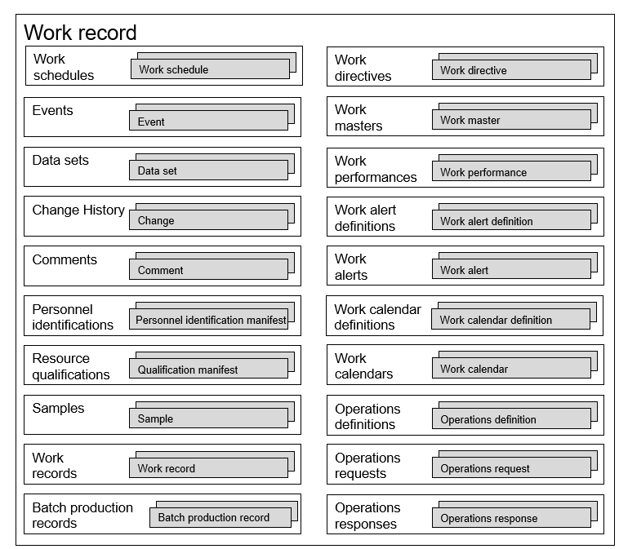

Figure F.2 – Example, Work record container

Elements of a *work record* can reference other elements within the *work record*, as illustrated in Figure F.3. It shows an example with one *change history* that references a changed *work directive workflow specification*, two *personnel identification manifests*, and one *comment* that references a *change history element*. One *personnel identification manifest* identifies the person and “Done by” action on the *change history*. The second identifies the *person* and *“Checked by” action* on the *change history*. The *comment* contains a comment associated with the change.



Figure F.3 – Example, work record element reference

* + 1. Work record model example

The work record model is shown in Figure F.4. The objects with gray shading are defined in ANSI/ISA-88.00.04.

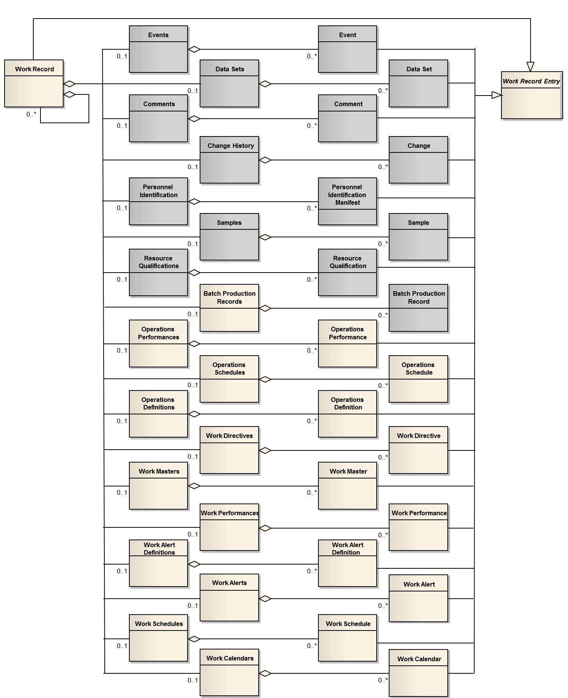

Figure F.4 – Example, work record model

* + 1. Work record entry

A *work record entry* is an abstract type used to define common attributes for many of the objects that make up a *work record*. All specialized types of *work record entry* objects (shown in Figure F.4) shall have the relationships defined in Table F.3 and the attributes defined Table F.4.

Table F.3 – Work record entry relationship

| Related object | Relationship | | | | Description |
| --- | --- | --- | --- | --- | --- |
| Role | Multiplicity | Name | Type |
| Work record,  Event,  Data set,  Comment,  Change,  Personnel identification manifest,  Sample,  Resource qualification,  Operations performance,  Operations schedule,  Operations definition,  Work directive,  Work master,  Work performance,  Work alert definition,  Work schedule,  Work calendar. | External reference | 0..* | Is superclass of | Generalization | The specialised object represents the related object, the *work record entry* specialization references.  *Work record* *entries* are abstract objects which cannot be instantiated, only the specialized objects can be instantiated.  Contains a reference to data which is stored externally to the *work record*.  If data is embedded in the *work record*, this attribute is not used.  The format of the reference is determined by a conforming specification.  The objects type is identified by the *object type* attribute in the *work record entry*. |

Table F.4 – Work record entry attributes

| Attribute name | Description | Examples |
| --- | --- | --- |
| Entry ID | ID which is unique within the scope of a *work record*. This attribute is mandatory. | 1  239432  4A34B |
| Description | Additional information about the entry. | The *work directive* is embedded in this *work record entry*.  Data set time series data is stored in the historian database. |
| External reference | Contains a reference to data which is stored externally to the *work record*.  If data is embedded in the work record this attribute is not used.  The format of the reference is determined by a conforming specification. | Control system for work cell A  \\dept_share\archive2004\ product ABC |
| Object type | Identifies the type of object an entry is based upon. | *Work master*  *Data set*  *Change history* |
| Time stamp | The time stamp associated with the entry. | 2013-07-14 1454+0100  01 March 2014 14:25 UTC  April 23, 2012 8:30 AM ET |

* + 1. Work record container objects

The following objects are container objects having no defined attributes.

1. *Operations schedules* shall be defined as a container of *operations schedule* elements (as defined in Part 2 of this standard).
2. *Operations definitions* shall be defined as a container of *operations definition* elements (as defined in Part 2 of this standard).
3. *Operations performances* shall be defined as a container of *operations performance* elements (as defined in Part 2 of this standard).
4. *Work masters* shall be defined as a container of *work master* elements.
5. *Work directives* shall be defined as a container of *work directive* elements.
6. *Work schedules* shall be defined as a container of *work schedule* elements.
7. *Work performances* shall be defined as a container of *work performance* elements.
8. *Work calendars* *definitions* shall be defined as a container of *work calendar* elements.
9. *Work calendar* shall be defined as container of *work calendar definition* elements
10. *Work alert definitions* shall be defined as container of *work alert definition* elements
11. *Work alerts* shall be defined as a container of *work alert* elements.
12. *Batch production records* shall be defined as a container of *batch production record* elements (as defined in ANSI/ISA-88.00.04).
    * 1. Event types and subtypes

The *procedural execution event* (defined in ANSI/ISA-88.00.04 shall be used to refer to events associated with a *job order’s workflow specification*.

As shown in Table F.5, the standard *event types* and *event subtypes* defined in shall be added to the ANSI/ISA-88.00.04 standard *event types.*

Table F.5 – Additional event types and subtypes

| Event type | Event subtype | Description |
| --- | --- | --- |
| Work directive | Modification | Change in value for a *parameter* in a *work directive*.  Value attribute contains the new data value. The previous value contains the old data value.  EXAMPLE 1  Temperature set point changed to 500, *scaling factor* applied to *work directive.* |
| Work directive | Equipment | Change in *equipment* assigned to or bound to a *work directive*.  *Value* attribute contains the new *equipment* name. The previous *value* contains the old data’s *equipment* name.  EXAMPLE 2  Packing Line 22 bound to Workflow Step 184. |
| Equipment | Allocation | Allocation of *equipment* to a *job order.*  *Value* attribute contains the *equipment ID*.  EXAMPLE 3  *Work unit acquired.* |
| Equipment | Deallocation | Deallocation of *equipment* from a *job order*.  *Value* attribute contains the *equipment ID.*  EXAMPLE 4  *Work unit* *released.* |
| Procedural execution | Prompt | A request from a workflow to the operator to provide information for the completion of the workflow logic.  *Value* attribute contains text sent to the operator.  EXAMPLE 5  Execute SOP 324, perform line clearance per SOP 394. |
| Physical asset | Allocation | Allocation of a *physical asset* to a *job order.*  *Value* attribute contains the *equipment ID.*  EXAMPLE 6  *Work unit acquired.* |
| Physical asset | Deallocation | Deallocation of a *physical asset* from a *job order.*  *Value* attribute contains the *equipment ID.*  EXAMPLE 7  *Work unit released.* |
| Personnel | Assignment | Assignment of a *person* to a *job order.*  *Value* contains the *person ID.* |
| Personnel | Unassigned | Removal of an assignment of a *person* to a *job order.*  V*alue* contains the *person ID.* |
| Work alert | Generated | A *work alert* was generated.  *Value* contains the *work alert* information. Additional information may be recorded in an *alarm event* (defined in IEC 61512-4). |

Bibliography

IEC 61512 (all parts), Batch control

IEC 62541 (all parts), OPC unified architecture

ISO 22400 (all parts), Automation systems and integration – Key performance indicators (KPIs) for manufacturing operations management

ANSI/ISA-88.00.01-2010, Batch Control – Part 1: Models and Terminology

MIMOSA OSA-EAI CCOM V3.2 – [www.mimosa.org](http://www.mimosa.org)

BPMN specifications are maintained by Object Management Group (OMG) at <http://www.omg.org/spec/BPMN>. The current version is 2.0.

_____________